For more information, please contact Marta de Paco
On +34 670 780 664 or email press@comunicahair.com

Important:
These images are only available for editorial content.
Credits must be included.
Notification of their publication is expected.

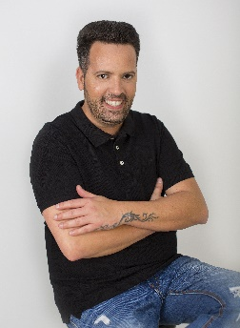
RAFAEL BUENO
SECOND SKIN Collection

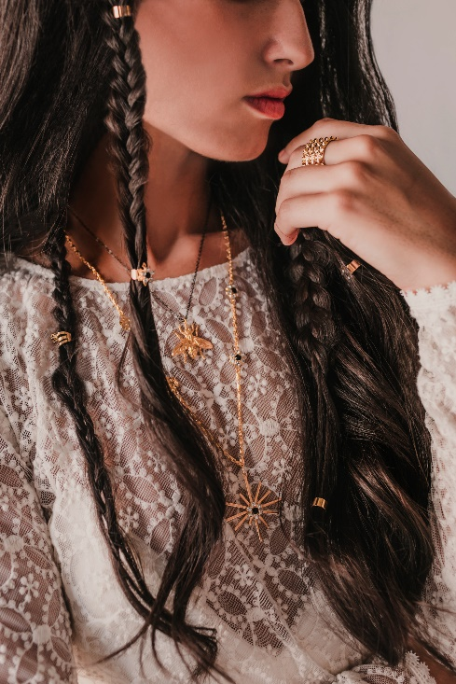
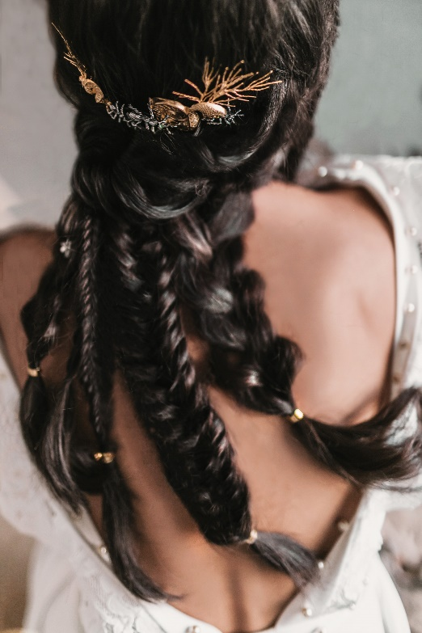
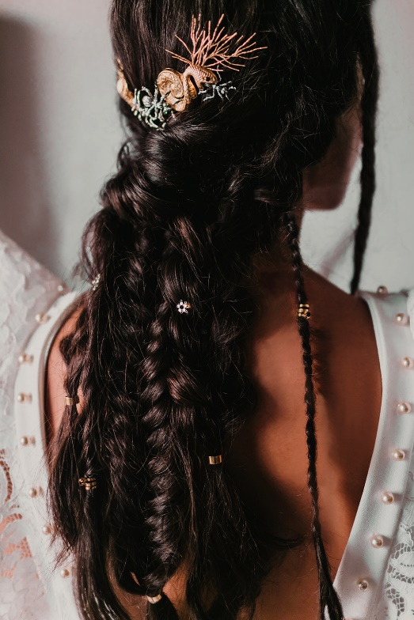
Hair: Rafael Bueno @Rafael Bueno Peluqueros
Hair Instagram: @rafaelbuenopeluqueros
Hair Assistant: Moysés Utrera Instagram: @moysesutrera
Photography: Amanda Watt Instagram: @amandawattr
Styling: Rodolfo McCartney Instagram: @rodolfomcartney de @noquieroagencia
Dresses: @santoscostura @otaduy @larcabarcelona
MUA: Lulú Pérez y Ariadna Roji Instagram: @_luluperez_ y @ariadna_roji
Video: Essential Films Instagram: @essential.films
Floral styling: La Bohème Estilismo Floral Instagram: @laboheme.estilismofloral
Jewels: Martina Dorta Instagram: @martina_dorta
Furniture and lighting: Más Que Palets Instagram: @masquepalets
Models: @lolaarivas @solmgarrido @lifebeing.us
RAFAEL BUENO
SECOND SKIN Collection

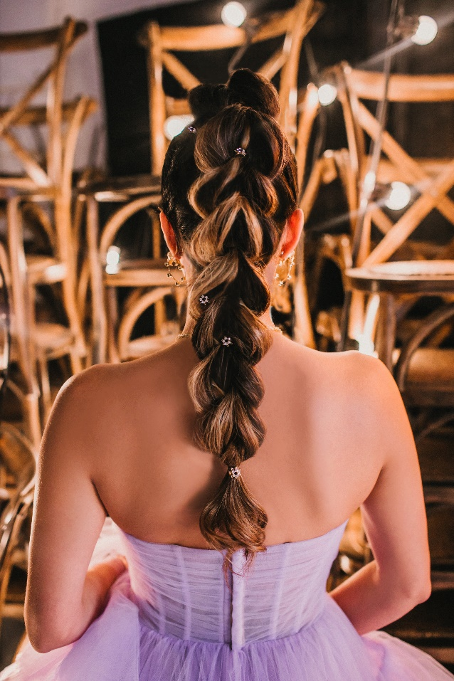

This collection aims to inspire and transmit different emotions to those who see the hairstyles and the pieces that decorate the hair. Each of the jewel accessories has a great individual value, in which current hairstyles are combined with the craftsmanship of their free culture pieces and unmistakable styles.
The various types of braiding, textures and shapes that are made in hair make this collection adaptable to the new times. Hair becomes a new object of desire, artistic and emotional, thanks to the handmade textures of the braiding and the combination of objects with different motifs such as insects, reptiles and headpieces that offer versatile, fresh, alternative and daring jewelry.

