The Neumann MT 48 Becomes an Immersive Audio Interface
Neumann releases the Monitor Mission

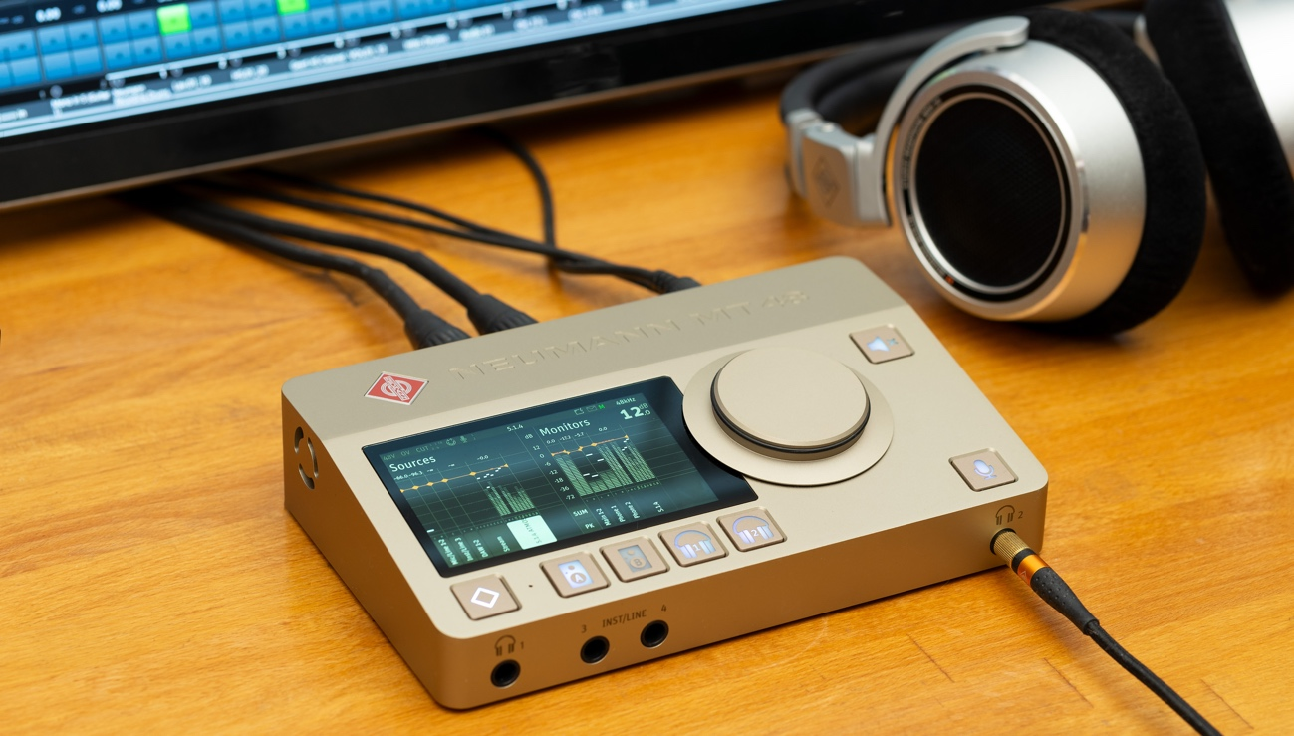

Neumann/Berlin, January 25, 2024 – At NAMM 2024, the legendary studio equipment specialist Neumann.Berlin is presenting a feature upgrade for the MT 48 audio interface introduced last year. The Monitor Mission transforms the MT 48 into a freely configurable monitoring controller. In addition to mono and stereo, the Monitor Mission can also handle surround formats such as 5.1 as well as highly sought-after immersive audio formats such as Dolby Atmos 7.1.4. This opens up a whole new field of applications, particularly in the mixing and mastering sector.

The Monitor Mission includes flexible bass management and complex alignment functions to adjust the frequency and time domain characteristics of loudspeakers to the listening position. The downmix feature allows multichannel audio to be monitored in either mono or stereo.

The extensive range of connectivity options makes it possible to connect studio monitors in a variety of ways, whether analog or digital via S/PDIF or ADAT. It is even possible to combine several connection types for one speaker group. Using the four analog monitor outs and an external ADAT converter, systems of up to 7.1.4 can be realized. In addition, the built-in AES67 interface allows the connection of highly professional multi-channel converters such as the Merging Hapi MKII and/or Neumann studio monitors in the AES67 version. In this way, almost any number of channels can be realized.

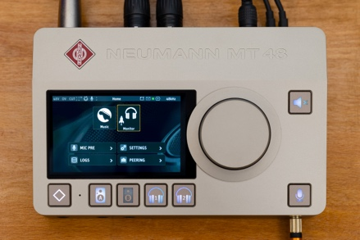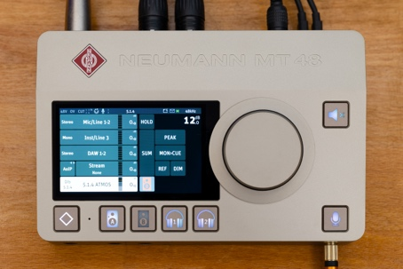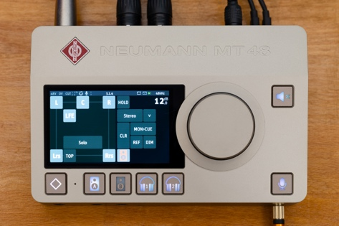

“The Monitor Mission turns the MT 48 into an immersive audio interface!” says Stephan Mauer, Head of Product. “This makes the MT 48 virtually unrivaled – with the exception of its sister product, the Merging Anubis, where the Monitor Mission has already proven itself in countless professional setups. Users can therefore be sure that they are getting a perfect solution. In addition, the MT 48’s extended connectivity compared to the Anubis makes immersive solutions even more flexible and affordable for studios of all sizes. With its integrated AES67 support and class compliant USB IO, the MT 48 is the perfect interface for easy integration.”

Prices and Availability
The Monitor Mission does not require a download but is part of the MT 48 firmware from version 1.6.x, which will be released in February. The Monitor Mission is activated via an individual software key. Users who register their MT 48 with the manufacturer before July 1, 2024, will receive their activation key for the Monitor Mission free of charge.

More Information:
https://www.neumann.com/en-en/produkte/audiointerfaces/mt-48/

Features:
- Turns the MT 48 into an immersive audio interface & monitor controller
- For mono, stereo, surround and immersive audio
- Downmix, e.g. for headphone playback
- Flexible bass management
- Room alignment of the connected speakers in frequency and time domain
- Remote Application and Web Control support
- Fully functional in standalone and class compliant operation

About Neumann
Georg Neumann GmbH, known as “Neumann.Berlin”, is one of the world’s leading manufacturers of studio-grade audio equipment and the creator of recording microphone legends such as the U 47, M 49, U 67, and U 87. Founded in 1928, the company has been recognized with numerous international awards for its technological innovations. Since 2010, Neumann.Berlin has expanded its expertise in electro-acoustic transducer design to also include the studio monitor market, building upon the legacy of the legendary loudspeaker innovator Klein + Hummel. The first Neumann studio headphones were introduced in 2019, and since 2022, the company has increased its focus on reference solutions for live audio. With the introduction of the first audio interface MT 48, and its revolutionary converter technology, Neumann now offers all the necessary technologies needed to capture and deliver sound at the highest level. Georg Neumann GmbH has been part of the Sennheiser Group since 1991 and is represented worldwide by the Sennheiser network of subsidiaries and long-standing trading partners. www.neumann.com

Press Contacts Neumann:
Andreas Sablotny
andreas.sablotny@neumann.com
T +49 (030) 417724-19

Raphael Tschernuth
raphael.tschernuth@neumann.com
T +49 (030) 417724-67

