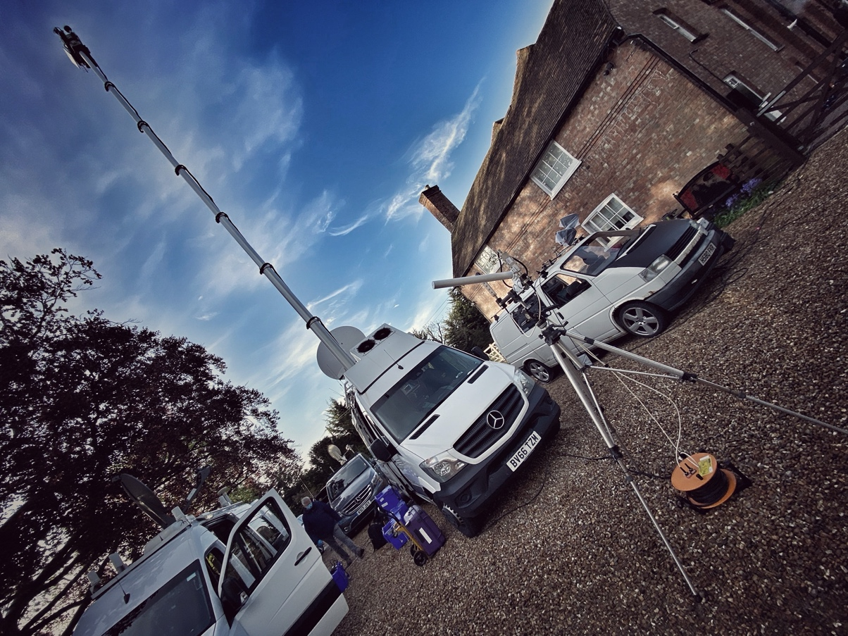

Nation’s favourite Captain Sir Tom Moore’s story preserved by Sennheiser
War veteran’s 100th Birthday celebration was captured using Digital 6000 series

Marlow/UK, 3 July 2020 – At the end of April, British war veteran and beloved walking hero, Captain Sir Thomas Moore, raised more than £32m for NHS charities by walking 100 laps of his garden before his 100th birthday on the 30th of April. On his birthday morning, thousands of people worldwide offered their well wishes to the former tank commander. Joining the widespread celebration, Captain Sir Tom Moore thanked the public for their overwhelming generosity from his home in Bedfordshire. Speaking to the BBC Breakfast team, his voice was heard loud and clear thanks to Sennheiser’s rock-solid Digital 6000 wireless microphone system.

Broadcast sound engineer, Paul Cutler, who has been working with clients such as the BBC, ITV, ITN and Sky for over 23 years, was in charge of audio on the day.

“I have worked with BBC Breakfast on several other interesting large scale outside broadcasts and special features,” says Cutler. “This particular project gained momentum very quickly and it also grew technically.”

Cutler explains that, after having an initial Zoom meeting with engineering managers on both BBC Breakfast and BBC News, he immediately left his home and went straight to the house of Captain Tom Moore to do the recce that afternoon.

“I did that so that I could physically see the site for the Outside Broadcast and meet Captain Tom Moore in person, with safe distancing adhered to, of course” continues Cutler. “At that time, it became apparent to me that the kit I needed was going to be fairly large scale, due to the nature and complexity of the OB and that was when I made the call to Presteigne Broadcast Hire.”

Presteigne Broadcast Hire is well-known to Cutler. He is familiar with their product inventory and high standards of service. “I have complete confidence that the equipment they provide always works and is in excellent condition,” he adds.

After consulting with Dan Somogyi, Senior PPU & RF Hire Manager, about what he needed to achieve, Cutler had a consultation with David Handley, Head of Audio at Presteigne.

“Collectively, we decided on using Sennheiser’s Digital 6000 Series,” says Cutler. “These radio mics were chosen because I needed 100% reliable performance. Also, the mics needed to work on a fairly short local range as the receivers were close to where the action was taking place. In radio mic terms ‘less is more’. What you don’t want is lots of high power when you’ve got multiple frequencies plus IEMs and Captain Tom Moore’s Bluetooth hearing aid all radiating in local proximity, so low power output was important, combined with battery consumption and the crystal-clear audio quality.”

Another important requirement for Cutler was for the radio mics to be intuitive. “This was the first time Jamie Dunn, my sound crew for the day, had used these particular mics and this was a live situation, going out to over seven million people,” exclaims Cutler. “There was absolutely no room for an error, so it was crucial to have the mics that are very user friendly, allowing him to quickly and easily change frequencies or gain settings, if needed.”

Due to safe distancing guidelines, all contributors had to be able to mic themselves. Everything was sterilized, with Dunn laying the microphones out on the table so the contributors could clip their mic onto themselves following Dunn’s demonstration.

“The age range of the contributors was really varied, from Captain Tom Moore’s grandchildren, to the centenarian himself,” says Cutler. “This meant that ergonomics was very important; the mics had to be nice and small, easy to clip on and robust - really robust!”

Another important consideration was battery life as, once the mics were on contributors, there was no way to change batteries.

“We were on air from six in the morning until just gone nine,” says Cutler. “However, even before then we did a lot of checks, so the radio mics were fired up from five. We had to know the batteries would last the distance. This was another why Presteigne suggested Digital 6000.”

The inventory for the day consisted of eight SK 6212 digital miniature bodypacks, which have a battery life of up to 12 hours, plus ten channels of 6000 series and 9000 series capsules on two SKM 6000 transmitters. Four Sennheiser MKH 416 mics were also provided, which were used as ambient mics for the RAF flypast and two further Sennheiser MKH 416 mics mounted on poles for ultimate standbys.

With the story having huge momentum behind it, both in the UK and globally, technical failures were not an option and all equipment needed to be entirely trusted.

“D6000 was the obvious choice for us,” says David Handley, Head of Audio at Presteigne. “It is known for its outstanding audio quality and rock-solid RF wireless transmission, so it was perfect for a demanding live production such as this one. Additionally, the latest software update now allows even more channels to packed into an already congested environment, which was great to have in case it was needed.”

"It had to be Sennheiser," confirms Cutler. "The microphones had to work perfectly, as any technical issues would mean losing the creative feel of the programme and the momentum to carry the story."

Comparing standard outside broadcast practice with how the team approached social distancing requirements on the day, Cutler describes the additional precautions put in place.

“Normally, I would sit in the van with production, mixing in a fairly open gallery,” he explains. “With the current situation, the risk assessment had to be watertight. I used a separate vehicle just for audio, which I set up myself, receiving feeds from the radio mics, which were then sent to the satellite truck.

“There are always challenges for outside broadcasts, like RF interference from other broadcasters turning up. Luckily, BBC Breakfast had exclusivity that morning.”

Following his remarkable fundraising success story, Captain Tom Moore was made an honorary Colonel, as well as an honorary member of the England cricket team. The milestone occasion was marked with an RAF flypast and birthday greetings from The Queen and Prime Minister. The following month, Captain Tom Moore was awarded a knighthood for his fundraising efforts.

Cutler shares how extraordinary it was for him to meet Captain Sir Thomas Moore, now referred to as the nation’s talisman, in person and be part of such an incredible celebration of generosity and kindness.

“Working in the audio industry for over two decades has given me a unique opportunity to be part of many worthy events. This one definitely topped my list of most memorable projects,” concludes Cutler. “It brings me enormous pleasure to know that such a cherished story can be preserved thanks to the top-quality audio equipment, and that we can keep our memories of Captain Sir Tom Moore alive for many years to come.”

About Sennheiser
Founded in 1945, Sennheiser is celebrating its 75th anniversary this year. Shaping the future of audio and creating unique sound experiences for customers – this aim unites Sennheiser employees and partners worldwide. The independent family company, which is managed in the third generation by Dr. Andreas Sennheiser and Daniel Sennheiser, is today one of the world’s leading manufacturers of headphones, loudspeakers, microphones and wireless transmission systems. In 2018, the Sennheiser Group generated sales totalling €710.7 million. www.sennheiser.com

Local Press Contacts

Sarah James Maik Robbe
sarahj@gasolinemedia.com maik.robbe@sennheiser.com
+44 (0) 1483 223333 +44 (0) 7393 462484

