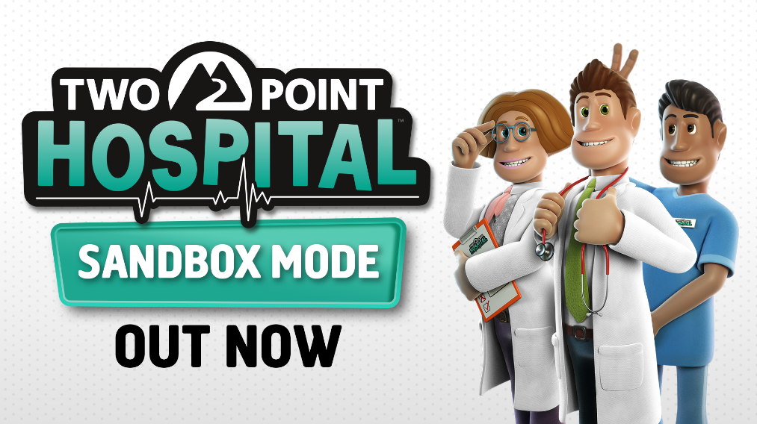

**Two Point Hospital: Sandbox Mode available now as a free update on consoles!**

Jump into a world of limitless creativity with the free Two Point Hospital: Sandbox Mode update, available now on PlayStation 4, Xbox One and Nintendo Switch! Spend unlimited amounts of cash and Kudosh (yes!), unlock every item in the game, switch the difficulty level for your favourite playstyle and start building the hospitals you want, wherever you want. Are you stressed about those epidemics breaking out in Two Point Hospital? Just turn them off. Overwhelmed by all those patients queuing up outside the doctor's office or flooding your reception area? No more! Take even more control over your healthcare empire with Two Point Hospital: Sandbox Mode out now. Check out the trailer here: <https://youtu.be/RKrP-K4R15M>

In Two Point Hospital, the competition for the top healthcare provider in Two Point County is fierce. To become the best Hospital Administrator, players will have to prove themselves in a diverse assortment of hospital management challenges. Design your hospitals, train and manage staff with their own unique personalities, and research treatments for very unusual illnesses, such as Mock Star, Jest Infection or Cubism.

For more information about all things Two Point Hospital visit [www.twopointhospital.com](http://www.twopointhospital.com) and you can follow the game on [YouTube](https://www.youtube.com/channel/UCyM2ggE_7Ttc8h0ecy65_mw/featured), [Facebook](https://www.facebook.com/twopointhospital/) and [Twitter](http://www.twitter.com/2PointHospital). For more information about SEGA Europe, log on to [www.sega.co.uk](http://www.sega.co.uk/), follow us on [Facebook](http://www.facebook.com/sega) or on [Twitter](http://www.twitter.com/sega).