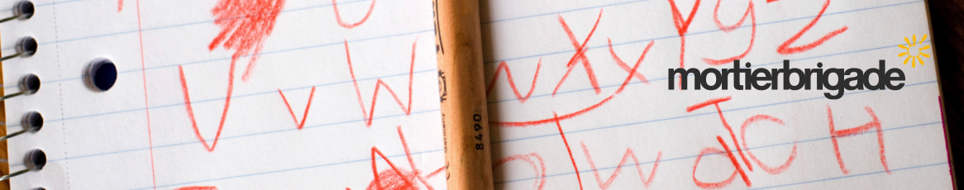
Technische Fiche:
Filip Pletinckx/Ellen Moriau/Mathias D’hondt: Client
Jens Mortier/Joost Berends/Philippe De Ceuster: Creative Directors
Vincent D'Halluin: Strategic Director
Kwint De Meyer & Willem De Wachter: Creative team
Charlotte Coddens: Business Director
Nathalie Blomme: Agency Producer
Caviar: TV Production Agency
Tom Willem (Caviar): Director
Audrey Dierckx (Caviar): TV Producer
Sonicville: Sound Production

