For more information, please contact Marta de Paco
On +34 670 780 664 or email press@comunicahair.com

Important:
These images are only available for editorial content.
Credits must be included.
Notification of their publication is expected.

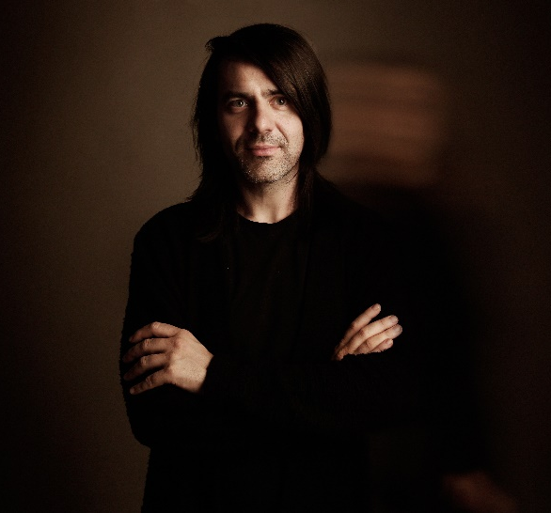
PELSYNERA
BASY Collection

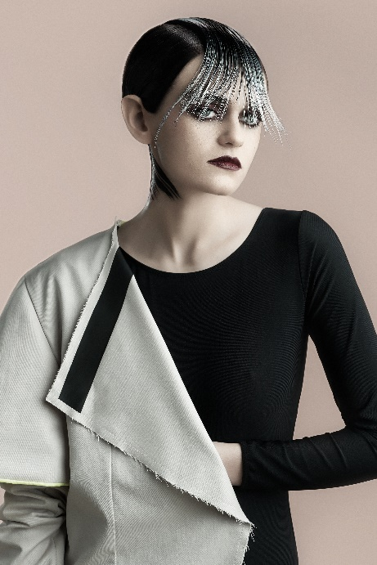
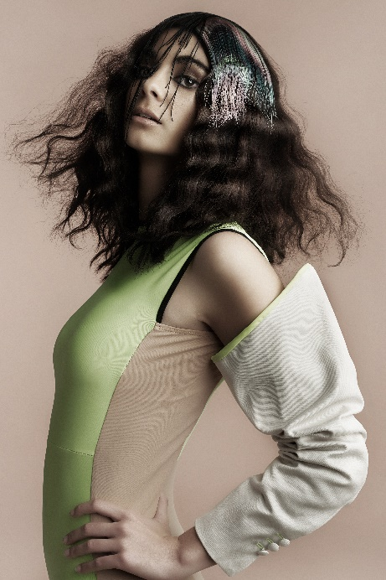
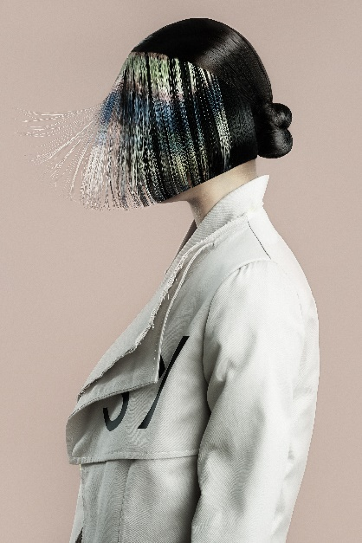

Hair: Pelsynera @pelsynera
Photography: Oliver Viladoms @oliver_viladoms_studio
Retouche: Oliver Viladoms @oliver_viladoms_studio
MUA: Pelsynera @pelsynera
Styling: Laura García Baena @baenalauragarcia
Models: Marta Sierra @martasierra12
Inma López @inmalopezinsta
Designer: Laura García Baena @baenalauragarcia

PELSYNERA
BASY Collection

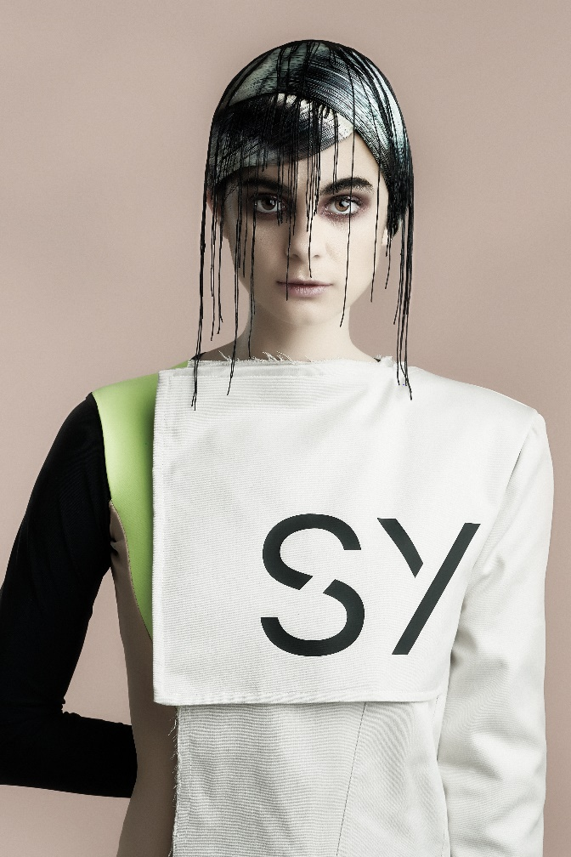

This is a fashion collection in which patterns of both clothes and hair refuse the predictable and expected. Color, like textures, suddenly erupts, reproducing an impression and treating hair as a fabric. As a whole, the image seems woven between geometries and threads, confusing the origin and without making clear which color or cut came first.

