Learn to use Evolution Wireless Digital in two free seminars
See for yourself why EW-D is the easiest radio microphone system available

Wedemark, 24 August 2021 – The Sennheiser SoundAcademy is welcoming everyone interested in wireless audio to a mini-series of two live seminars that will explain the new Evolution Wireless Digital system. Whether you are playing or singing in a band, are setting up mics for a place of worship, or are looking for a solution for moderation and speech, the app-based Evolution Wireless Digital is for you. Seminar 1 takes place on August 31 at 12:30 p.m. CEST (Berlin time) and gets you started on benefits, features and operation, seminar 2 on 14 September, again at 12:30 p.m. CEST, takes things further by taking a more in-depth look at the system. As these seminars are webcast live, the hosts are happy to answer any questions you may have. Please register at https://us06web.zoom.us/webinar/register/WN_kiKU__dJTVy8O5sZvibqKA.

Sennheiser experts Jonas Naesby, Vincent Tilgenkamp and Volker Schmitt are looking forward to meeting seminar participants remotely in the two EW-D courses

“Evolution Wireless will bring simplicity to your performance, show, service or talk while operating in the professional UHF spectrum,” said Volker Schmitt, Technical Application Engineering Manager, Pro Audio. “In our live seminars we will introduce the system to you and show you how easy it has become to set up wireless microphones.”
Seminar 1 will look at how to operate EW-D and get it set up with the help of the app, touching on all features and benefits that the system offers. Seminar No. 2 takes a detailed look at the app, at audio sensitivity and RF coordination.

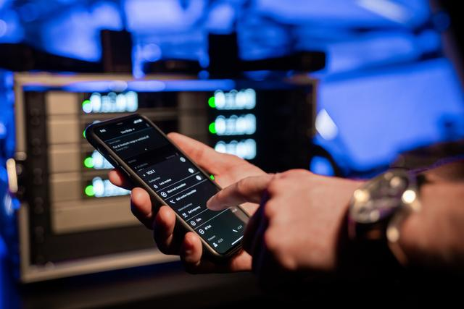 | With an app-based workflow and many professional features under the hood, Evolution Wireless Digital makes wireless easy

The seminars will be held in English. If you would like to book a free seminar in another language, please do reach out to de-soundacademy@sennheiser.com. These seminars can be specifically adapted to meet the needs of you or your team.

For your social media channels:
Ready to embrace the power of an app-controlled digital UHF system? Learn about the technical aspects of what makes Evolution Wireless Digital an amazing system: https://us06web.zoom.us/webinar/register/WN_kiKU__dJTVy8O5sZvibqKA

Evolution – evolving with you: www.sennheiser.com/EW-D
The images accompanying this press release can be downloaded here.

About Sennheiser
Shaping the future of audio and creating unique sound experiences for customers – this aim unites Sennheiser employees and partners worldwide. The independent family company, which is managed in the third generation by Dr. Andreas Sennheiser and Daniel Sennheiser, is today one of the world’s leading manufacturers of headphones, loudspeakers, microphones and wireless transmission systems. In 2020, the Sennheiser Group generated turnover totaling €573.5 million. www.sennheiser.com

Global Press Contact

Stephanie Schmidt
Stephanie.schmidt@sennheiser.com
+49 (5130) 600 – 1275

