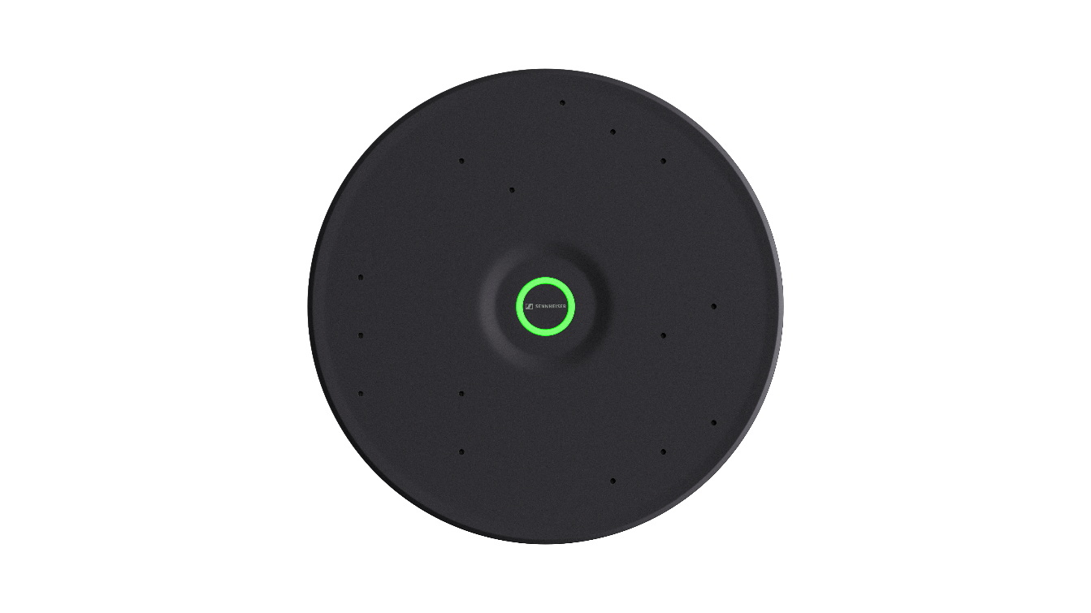
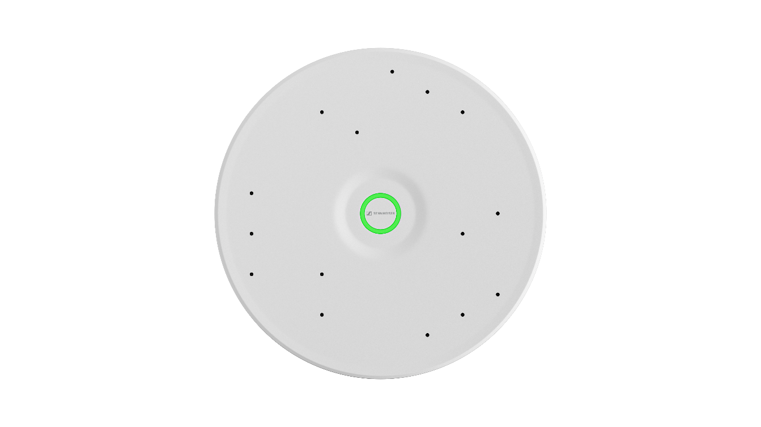

Sennheiser Announces TeamConnect Ceiling Medium

for Mid-Sized Spaces

Newest addition to the TeamConnect Ceiling Solutions portfolio unveiled at ISE 2023

Barcelona, Spain, January 31, 2023 – Sennheiser, the first choice for advanced audio technology that makes collaboration and learning easier, is pleased to announce a new ceiling microphone for mid-sized meeting rooms and lecture or collaboration spaces. Named TeamConnect Ceiling Medium (TCC M), the new TeamConnect Ceiling solution will be unveiled today at the Sennheiser stand (Hall 3, Booth 3C600) at Integrated Systems Europe in Barcelona.

TCC M delivers all the innovation and features of the award-winning TeamConnect Ceiling 2 (TCC 2) to a new segment of the meeting space market. With a coverage area of up to 40 m², customers can now bring the power of TCC 2 to their mid-sized meeting space, with a sleek design and at an attractive price-point.

“With the worldwide success of our TCC 2 for large meeting spaces, we wanted to provide that same experience to mid-size conference rooms and educational spaces,” said Jens Werner, Product Manager, UC Solutions, Sennheiser. “Now with TCC M, a whole new meeting category can realize TeamConnect Ceiling Solutions benefits like Trusted Sennheiser Audio Quality, efficient setup, brand agnostic integration and simple management and control. Also, when considering a new design, it was important to us to make a sustainable impact with smaller housing.”

Unlike the TCC 2, TCC M is round, but does offer the same ceiling installation choices - surface mounted, suspended, or flush mounted. These options allow for cable-free tables and flexible furniture arrangement.

TeamConnect Ceiling Solutions employ patented automatic dynamic beamforming technology and the TruVoicelift function. These offer perfect speech intelligibility while allowing the speaker great flexibility in movement and position. The high-quality built-in electret condenser capsules, which are made in Germany, have already proven themselves in numerous Sennheiser microphones. They ensure perfect speech intelligibility and offer outstanding audio quality by capturing the entire meeting room. These features enable the microphone to constantly determine the position of the person speaking, without manually needing to configure speaker zones ahead of time. If additional control is needed, priority and exclusion zones can be set in our industry leading Sennheiser Control Cockpit. This means that no spoken word is lost between the people in the meeting room and the external meeting participants.

Choosing a TeamConnect Ceiling Solution also comes with the added comfort of knowing that you are partnering with a truly customer-centric solution. By owning the manufacturing, Sennheiser has managed to navigate the supply chain crisis significantly better than others and was able to provide customers with full transparency and on-time delivery dates. In addition, starting with all TeamConnect Ceiling Solutions manufactured in 2023, Sennheiser is extending the warranty period from two to five years with product registration.

The TeamConnect Ceiling Solutions are part of the industry-leading TeamConnect Family – Sennheiser’s agnostic collaboration portfolio with state-of-the-art technology that suits the size and setup of any conference room. Built on over 75 years of German engineering, it redefines expectations for unified communications and meeting and lecture solutions through problem-solving, user friendly and sustainable products with modern look and design as well as the Trusted Sennheiser Audio Quality. To help customers find the most suitable TeamConnect Family solution for their specific meeting room environment, Sennheiser has just announced the first iteration of a new, browser-based room planner tool.

Visit ISE 2023 this week to experience the Sennheiser Room Planner and hear the TeamConnect Ceiling Solutions in action. More information about the Sennheiser TeamConnect Ceiling Solutions, including the new TCC M and can be found here. TCC M is expected to begin shipping mid-2023.

About the Sennheiser brand
We live and breathe audio. We are driven by the passion to create audio solutions that make a difference. Building the future of audio and bringing remarkable sound experiences to our customers – this is what the Sennheiser brand has represented for more than 75 years. While professional audio solutions such as microphones, meeting solutions, streaming technologies and monitoring systems are part of the business of Sennheiser electronic GmbH & Co. KG, the business with consumer devices such as headphones, soundbars and speech-enhanced hearables is operated by Sonova Holding AG under the license of Sennheiser.

www.sennheiser.com
www.sennheiser-hearing.com

Global Press Contact

Jeff Horan
+1 860-598-7539
jeffrey.horan@sennheiser.com

