February 9, 2018
Toyota Motor Corporation
GAZOO Racing Company

Rally Sweden: Preview
Yaris WRC drivers ready to star on Swedish snow

The TOYOTA GAZOO Racing World Rally Team heads to Rally Sweden (February 15-18) for the second round of the 2018 season with ambitions of a strong result on the snow and ice spectacular. The team already enjoyed a great start to the year with a double podium on last month’s Rallye Monte-Carlo and now moves on to the scene of the Toyota Yaris WRC’s maiden victory last year in the hands of Jari-Matti Latvala, with the clear aim of repeating that success.
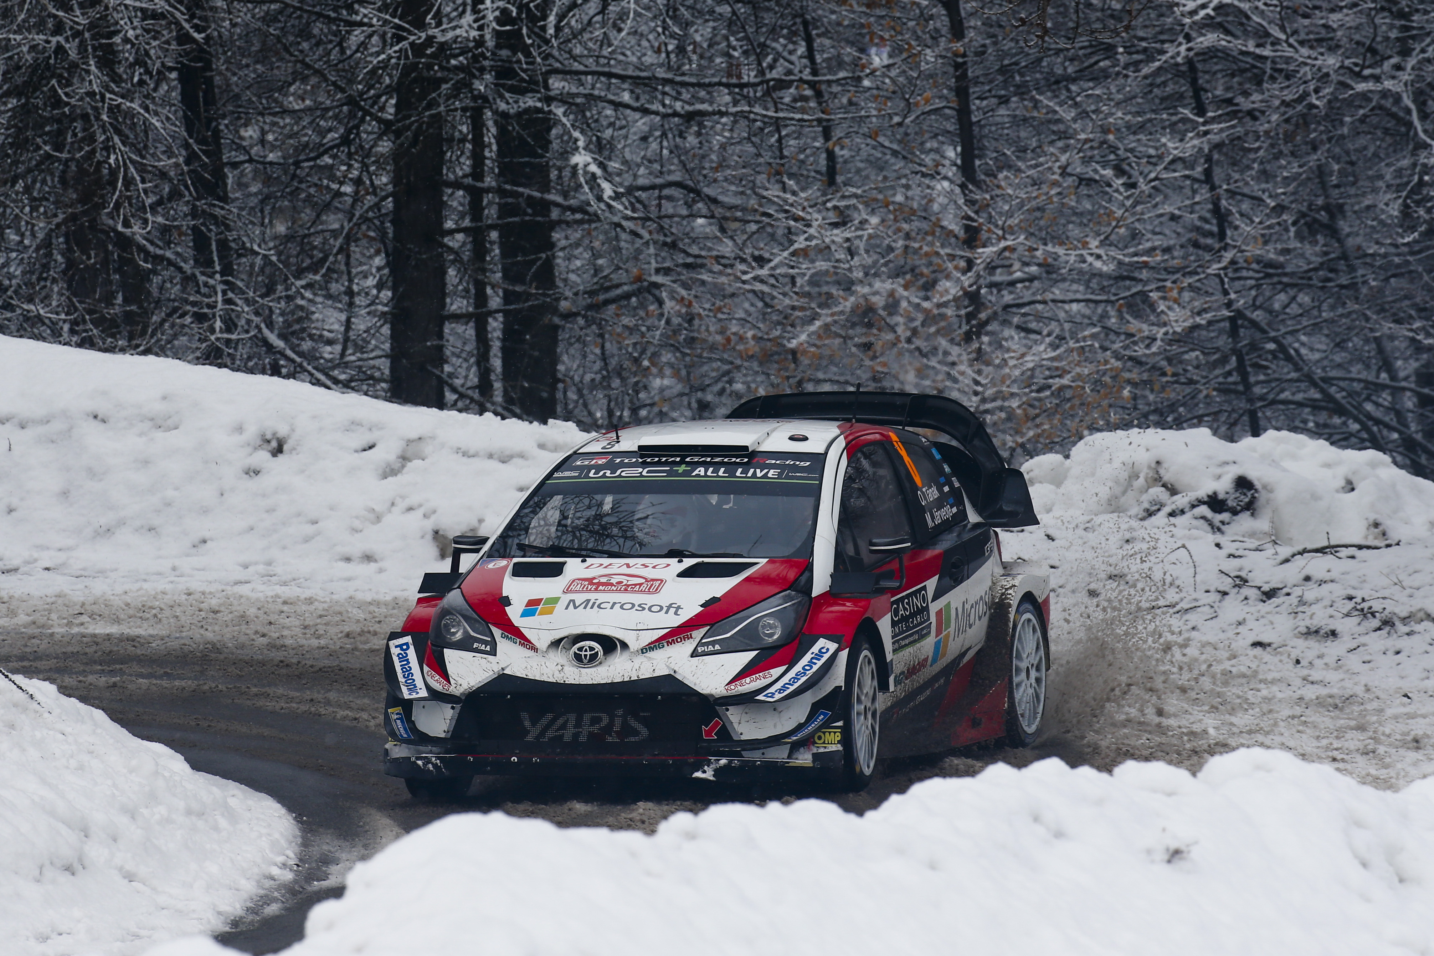

Car 8(Ott Tänak and Martin Järveoja)

A founding round of the world championship in 1973, Rally Sweden is the only full winter rally on the calendar. Metal studs inserted into the tyres punch through the ice to find grip, while drivers use the snow banks to stay on the road by ‘leaning’ through the corners: provided there is enough snow to do it. Full winter conditions are expected this year.

A superspecial kicks off the action in Karlstad in Thursday night before much of Friday’s action takes place over the border in Norway. Saturday features classic Swedish stage names such as Hagfors and Vargasen, followed by a repeat of the Karlstad and a ‘sprint’ near the service park in Torsby. It’s there where the rally will end with the Power Stage on Sunday, after two runs of the Likenas test.

Quotes:
Tommi Mäkinen (Team Principal)
“Of course, Sweden is one of the rallies where we are strong and we had a good snow test in Finland, with all the drivers doing two days each. But there is always a question mark about everyone else: we know that we have improved, but how much has everyone else improved? That is the challenge. We’re expecting full snow conditions for the rally, which will be really nice for all the spectators. The drivers are happy with their cars: Jari-Matti won last year, Ott was closely challenging him, and Esapekka always has a good feeling on snow too, although of course his experience is less than the others. We feel quite confident but also realistic: there are always ways to improve.”
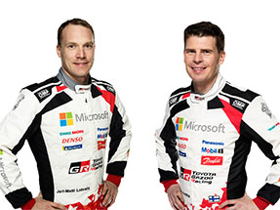
Jari-Matti Latvala (Driver car 10)
“Sweden is one of my favourite rallies and actually the place where I took my first WRC victory 10 years ago – although it really doesn’t feel like so long ago! Compared to last year I think we have a better car: we concentrated on improving it on the slower and more technical sections during our test, and we definitely made a step forward in this area. Having said that, the competition is even tougher this year: within our own team as well. It’s going to be a really nice challenge in proper winter conditions and that of course helps me raise my own game; I’m confident we can fight for the win again. This weekend I’m also taking part in a local rally on snow in Finland with Juho Hänninen in my historic Toyota Celica, so this will be a lot of fun and the perfect way to prepare.”
Jari-Matti Latvala and Miikka Anttila

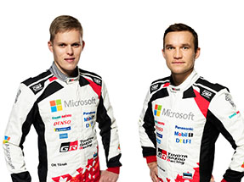
Ott Tänak (Driver car 8)
“I’m still learning about the Yaris WRC, but after driving it on snow during the test I’m beginning to understand why Jari-Matti won in Sweden last year. For the first part of the rally we’ll just have to see how everything goes, but of course I’m hoping that we can fight for the podium and even the win. If the snow is heavy on the stages, which seems to be the case, our start position of second on the road won’t be ideal, but of course the weather can change. I’m just going to enjoy the weekend and do my best. There’s a lot more still to come.”
Ott Tänak and Martin Järveoja

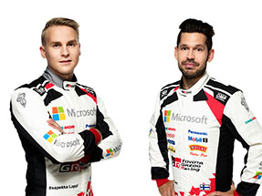
Esapekka Lappi (Driver car 9)
“It took me a few days to get over the disappointment of losing fourth place in Monte-Carlo on the last stage, but in the end, there were more positives than negatives. Up to that point, we had driven a very consistent rally, and my aim is to do the same in Sweden. We had a good test and did around 400 kilometres in two days, which was enough for me to get a good feel. Our car should be well-suited to Sweden but it’s a very different type of rally to Monte-Carlo: in Monte, sometimes you have to be brave by going slow enough, whereas in Sweden you need a different type of commitment. I didn’t compete on the rally last year, so I am missing a bit of experience, but snow is a surface I always feel comfortable on.”
Esapekka Lappi and Janne Ferm

The statistics (Rally Sweden):
Year | Jari-Matti Latvala | Ott Tänak | Esapekka Lappi
2017 | 1 | 2 | -
2016 | 26 | 5 | 12
2015 | DNF | 4 | -
2014 | 1 | 5 | -
2013 | 4 | - | -
2012 | 1 | DNF | -

What happened last year?
Last year’s Rally Sweden marked the first win for Toyota following a 17-year absence from the top step of the podium, courtesy of Jari-Matti Latvala: his 17th win and Toyota’s 44th. A total of 32 cars made it to the finish from 41 starters. The fastest stage (SS9) was run at a remarkable average of 137.81kph, while the slowest stage was the Karlstad super special at 72.69kph. Ott Tanak, now a Toyota driver, finished second.

Press release
URL: https://toyotagazooracing.com/release/2018/wrc/rd02-preview.html

Pictures will be uploaded here during the event
URL<New!>: https://www.tgr-dam.com
*In order to access the new media site, please register your ID and password through above URL.

Follow us!
Follow TOYOTA GAZOO Racing WRT:
∇Facebook: https://www.facebook.com/TOYOTAGAZOORacingWRC
∇Twitter: https://www.twitter.com/TGR_WRC (@TGR_WRC)
∇Instagram: https://www.instagram.com/tgr_wrc/ (@TGR_WRC)
∇YouTube: https://www.youtube.com/channel/UCCtALHup92q5xIFb7n9UXVg

<Contact>

TOYOTA GAZOO Racing PR Office
Email: tgr_pr @rights-apartment.com

TOYOTA GAZOO Racing Official website
http://toyotagazooracing.com/

TOYOTA GAZOO Racing World Rally Team is supported by following partners:

