Xilica and Sennheiser Enter Strategic Alliance for Frictionless Collaboration Experiences
Premium, integrated audio solutions enhance Microsoft Teams Room user experiences, accelerate installation times, and optimize audio quality and networking inside the collaboration space

Toronto/Marlow, September 14, 2021 — Xilica®, a provider of collaboration products that help unlock the power of human connection, has partnered with global audio specialist Sennheiser to develop a tightly integrated room solution that minimizes installation time, improves audio quality, and enhances collaboration for end users. The partnership will leverage premium audio products from both companies, offering integrators a seamless way to deploy adaptable, IT-friendly audio conferencing systems.

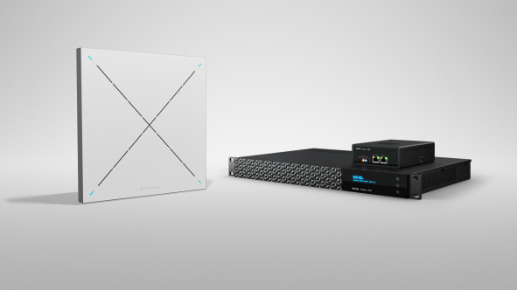
The Xilica-Sennheiser solution pairs the Sennheiser TeamConnect Ceiling 2 beamforming microphone array with Xilica’s ecosystem of DSP, user interfaces and network endpoints

The complete solution, which pairs the Sennheiser TeamConnect Ceiling 2 beamforming microphone array with Xilica’s ecosystem of DSP, user interfaces and network endpoints, ensures exceptional speech intelligibility for physical and remote participants in hybrid spaces. This gives end users the flexibility to move throughout their space and present in their own style, while eliminating risk of inaudibility. Integrators and end users benefit from the Sennheiser TeamConnect Ceiling 2’s seamless integration with Xilica Solaro processors and Xilica Gio network endpoints, enabling an easy, no-code setup with pre-validated compatibility.

As part of the alliance, Xilica has enabled support for the TruVoicelift functionality of Sennheiser’s TeamConnect Ceiling 2 (TCC2) across its Solaro Series of DSPs, which simplifies the installation of multiple Sennheiser TCC2 microphones through automatic testing and calibration of audio, saving hours of time during system commissioning. Additionally, TruVoicelift offers noise reduction, speaker amplification and creates targeted zones to home in on participants speaking in busy spaces. When paired with Xilica’s proprietary noise reduction and HearClear echo cancellation algorithms, the combined solution offers a robust defence against meeting distractions.

Additionally, Sennheiser TeamConnect Ceiling 2 and Xilica Solaro processors offer end-to-end mute status sync for Microsoft Teams. This enables a software-based mute action, such as clicking a button in the Microsoft Teams application, to be reflected throughout the chain and back to the Sennheiser TCC2’s status indicator LED. Similarly, when using Xilica user interfaces, a mute action can be reflected both to the Sennheiser TeamConnect Ceiling 2 and back into the Microsoft Teams application – giving room users complete visibility.

“Modern meetings have more remote participants than ever, and they need to hear clearly without being distracted by background noise and interruptions,” said Charlie Jones, Global Alliance and Partnerships Manager for Sennheiser. “TruVoicelift is perfect for large conference spaces and lecture halls that allow everyone to hear a presenter, or a question from a student that is raised. Together with Xilica DSPs, end users are assured high-quality, dependable audio with exceptional room and user control.”

Jones adds that the ultra-low-profile Xilica Solaro QR1 DSP will benefit integrators working in corporate and education environments with limited or no rack space. He notes that bundling the Sennheiser TeamConnect Ceiling 2 and Xilica Solaro QR1 is ideal for these situations because no special wiring or configuration is required.

“Our customers are seeking cost-effective ways to add audio and UC to rooms that historically had no audio or only a simple microphone,” said Jones. “The Xilica Solaro QR1’s compact form factor allows installers to mount the DSP virtually anywhere. It’s small, powerful and PoE, and upon first seeing it we realized that many Sennheiser customers could benefit from a combined solution. It’s also the standard for Sennheiser demonstrator kits worldwide.”

Additionally, general availability of the Xilica follow-me camera tracking module for the Sennheiser TeamConnect Ceiling 2 is expected in Q4 2021, enabling automated pan-tilt-zoom by using the beam position information from the TeamConnect Ceiling 2. This gives room users even greater freedom to present throughout their space without consideration of the AV infrastructure.

“We’re pleased to partner with Sennheiser to help unlock the power of human connection,” said James Knight, COO, Xilica. “Our joint solution offers a pre-validated room system for the high-value collaboration space that delivers greater freedom and flexibility to end users, while eliminating lengthy setup for integrators. Pairing Sennheiser’s patented technologies with the audio-enhancing algorithms of Xilica processors give a distraction-free experience in which people can come together.”

About Xilica
Xilica® creates collaboration products that help unlock the power of human connection. Built on decades of reimagining how people use technology, Xilica’s solutions bridge the distance between individuals, teams, ideas and organisations — unleashing the power of understanding to transform business and society for the better. Through our focus on the enterprise, education and government markets, Xilica and its partners touch the daily lives of people in more than 100 countries. To learn more about Xilica’s solutions, visit www.xilica.com.

About Sennheiser
Shaping the future of audio and creating unique sound experiences for customers – this aim unites Sennheiser employees and partners worldwide. The independent family company, which is managed in the third generation by Dr. Andreas Sennheiser and Daniel Sennheiser, is today one of the world’s leading manufacturers of headphones, loudspeakers, microphones and wireless transmission systems. In 2020, the Sennheiser Group generated turnover totaling €573.5 million. www.sennheiser.com

Global Press Contact Xilica Global Press Contact Sennheiser
Brian Galante Stephanie Schmidt
+1 207-494-8428 +49 (5130) 600 – 1275
brian@dimensionpronline.com stephanie.schmidt@sennheiser.com

Local Press Contacts
Sarah James Maik Robbe
sarahj@gasolinemedia.com maik.robbe@sennheiser.com
+44 (0) 1483 223333 +44 (0) 7393 462484

