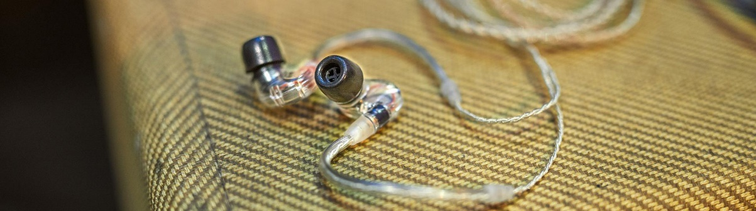

Anniversary offers on IE 400 PRO and IE 500 PRO in-ears

Wedemark, 1 April 2020 – The month of April brings a very special deal for musicians and music lovers: Starting today, they can get up to 50% off the IE 400 PRO and the IE 500 PRO in-ears. Visit www.sennheiser.com/special-deals to find a local dealer participating in the promotion.

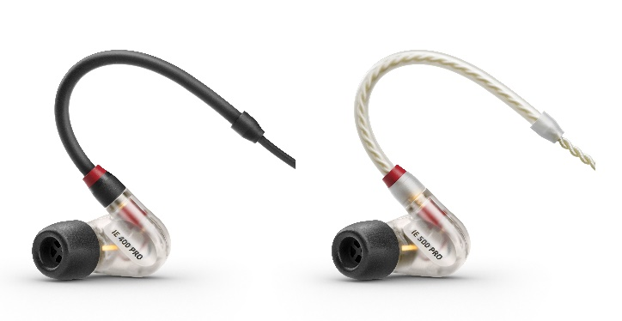 | The IE 400 PRO and IE 500 PRO deliver precise and natural sound – with their ergonomically shaped, low-profile ear mould, they are the next best thing to custom moulds

Made in Germany for natural sound and monitoring accuracy
Since their launch in 2019, the IE 400 PRO and IE 500 PRO have been praised by musicians and audio lovers the world over for their precise, natural sound, high resolution and a comfortable fit that comes as close as possible to custom ear-moulds.

Throughout the month of April, the IE 400 PRO will retail at EUR199 (MSRP)/USD199.95 (MAP) (reduced from EUR349/USD349.95), while the IE 500 PRO is available for EUR299 (MSRP)/USD299.95 (MAP) (reduced from EUR/USD599).

Using a single dynamic driver, the IE 400 PRO and IE 500 PRO cover the entire audio frequency range with ease, and deliver distortion-free, detailed and accurate sound. The ergonomically shaped ear-mould has a low profile and is extremely lightweight, with a break-proof inner cable duct that sits the cable’s sturdy anti-kink sleeve directly on the ear mould to provide a long-lasting solution for the rigors of stage use.

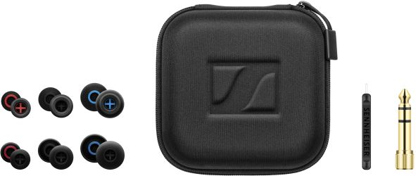 | The accessories included with the IE 400 PRO and IE 500 PRO

Learn more about the making of the IE PRO series here:
https://www.inearmonitor.org/in-ear-monitoring-news/insights-into-sennheisers-ie-pro-series

Special offers throughout Sennheiser’s 75th anniversary year
In its anniversary year, Sennheiser will be offering incredible savings on selected wired microphones, wireless systems and headphones. To stay informed about the latest offers, make sure to take a regular look at the campaign website www.sennheiser.com/special-deals to discover new promotions every month.

The images accompanying this press release can be downloaded at https://sennheiser-brandzone.com/c/181/rgcuNcsS.

About Sennheiser
Founded in 1945, Sennheiser is celebrating its 75th anniversary this year. Shaping the future of audio and creating unique sound experiences for customers – this aim unites Sennheiser employees and partners worldwide. The independent family company, which is managed in the third generation by Dr. Andreas Sennheiser and Daniel Sennheiser, is today one of the world’s leading manufacturers of headphones, loudspeakers, microphones and wireless transmission systems. In 2018, the Sennheiser Group generated turnover totaling €710.7 million. www.sennheiser.com

Global Press Contact

Stephanie Schmidt
Stephanie.schmidt@sennheiser.com
+49 (5130) 600 – 1275

