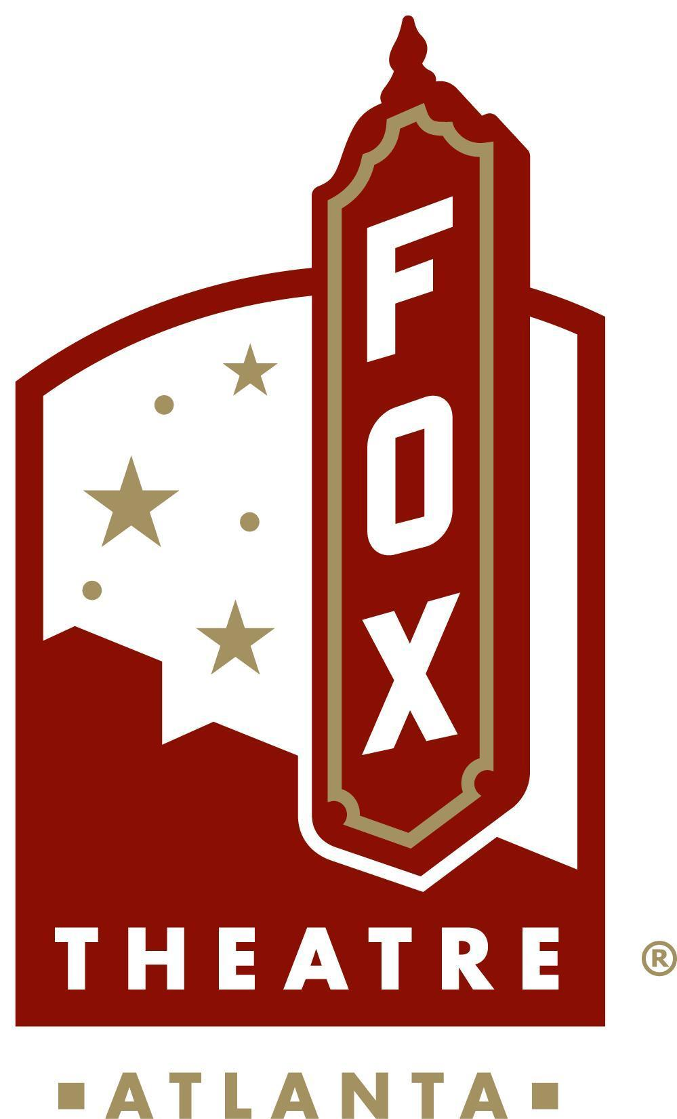
For More Information:
Sarah Wynn Benton
BRAVE Public Relations
404.233.3993
sbenton@emailbrave.com

FOR IMMEDIATE RELEASE

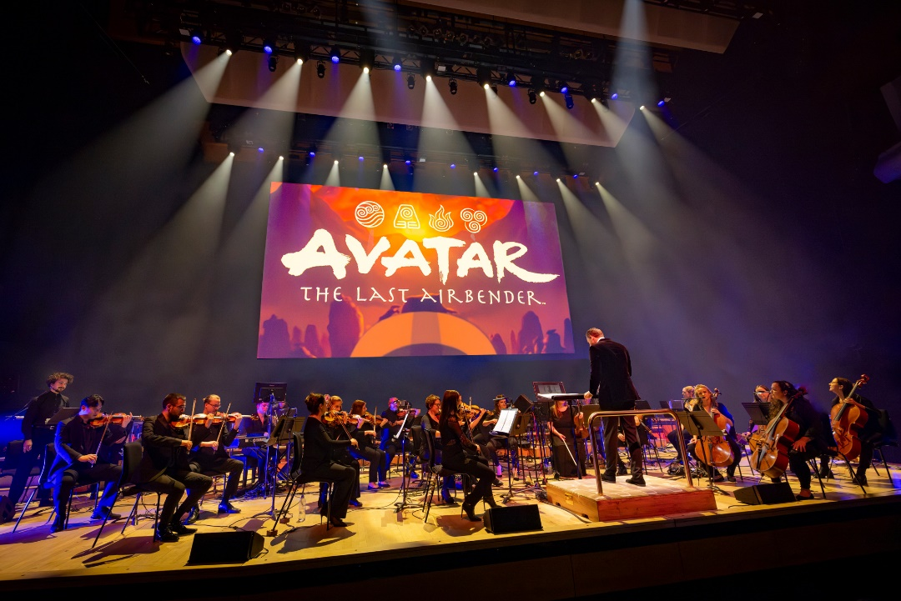
“Avatar: The Last Airbender” in Concert Comes to Atlanta’s Fox Theatre Aug. 17
World Tour Launches in August and Heads to 100 Cities Across the Globe Through 2025

Experience the Beloved Animated Series' Soundtrack Performed by a Live Orchestra, as Aang’s Epic Journey Comes to Life on a Cinema Screen

ATLANTA – (June 3, 2023) – Get ready for an unparalleled musical odyssey as Nickelodeon, GEA Live and Senbla proudly present: “Avatar: The Last Airbender” in Concert. Immerse yourself in an over two-hour production with a live orchestra bringing the show’s iconic musical score to life, in perfect harmony with highlights and favorite moments from the series. Taiko and erhu will share the spotlight with violins and clarinets, while the series' most beloved scenes play out on screen, bringing viewers into the Avatar world to experience the series’ most memorable moments with Aang, Katara, Toph, Sokka, Zuko and more. “Avatar: The Last Airbender” in Concert will perform at Fox Theatre on Saturday, Aug. 17. Tickets are on sale now at www.avatarinconcert.com.

The tour will kick off in the United States in August before heading to Los Angeles, Seattle, Dallas, Atlanta, Washington, D.C., Boston and many more cities in 2024. The global tour continues in 2025 to a myriad of European cities across the United Kingdom, Germany, France and the Netherlands among others; additionally, the tour will make stops in various cities across Australia.

“Avatar: The Last Airbender” in Concert will allow audiences to immerse themselves in a two-hour special with a live orchestra bringing the show’s iconic musical score to life, in perfect harmony with highlights and favorite moments from all three seasons of the series. Taiko and erhu will share the spotlight with violins and clarinets, while the series' most beloved scenes play out on a full-size cinema screen, bringing viewers into the “Avatar” world to experience the series’ most memorable moments with Aang, Katara, Toph, Sokka, Zuko and more.

The creative mastermind behind the original music for the “Avatar: The Last Airbender” animated series, Emmy Award-winning composer and musician Jeremy Zuckerman, has teamed up with show co-creators Michael Dante DiMartino and Bryan Konietzko as well as Jeff Adams (the show's original editor) to expand the series original compositions for the concert series. This spectacular production not only magnifies the epic scope and high drama of the series, but also marks a thrilling first for fans offering an opportunity to experience the captivating world of “Avatar: The Last Airbender” through this live orchestra concert.

"It’s been incredibly satisfying and moving to see the audiences’ emotional response to these concerts, and to be a part of that atmosphere is a uniquely beautiful experience,” said Zuckerman. “I’m overjoyed that many more people - Avatar fans both new and old - will get to experience the show during this wider tour."

Don't miss this extraordinary chance to relive the epic odyssey of “Avatar: The Last Airbender” like never before. For more information, tour dates and tickets, please visit www.avatarinconcert.com and follow #avatarinconcert, @avatarthelastairbender on Facebook and Instagram; and, @teamavatar on YouTube.
Honored with a Peabody Award and Primetime Emmy, along with multiple Annie Awards and Genesis Awards Nickelodeon’s “Avatar: The Last Airbender” emerged from its three-season run (61 episodes), from February 2005 to July 2008, as one of the most beloved animated properties in history. In 2021 Nickelodeon announced the launch of Avatar Studios, a new division designed to create original content spanning animated series and movies based on the world of “Avatar: The Last Airbender” and “The Legend of Korra.”
The animated series’ success has also spawned a companion podcast “Avatar: Braving the Elements,” currently in its season third season, a remastered soundtrack from series (and tour) composer, Jeremy Zuckerman, now out on digital and vinyl. The property has also been translated into several bestselling book series, which continue to roll out new original stories. The graphic novel series has sold over three million copies, and the young adult novels have spent 25 total weeks on the New York Times bestseller list and have over 700,000 copies in print.
Press Assets
Watch the official trailer here:
###
About Nickelodeon
Nickelodeon, now in its 45th year, is the number-one entertainment brand for kids. It has built a diverse, global business by putting kids first in everything it does. The brand includes television programming and production in the United States and around the world, plus consumer products, digital, location-based experiences, publishing and feature films. For more information or artwork, visit http://www.nickpress.com. Nickelodeon is a part of Paramount’s (Nasdaq: PARA, PARAA) global portfolio of multimedia entertainment brands.

About GEA Live
Since its inception in 2003, GEA Live has delivered innovative live entertainment projects in more than 40 countries, becoming a global leader in the location-based entertainment sector. GEA Live has closely cooperated with the legend Maestro Ennio Morricone (representing him exclusively for all live touring) as well as with icons of music film industry such as James Newton Howard, Giorgio Moroder and George Fenton. In addition to producing live cinematic experiences such as the Johnny Cash Official Concert Experience or Elvis Live On Screen, GEA Live has produced live screenings with orchestra and choir of major motion pictures such as Spider-Man, Dirty Dancing, The Godfather, Titanic, La La Land, Twilight, The Hunger Games, Paddington and Amadeus. This journey has led to fruitful collaborations with renowned studios and IP giants such as Lionsgate, Viacom, Sony Pictures, Warner Brothers, and other global leaders in the branded entertainment landscape, earning GEA Live its well-deserved position as the most reliable and trusted partner for location-based entertainment projects worldwide.

About Senbla
Senbla is part of Sony Music Entertainment and operates both nationally and internationally across music, performing arts and entertainment concert touring, festivals family entertainment, theatre and experiential. Senbla operates in some of the most prestigious venues in the world and works with some of the world’s leading artists in their fields as well as some of the biggest entertainment companies and Studios. In recent years Senbla has brought leading artists such as Michael Buble, My Chemical Romance, Duran Duran, The Chemical Brothers, Diana Ross, and more to unique outdoor venues across the UK.
About the Fox Theatre
The Fox Theatre is one of Atlanta's premier venues for live entertainment, welcoming more than 200 performances a year in its 4,665-seat theatre. From concerts to ballets, comedy, and movies, the historic venue attracts more than 500,000 visitors annually. The theatre hosts over 100 annual private events like wedding receptions, trade shows, corporate meetings, and association functions in two fabulous ballrooms. The Fox’s premium Marquee Club, presented by Lexus, is a 10,000 sq. ft, three-story luxury bar accessible to all Club Level ticket holders or annual members of the Fox Theatre. As a 501(c)(3) nonprofit arts organization, the Fox Theatre is a fiercely protected landmark and nationally acclaimed theatre today. The Fox Theatre proudly acknowledges its partners' generous support: Coca-Cola, Georgia Natural Gas, Georgian Terrace Hotel & Livingston Restaurant, Humana, Lexus, Northside Hospital, and Regions Bank. Tickets for all events are available at FoxTheatre.org, or toll-free at 855-285-8499. Stay connected by following the Fox Theatre on social via @theFoxTheatre on Instagram, Twitter, and Facebook.
Notable accolades include 2023 Billboard Magazine #2 Highest Grossing Theatre Worldwide (5,000 seats or less); 2023 VenuesNow Magazine #2 Year-End Top Stops (2,001-5,000 seats); 2022 IEBA Theatre of the Year; 2021 Billboard Magazine #1 Highest Grossing Theatre Worldwide (5,000 seats or less); 2021 Pollstar Magazine #2 Theatre Worldwide in Ticket Sales and 2021 VenuesNow Magazine #2 Year-End Top Stops (2,001-5,000 seats). Additionally, in 2019, the Fox Theatre was honored with the VenuesNow #1 Top Stop of the Decade Award for Tickets Sold, further cementing its reputation as a premier entertainment venue.

