Pocketable Powerhouse
The all-new ACCENTUM True Wireless delivers the essential Sennheiser sound experience with modern features and ergonomics that fit like a glove.

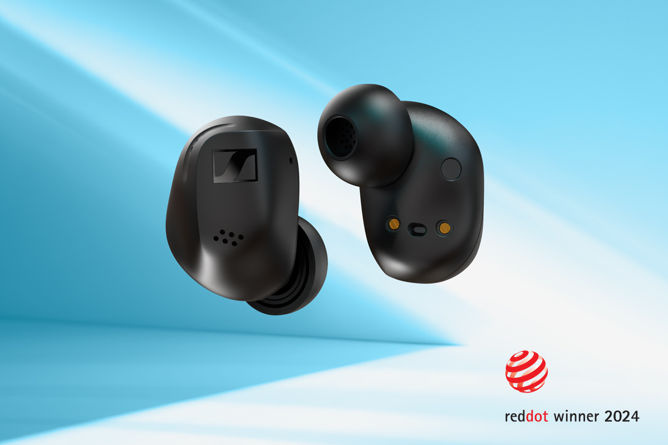
Wedemark, Germany – May 7, 2024 – The Sennheiser brand today launches the latest member of their portable portfolio, ACCENTUM True Wireless. Packed with signature Sennheiser acoustics, dynamic wireless capabilities, and an all-new ergonomic design, it is an easy choice for an on-the-go, connected lifestyle.

“ACCENTUM True Wireless builds on what their over-ear counterparts are renowned for: incredible sound, useful features, and unbeatable value.” says Frank Foppe, Sennheiser Product Manager, “We packed these qualities inside a reimagined, award-winning design that unlocks the magic of ‘the Sennheiser sound’ to anyone needing an untethered upgrade.”

Signature sound
From the first listen, ACCENTUM True Wireless is a serious performer. It all starts with the brand’s proprietary 7mm dynamic True Response Transducers that reproduce powerful and engaging bass, natural mids and crisp treble–handling even the most complex modern music without breaking a sweat. The ultra-low distortion drivers are made at the Sennheiser Tullamore factory, under the same roof as those found in other ACCENTUM, MOMENTUM and audiophile headphones.

Pictured: ACCENTUM True Wireless is available in blackand white (pictured)

Ear-gonomic
All of its capabilities are housed inside a completely unique take on earbud ergonomics; in a close collaboration with Sonova—a leading hearing aid manufacturer—thousands of ear models were analyzed to arrive at the ideal balance of stability, comfort, and sophistication. The result of the collaboration is an innovative contour that complements a wide range of wearers in a singular form. The earbuds, still under the veil of secrecy, was a recent winner of the prestigious Red Dot Design award. Four sizes of ear tips are included to further ensure a great seal for impactful low-frequency response and effective hybrid noise cancellation.
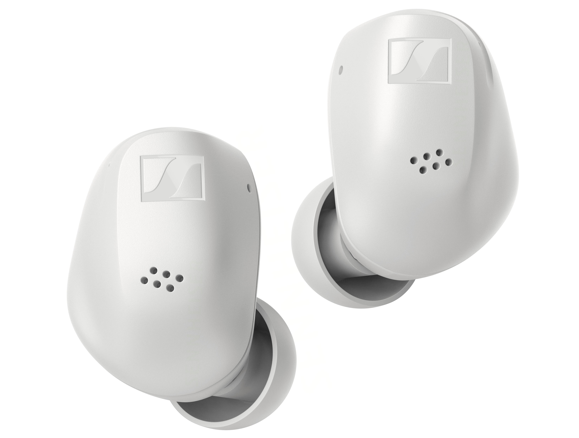

“It’s no secret that fit is essential to great sound and comfort.” says Friederike Menking, Sennheiser Product Manager, “We crafted ACCENTUM True Wireless after poring over one thousand distinct ear profiles, arriving at a design that is meticulously crafted yet feels like it is barely there.”

The art of being transparent
When combined with the discreet beamforming mic array, the ANC reduces droning low-frequency distractions to a whisper, making quick work of airplane cabin noise, humming appliances, nearby traffic and the murmur of bustling coffee shops. ACCENTUM True Wireless’ Hybrid ANC and Transparency modes make it easy to manage disruptions, allowing wearers to listen to ambient surroundings on-demand via simple tap gestures or the free Sennheiser Smart Control app. With the app, the user can select the amount of transparency while further tailoring their sound using the 5-band equalizer and Sound Check–a guided preset creator that one can upload to the cloud to access on all of your iOS or Android devices. EQ customization is only the beginning, with user-definable touch controls for managing media, phone calls, and voice assistants too.
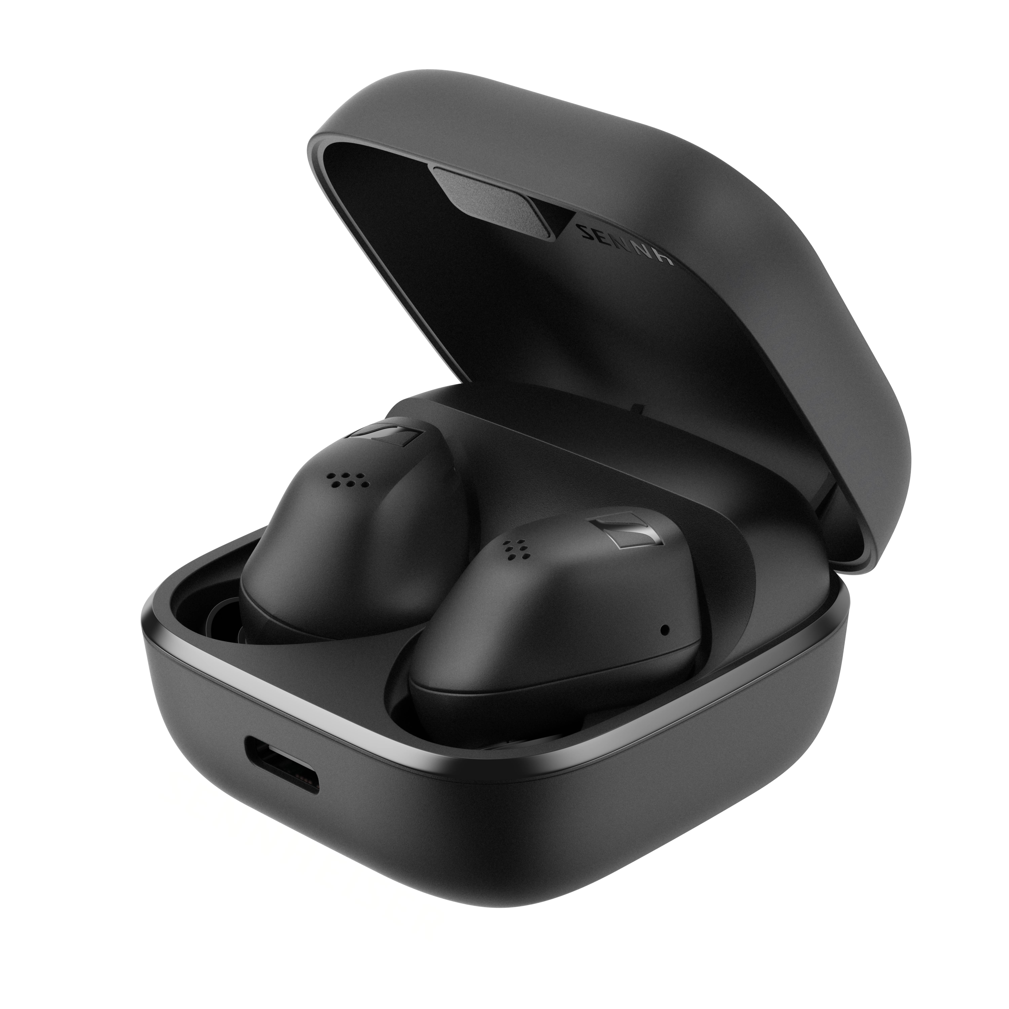
Pictured: ACCENTUM True Wireless in its compact Qi-enabled charging case

Ready for fun
Connecting ACCENTUM True Wireless to a smartphone goes beyond managing media and calls, thanks to Bluetooth 5.3. The earbuds are Bluetooth LE Audio and Auracast capable, for advanced connectivity to shared audio streams at Auracast-enabled museums, cafes, airports, and more in the near future. In addition to SBC and AAC codec support, the earbuds also utilize aptX™ and LC3 for maintaining dependable audio quality and extensive battery life–up to 8 hours per charge and 28 total hours with the case.
Feeling recharged
Charging is just as versatile, with both USB-C and Qi wireless charging available inside the compact case. That case holds over 2 additional replenishments, and supports quick charging over USB, giving users up to 1 hour of playback in about 10 minutes. A USB-A to type C cable is included, making setup delightfully efficient.

Availability
ACCENTUM True Wireless is available for pre-order starting today and will officially launch on May 21. The earbuds come in black or white colorways, and will be available from select retailers and at sennheiser-hearing.com with an MSRP of €199.99 / $199.99 USD
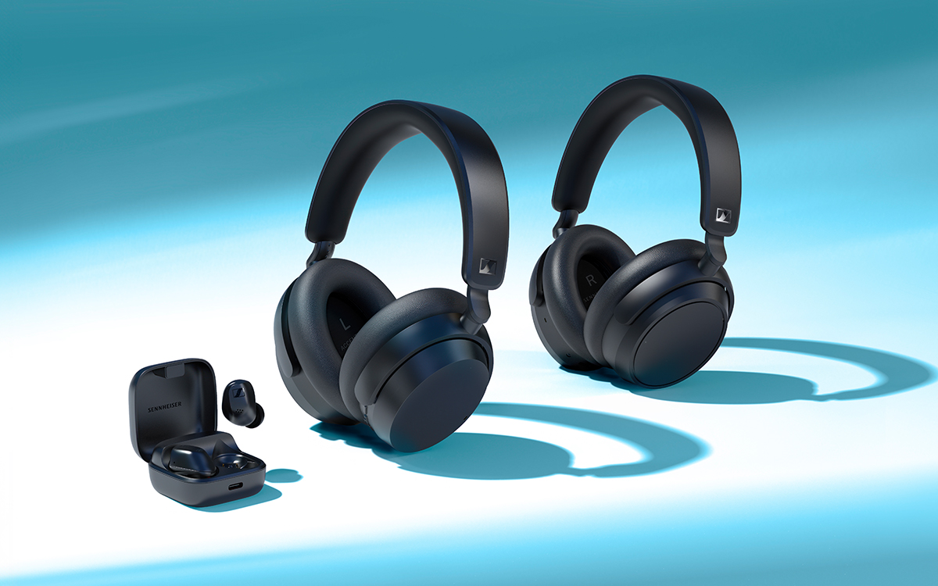
Pictured: The complete family (left to right); ACCENTUM True Wireless, ACCENTUM Wireless, and ACCENTUM Plus Wireless

About the Sennheiser brand
We live and breathe audio. We are driven by the passion to create audio solutions that make a difference. Building the future of audio and bringing remarkable sound experiences to our customers – this is what the Sennheiser brand has represented for more than 75 years. While professional audio solutions such as microphones, meeting solutions, streaming technologies and monitoring systems are part of the business of Sennheiser electronic GmbH & Co. KG, the business with consumer devices such as headphones, soundbars and speech-enhanced hearables became part of the Sonova Holding AG group of companies in 2022, who have licensed the Sennheiser trademark for this purpose.

www.sennheiser.com
www.sennheiser-hearing.com

About Sonova Consumer Hearing
Sonova Consumer Hearing offers premium headphones and hearables – primarily in the true wireless segment – as well as audiophile headphones, hearing solutions and soundbars under the Sennheiser brand. The business is part of the Sonova Group, a global leader in innovative hearing care solutions with headquarters in Switzerland and more than 17,000 employees worldwide.

Press contact
Sonova Consumer Hearing GmbH

Paul Hughes
Head of PR and Influencers, Sennheiser Headphone and Soundbars
T +49 (0) 162 2921 861
paul.hughes@sonova.com

