SENNHEISER LAUNCHES EXPAND SP 30T, CERTIFIED FOR MICROSOFT TEAMS FOR SEAMLESS COLLABORATION
Portable wireless conferencing solution brings conferencing to the future for today’s virtual workforce.

Sydney, Australia, November 8, 2019 – Global audio specialist Sennheiser announces a new addition to its EXPAND product line with the launch of the EXPAND SP 30T portable wireless speakerphone at Microsoft Ignite in Orlando, USA, November 4-8, 2019. The EXPAND SP 30T is designed specifically for businesses implementing Microsoft Teams and supports Sennheiser’s mission to create collaborative audio tools that enhances the way we work.

“The integration with Microsoft Teams promotes a more intuitive, streamlined workplace of the future — boosting efficiency, increasing collaboration, and enabling innovation,” commented Theis Moerk, Vice President of Product Management Enterprise Solutions at Sennheiser. “Supporting the Microsoft product suite allows our customers to further reimagine the way they work regardless of their environment.”
Do more together with Microsoft Teams and EXPAND SP 30T
Microsoft Teams brings together people, conversations, content, and tools that teams need to collaborate. Users can chat, meet, share files, and engage with built-in Microsoft Office 365 business applications.

The EXPAND SP 30T offers an integrated Teams experience including a dedicated Microsoft Teams button — providing easy access to key functionalities to improve productivity and efficiency. From the speakerphone itself, Microsoft Teams’ users can open Teams, activate Cortana, check the Teams connection status via the white LED light, and receive notifications for missed calls, voice messages, and meetings in progress.
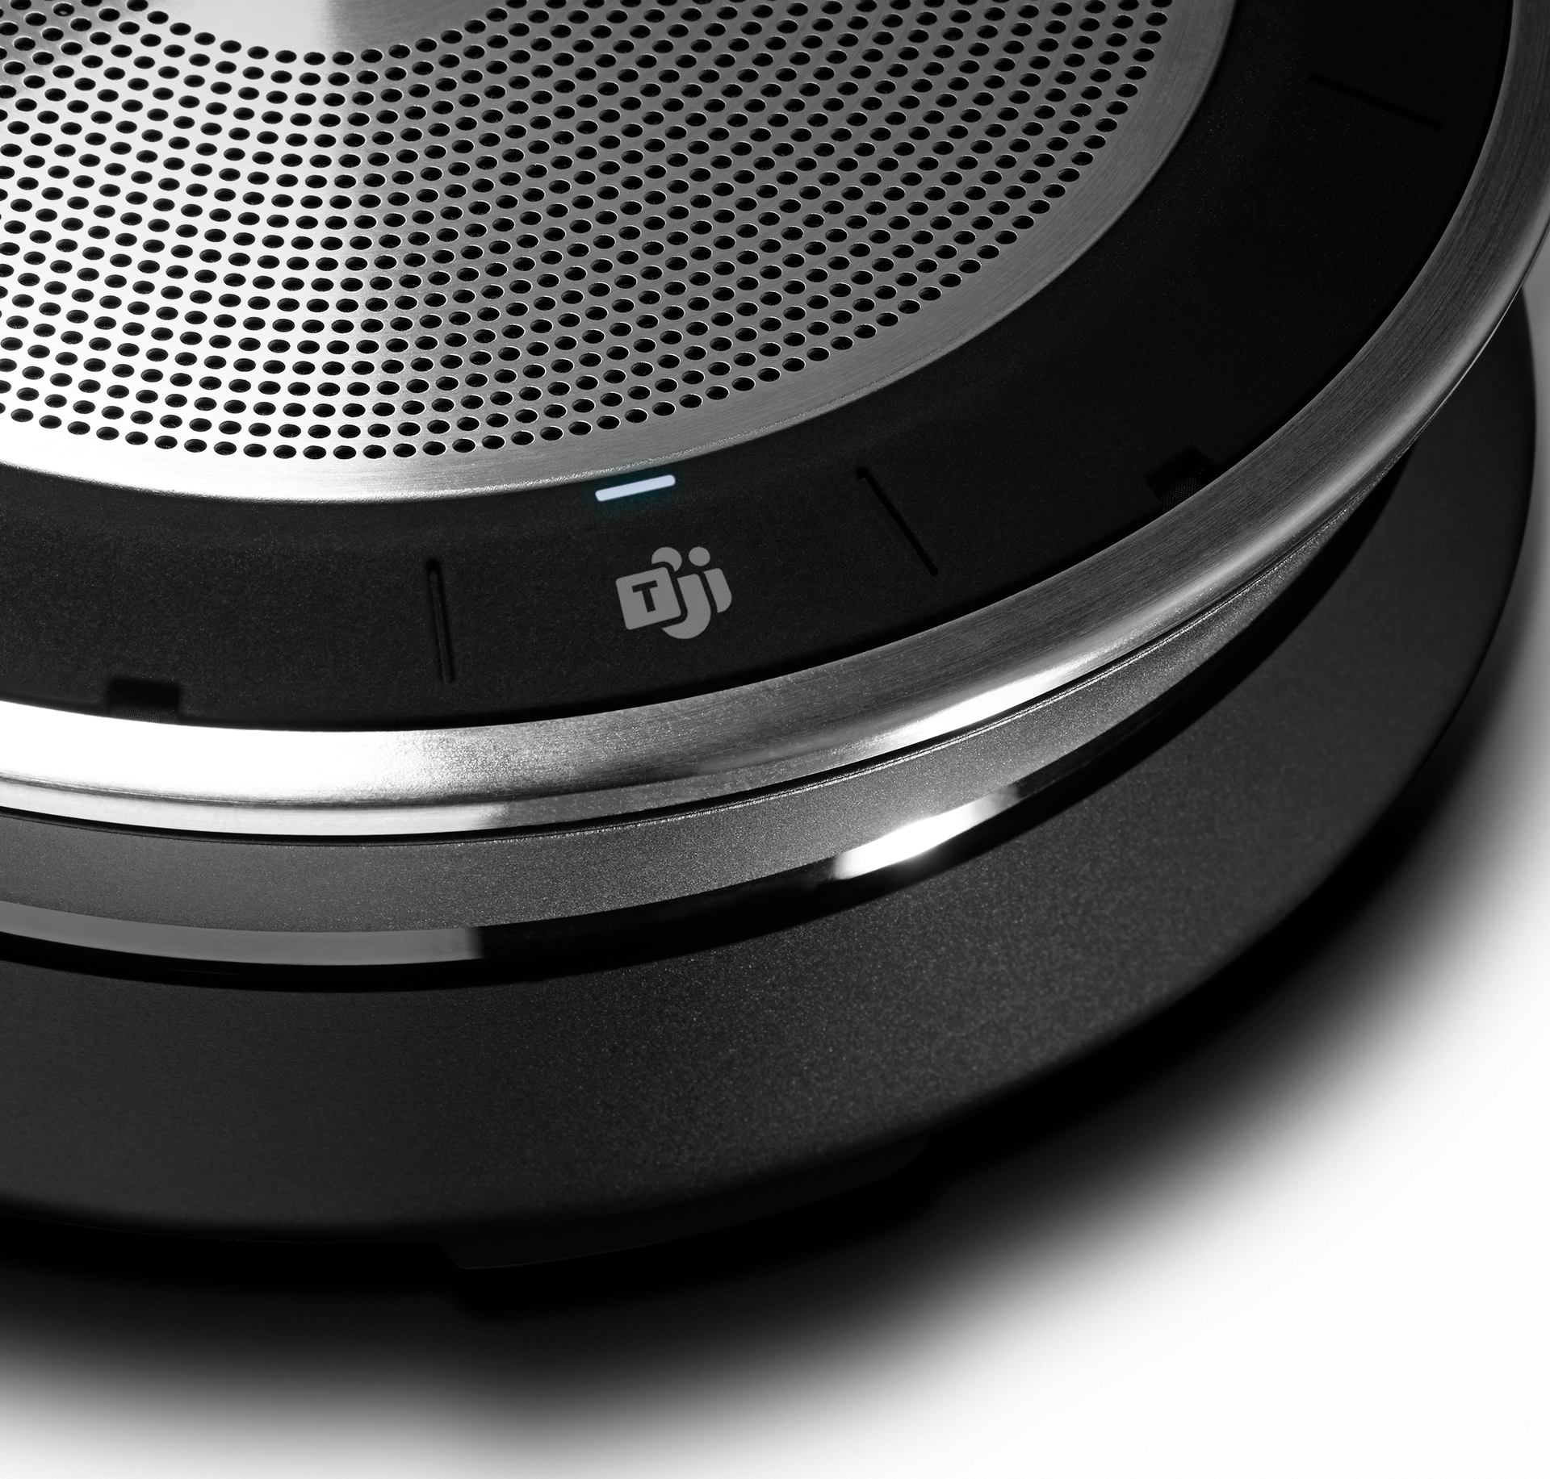
“As our customers increasingly depend on Microsoft Teams for calling and meetings in their modern workplace, devices like the Sennheiser Expand SP 30T play an important role in enabling a high-quality experience for today’s highly mobile users.” said Ilya Bukshteyn, Partner Director, Microsoft Teams Devices. ”Sennheiser’s portfolio of Certified for Microsoft Teams devices provides our joint customers with the solutions they need to use Teams wherever they may be.”

Instant conferencing anywhere
The EXPAND SP 30T is a portable wireless speakerphone for today’s mobile workforce, supporting both personal and small to medium sized conferencing up to eight people. Users can set up a call at a moment’s notice or use the device as part of a permanent conference room solution. Building on the features of the EXPAND line’s flagship product, the EXPAND SP 30T boasts 18 hours of battery life, portable Bluetooth® or USB-C connection, and multipoint connectivity for up to three devices, enabling users to connect to conferencing anywhere, anytime. In addition, the EXPAND SP 30T upgrades to exceptional audio performance with Sennheiser Voice Clarity — an ultra-low distortion speaker plus echo and noise-cancelling microphones supported by highly advanced DSP algorithms. This makes for crystal clear audio for calls, music and multimedia in even the most boisterous environments. The EXPAND SP 30T is crafted with premium quality materials in a compact, lightweight design with convenient cable winding and safe dongle storage for ease of travel. It features an improved speech and listening experience with industry-leading duplex performance for up to eight participants — acting as a personal device for conferences on the go or a shared tool in huddle spaces as well as small to mid-sized meeting rooms. The EXPAND SP 30T also offers flexible connectivity options to PC and smartphone devices.

To learn more about EXPAND SP 30T, please visit: Sennheiser.com/sp-30
To learn more about Sennheiser’s journey to Microsoft Teams, please visit: Sennheiser.com/teams

Visit Sennheiser at Microsoft Ignite November 4-8, 2019
Sennheiser will exhibit the EXPAND SP 30T Speakerphone at booth number 1937.

Availability and price
Certified for Microsoft Teams
Availability: December 2019
AU RRP: $399
NZ RRP: $449

ABOUT SENNHEISER COMMUNICATIONS
Sennheiser Communications A/S develops award winning headsets for business professionals and the gaming community from its headquarters in Copenhagen, Denmark. The company specializes in combining high-end audio and sound reproduction quality with leading hearing aid and advanced digital signal processing technologies for state-of-the-art communication products for call centers and office applications, as well as headsets for gaming and mobile devices. Its success builds on a strong sound heritage, the very latest technologies, and most of all, a team of committed experts and professionals. Founded as a joint venture in 2003, Sennheiser Communications draws on the experience of two world leading sound experts: German electro-acoustic specialist, Sennheiser Electronic GmbH & Co. KG and the Danish hearing healthcare company, Demant. With the great potential in the company’s full range of business segments, it is about to embark on a new chapter, where Sennheiser Communications will demerge in 2020 and a new company will form under Demant A/S, focusing on business solutions and gaming.
Find more information about Sennheiser Communications at www.senncom.com.

Local PR Contact Global PR & Corporate Communication,
Sennheiser Australia Sennheiser Communications A/S

Heather Reid Tanja Krebsø
T +61 448 119 609 T +45 25356887
heather.reid@sennheiser.com takr@senncom.com

