Inside the Best Immersive Audio Albums: Neumann Monitors Deliver Grammy Award-Winning Sound

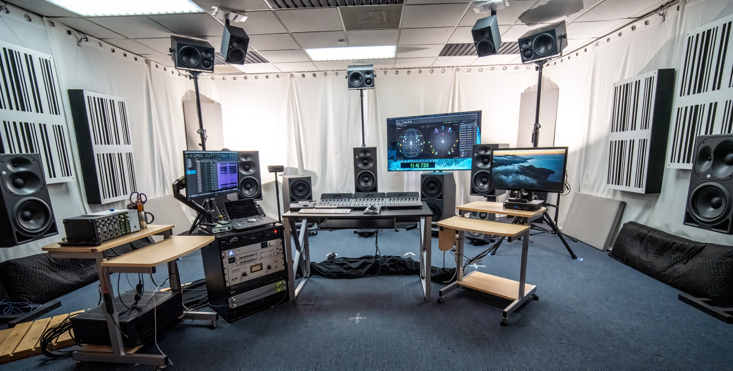

From major artists like Alicia Keys to game franchises like God of War, Grammy® award-winning audio engineers George Massenburg, Michael Romanowski, Eric Schilling, and producer Herbert Waltl rely on Neumann monitors to deliver breathtaking immersive mixes.

Los Angeles, California, February 2, 2026 — In the world of immersive audio production, accuracy and consistency are non-negotiable. From major pop productions to expansive orchestral soundtracks, Neumann studio monitors continue to shape the sound of award-winning immersive audio. Recent Grammy® wins for Best Immersive Audio Album by acclaimed engineers George Massenburg, Michael Romanowski, Eric Schilling, and producer Herbert Waltl all share one technical constant: the Neumann KH line of monitors.

From pop icons to epic scores

Whether remixing the iconic Alicia Keys catalogue (with the help of Keys’ producer and engineer Ann Mincieli), shaping the expansive score of God of War: Ragnarök, or producing the genre-blending Divine Tides by Stewart Copeland and Ricky Kej, these engineers and producers have trusted Neumann’s KH series monitors to translate their creative visions with stunning fidelity — across formats, genres, and playback systems.

These albums were mostly brought to life inside California’s Media HYPERIUM immersive studio, which was built in 2020 by multi-platinum and three-time Grammy-winning producer Herbert Waltl in collaboration with engineer Eric Schilling. Waltl has won Grammy Awards for Album of the Year and Best Surround Sound Album, both for Ray Charles’ Genius Loves Company, as well as Best Immersive Audio Album for Divine Tides, in addition to several nominations. Broadcast music mixer for the Grammy show and eight-time Grammy-winning engineer Eric Schilling takes on the role of Chief Engineer at the studio, which is outfitted with a custom-designed Neumann system to support immersive audio mixing. Schilling has won the award for Best Immersive Audio Album for Alicia, The Diary Of Alicia Keys, and Divine Tides, among others.

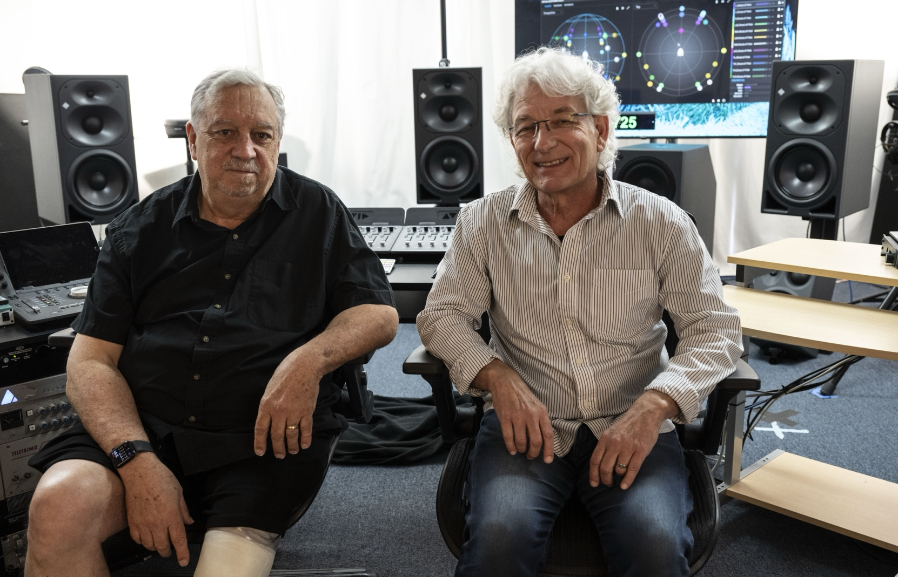
Eric Schilling (L) and Herbert Waltl (R) at mediaHYPERIUM

“Everything we’ve done here the last few years was mixed on Neumann speakers,” says Schilling of his partnership with Waltl. “We’ve got KH 420s, 310s, 120s, and the subs. The room is tuned around them, and the sound just translates — I’m never surprised when I hear a mix outside this room.” Schilling adds, “The sound [doesn't] fall apart at higher volumes — it [stays] musical. That’s rare.”

A reliable system that delivers sonic truth

The mediaHYPERIUM room features seven KH 420 tri-amplified mains and dual KH 870 subwoofers, anchored by KH 310s and KH 120s in height and floor positions — a hybrid layout that switches seamlessly between immersive formats.

While Schilling and Waltl work out of mediaHYPERIUM, their frequent collaborator Michael Romanowski heads up Coast Mastering in Berkeley as Chief Mastering Engineer. He is one of the very first immersive audio mastering engineers and has won Grammy Awards for Best Immersive Audio Album for Alicia, The Diary Of Alicia Keys, and The United States Army Field Band And Soldiers' Chorus’ Soundtrack of the American Soldier, plus several other wins and nominations. The in-demand engineer has outfitted his own mastering and mix environments with Neumann KH 310s and KH 120s, and regularly co-leads immersive projects with the others. “I love how natural they sound ... They’re accurate. What you hear is what you get,” Romanowski says of the monitors. “That’s what makes them the best tools for immersive. Some monitors are shouty — they’re trying too hard. Not Neumann. They’re smooth, accurate, and never fatiguing. They’re just honest – that's what you need.”
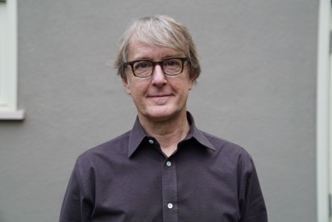
Michael Romanowski

Precision meets emotion

For frequent collaborator George Massenburg, immersive audio is not just about technical fidelity — it's about emotion. “You need transparency to reach a listener’s heart,” he says. “Monitoring must be musical, not just analytical. Neumann monitors helped us keep the listener in mind, to build a story in three dimensions.” Through a career lasting over 50 years, Massenburg is a globally renowned producer, engineer, audio equipment and studio designer. He is the founder of Massenburg DesignWorks and George Massenburg Labs, and has won a Grammy for Technical Achievement. His studio work has gained him international recognition and six Grammys (including the Grammy for Technical Achievement in 1998, making him one of only seventeen individuals to receive that honor at the time), as well as numerous nominations and awards. Additionally, he has earned Grammy Awards for The Diary Of Alicia Keys, Alicia, Patty Loveless’ Mountain Soul II, and more.

Massenburg contributed immersive mixes to Alicia Keys’ “Underdog” and other tracks, often working remotely and referencing across multiple systems. Despite those variables, Neumann’s consistency stood out. “We could trust what we were hearing. When I took mixes from my place to Eric and Herbert’s room at mediaHYPERIUM, the character held up.”

A dream team with seamless collaboration

Massenburg, Romanowski, Schilling and Waltl developed a seamless collaborative workflow — reviewing ADM files, referencing between systems, and constantly adjusting mixes for translation. Neumann’s consistency across sizes and formats proved crucial. “I’ve worked on many speakers, but these make the experience more fun,” says Schilling. “Even when I travel, the smaller Neumann systems carry the same character. I trust them.”

That trust and seamless collaboration is a cornerstone of their Grammy success. Together, the four have taken home multiple wins in the Best Immersive Audio Album category over the past four years – a category historically won by artists like Beyoncé, Paul McCartney and The Beatles.

George Massenburg

Building an entire ecosystem over several decades

The Grammy-winning Divine Tides project, which fuses global instrumentation with lush production, was another immersive success story crafted on Neumann monitors. So too was God of War: Ragnarök, with over 400 audio tracks and larger-than-life orchestral arrangements. “It doesn’t matter if it’s a string quartet or a monster score — the system just handles it,” says Waltl. “We’ve had composers and artists walk in, listen, and say, ‘This is one of the best sounding immersive rooms we’ve ever heard.’”

Waltl, who founded mediaHYPERIUM in 1996, recalls first hearing Neumann monitors at Skywalker Sound. “The KH 310s impressed me from the start,” he says. “Now, we’ve built an entire ecosystem around them — not just for mixing, but also listening, teaching, and inspiring. The speakers let the music speak.”

Grammy Awards 2026 Update

At the awards ceremony on February 1, 2026, Michael Romanowski was once again honored with a Grammy. This time for mastering Justin Gray's album Immersed, which was specifically composed, recorded and produced for immersive audio.

More information:
mediaHYPERIUM: https://www.mediahyperium.com/

Coast Mastering: https://www.coastmastering.com/

Massenburg DesignWorks: https://massenburgdesignworks.com/

About Neumann
Georg Neumann GmbH, known as “Neumann.Berlin”, is one of the world’s leading manufacturers of studio-grade audio equipment and the creator of recording microphone legends such as the U 47, M 49, U 67, and U 87. Founded in 1928, the company has been recognized with numerous international awards for its technological innovations. Since 2010, Neumann.Berlin has expanded its expertise in electro-acoustic transducer design to also include the studio monitor market, building upon the legacy of the legendary loudspeaker innovator Klein + Hummel. The first Neumann studio headphones were introduced in 2019, and since 2022, the company has increased its focus on reference solutions for live audio. With the introduction of the first audio interface MT 48, and its revolutionary converter technology, Neumann now offers all the necessary technologies needed to capture and deliver sound at the highest level. Georg Neumann GmbH has been part of the Sennheiser Group since 1991 and is represented worldwide by the Sennheiser network of subsidiaries and long-standing trading partners.
www.neumann.com

Local Press Contacts
Daniella Kohan
daniella.kohan@sennheiser.com
+1 (860) 227-2235

Kirsten Spruch
kirsten.spruch@sennheiser.com
+1 (860) 598-7484

Peter Schuyler
peter@ingearpr.com
+1 (917)-496-8970

