The Business Suite  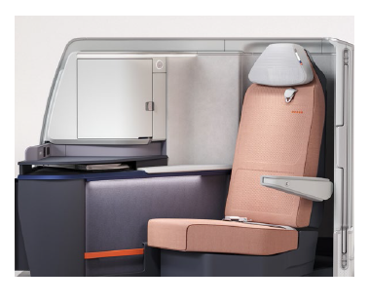 | Coming Soon - Q4 2023  Manufactured by: Safran Seats  Seat Model: VUE  Designed by: JPA Design  Description: Enclosed suite with lie-flat seat, privacy door and direct aisle access  Technical Specification:  - Width when seated: 20.4 inches  - Width in bed mode: 23.8 inches  - Bed length: 75 inches  Features:  - Electronically dimmable windows  - Wireless charging  - Power ribbon featuring AC, USB A and USB C outlets  - Enclosed stowage  - Ambient lighting  - Vanity mirror  - Reading light  - 17.3” 4K IFE display, Bluetooth headphone pairing  Cabin layout: 1-1
The Lie-flat Business Class Seat  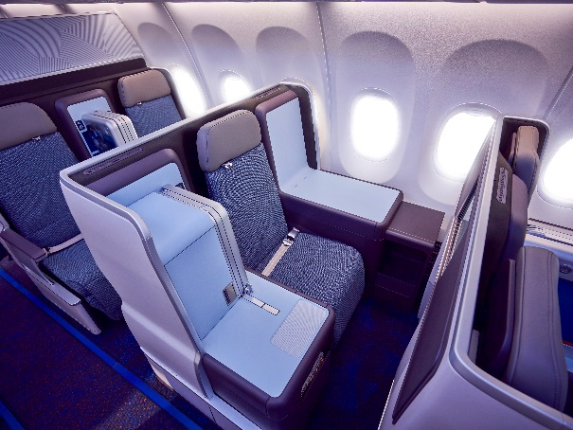 | Introduced to the fleet: 2017  Manufactured by: Thompson Aero Seating  Seat model: Vantage  Designed by: JPA Design  Decryption: Lie-flat business class seat  Technical Specification:  - Width when seated: 19.8 inches  - Width in bed mode: 21.3 inches  Bed length: 75 inches  Features:  - AC and USB A power outlets  - Generous stowage  - Ambient lighting  - Reading light  - 15.6” 1080p HD IFE display  Cabin layout: 2-2, 1-1

The Recliner Business Class Seat  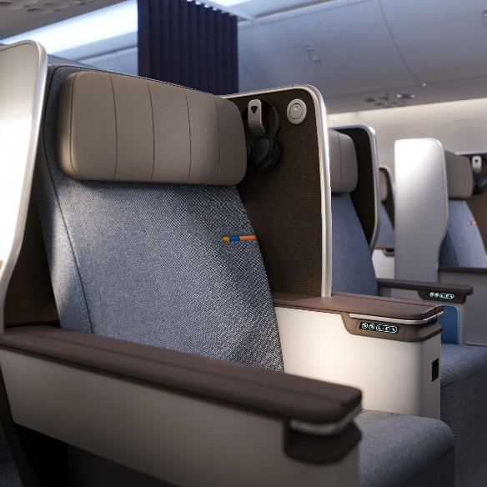 | Introduced to the fleet: 2021  Manufactured by: HAECO Cabin Solutions  Seat model: Eclipse  Designed by: JPA Design  Description: Electrically actuated, fixed back-shell business class recliner, angled and staggered to support ease of egress from the outboard seat  Technical Specification:  - Seat width: 21 inches  - Seat pitch: 45 inches  Features:  - AC, USB A and USB C power outlets  - Ambient lighting  - Thoughtful stowage for devices and personal belongings  - Reading light  - 15.6” 4K UFE display  - Bluetooth headphone pairing  Cabin layout: 2-2
The Economy Seats 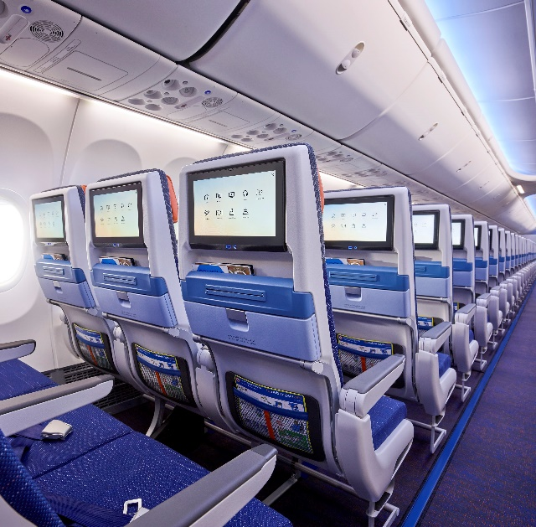 | Introduced to the fleet: 2017  Manufactured by: RECARO Aircraft Seating  Seat Model: CL3710  Designed by: JPA Design  Description: Ergonomically designed for a long-haul flight, our economy class seat features gentle recline, a six-way adjustable leather headrest and an articulating seat pan  Technical Specification:  - Seat width: 17 inches  - Seat pitch: 29-30 inches  - Seat recline: 3 inches  Features:  - USB A power outlet  - Multiple stowage for personal belongings  - 13.3” 4K IFE display  - Bluetooth headphone pairing  Cabin layout: 3-3

***
About flydubai
From its home in Dubai, flydubai has created a network of more than 110 destinations served by a fleet of 76 aircraft. Since commencing operations in June 2009, flydubai has been committed to removing barriers to travel, creating free flows of trade and tourism and enhancing connectivity between different cultures across its ever-expanding network.

flydubai has marked its journey with a number of milestones:

An expanding network: Created a network of more than 110 destinations in 50 countries across Africa, Central Asia, the Caucasus, Central and South-East Europe, the GCC and the Middle East, and the Indian Subcontinent.

Serving underserved markets: Opened more than 70 new routes that did not previously have direct air links to Dubai or were not served by a UAE national carrier from Dubai.

An efficient single fleet-type: Operates a single fleet-type of 76 Boeing 737 aircraft and includes: 30 Next-Generation Boeing 737-800, 43 Boeing 737 MAX 8 and 03 Boeing 737 MAX 9 aircraft.

Enhancing connectivity: Carried more than 80 million passengers since it began operations in 2009.

For all our latest news, please visit the flydubai Newsroom.

