Neumann Introduces RIME
An Integrated Solution for Monitoring Immersive Audio on Headphones

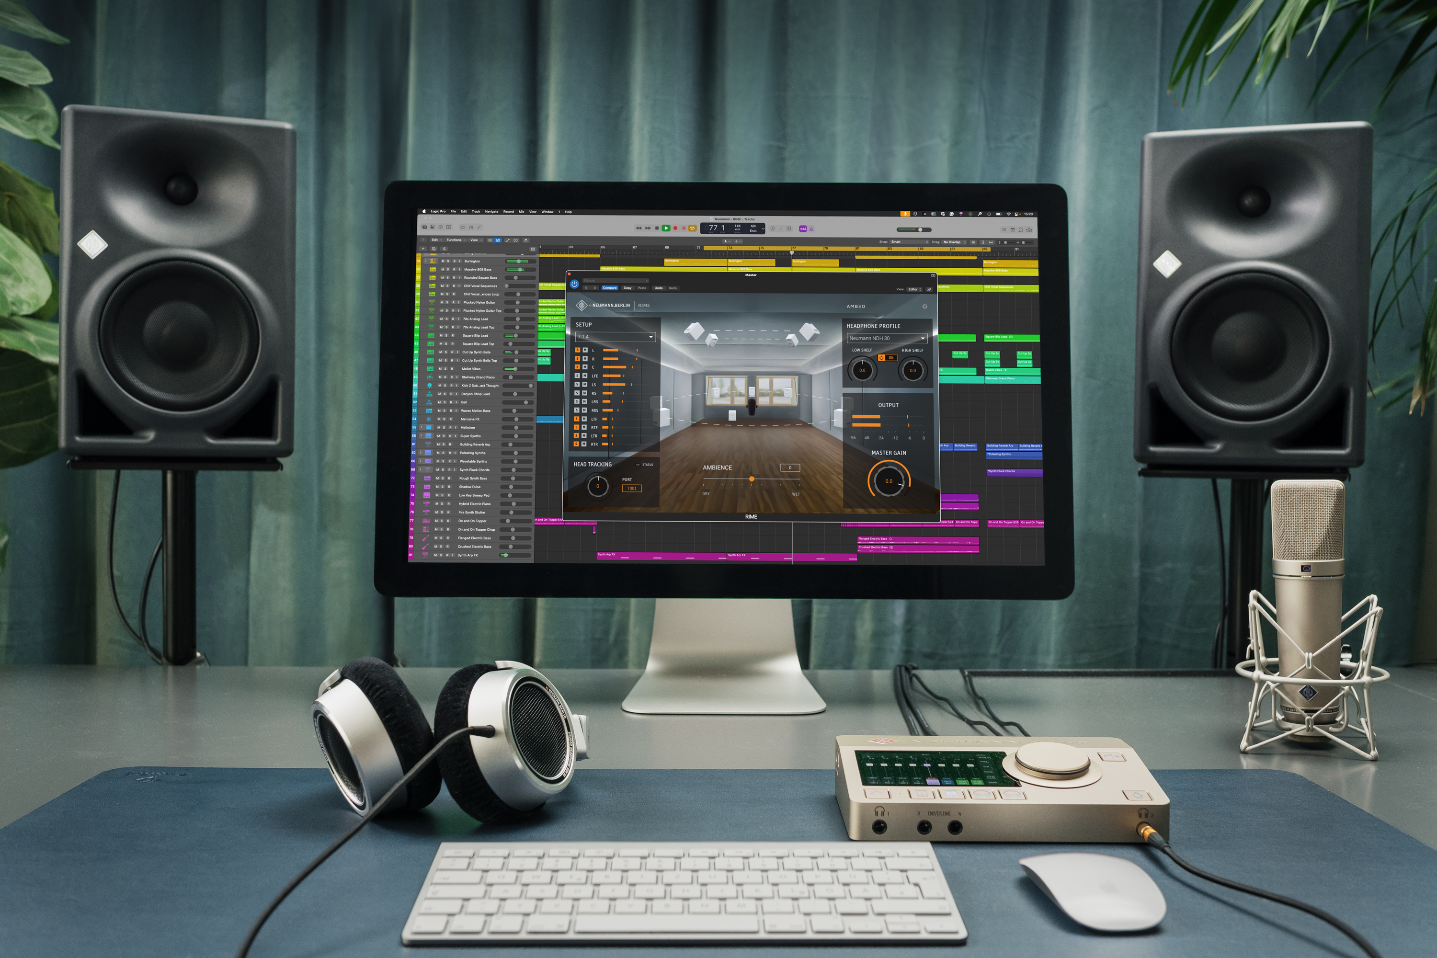

Berlin, April 23, 2025 – German pro audio specialist Neumann is proud to announce the release of RIME (Reference Immersive Monitoring Environment), a new software solution for Neumann headphones. RIME enables music producers and mixing engineers to monitor immersive formats like Dolby Atmos in reference quality, providing an excellent alternative when a multichannel loudspeaker setup is unavailable or when working on the go.

“Immersive audio is the new standard. Streaming services favor content that can be enjoyed in spatial audio formats such as Dolby Atmos or Sony 360 Reality. More and more DAWs now offer immersive audio capabilities, and engineers, producers, and musicians alike are eager to explore these new possibilities. Reliable monitoring is essential for this,” said Yasmine Riechers, CEO of Neumann. “With RIME, we're offering an integrated solution that meets these evolving needs, providing a more cost-effective and mobile alternative to loudspeaker-based monitoring solutions. Our NDH headphones have the same carefully balanced sound as our studio KH studio monitors, making it easy to switch between the two. With RIME this unique benefit extends to immersive monitoring as well.”

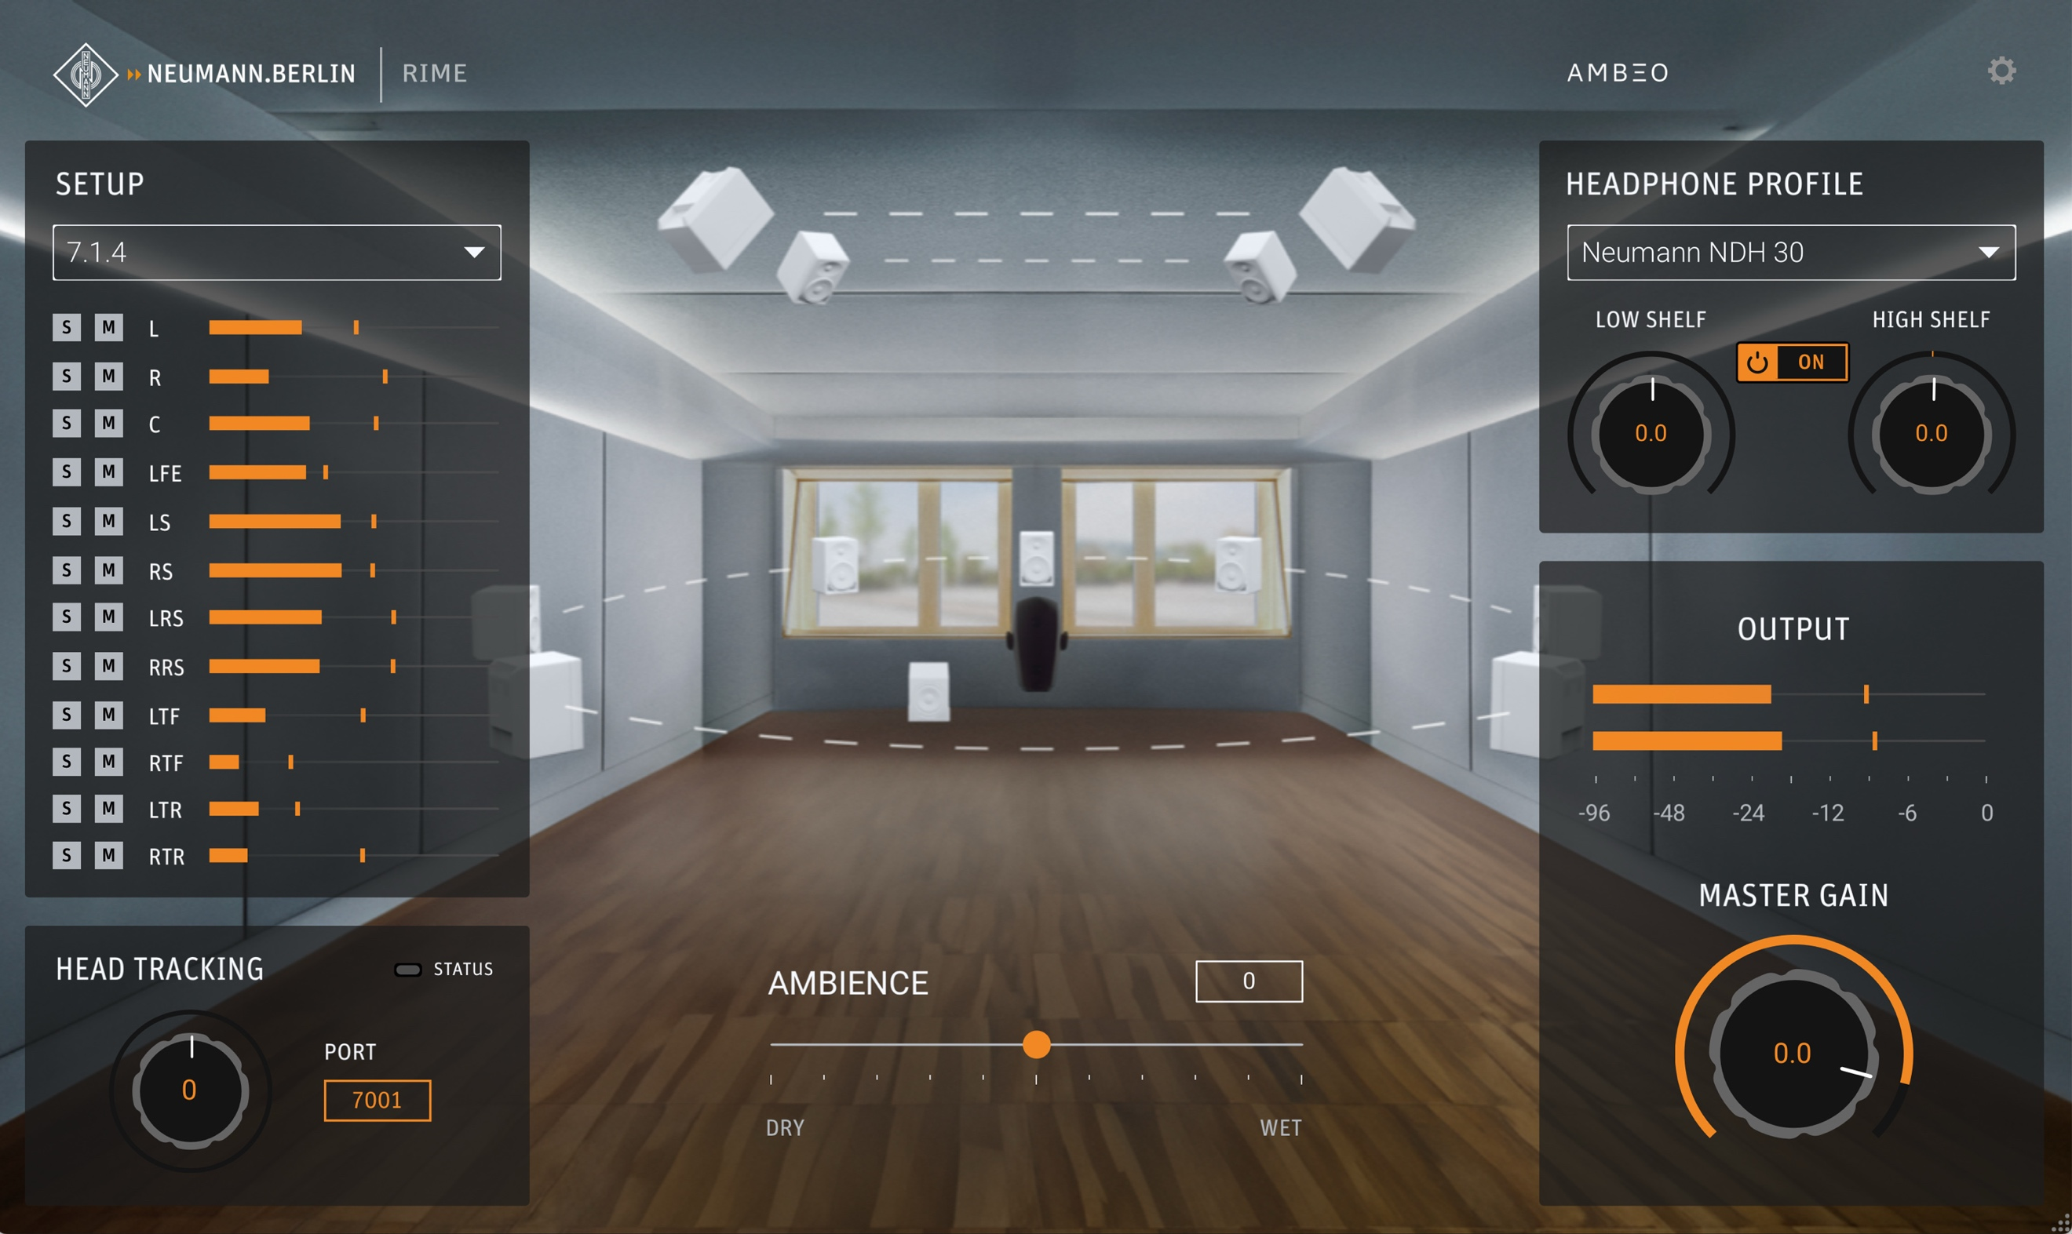
Neumann RIME Room View

RIME is a plug-in for all major DAWs on Mac and PC (VST3/AU/AAX) and is typically used on the output or monitoring bus. It converts multichannel formats to binaural audio, retaining surround and height channel information, thus enabling users to monitor and mix content in formats such as Dolby Atmos using headphones.

RIME captures a real purpose-built studio room using reference-quality Neumann equipment throughout. Immersive setups of Neumann KH Line loudspeakers and subwoofers were installed by acoustics experts and fine-tuned using MA 1 automatic monitor alignment. The three-dimensional sound field was captured using the legendary KU 100 binaural head microphone connected to Neumann’s acclaimed MT 48 audio interface featuring cutting-edge preamp and converter technology. This state-of-the-art setup ensures pristine sound quality throughout the entire signal chain.

“As RIME is made for Neumann headphones exclusively, this perfect signal chain extends all the way to the user,” explained Product Manager Jorma Marquardt. “Our NDH 20 and NDH 30 headphones are manufactured to extremely tight tolerances. And of course, we know all their acoustic parameters. Using groundbreaking AMBEO algorithms, we are able to realize true immersion with unmatched sonic consistency and razor-sharp 3D localization.”

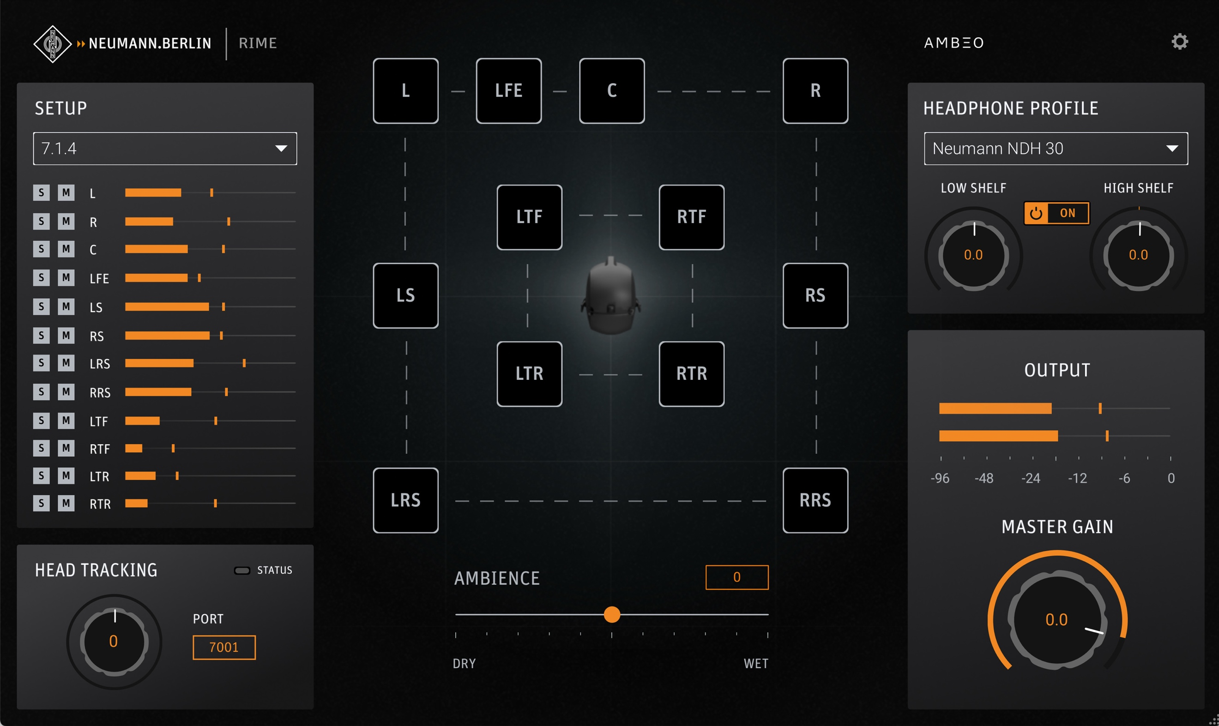
RIME Topview with Mute buttons for each channel

Unlike competing solutions that confound the user with a multitude of options and different sounding virtual spaces, RIME is easy to use and reproduces one reference room as a single source of truth. “RIME is not a simulation but captures an optimal control room in ultimate quality. RIME sounds real, because it is real!” Marquardt stated.

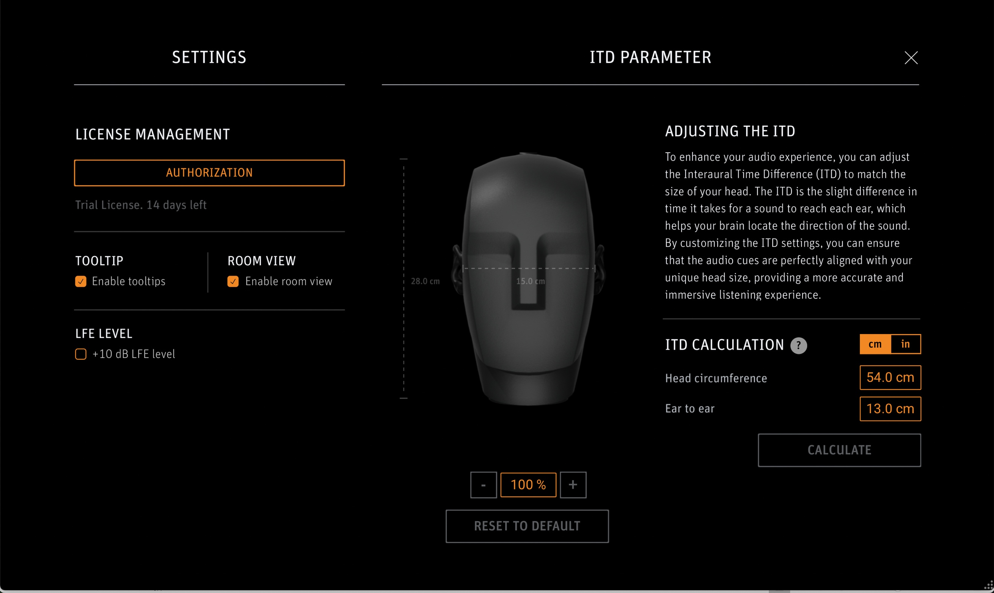
For added realism, RIME supports OSC compatible head tracker devices to create a listening experience that responds to the user’s head move–ments. Moreover, RIME can also be used for stereo playback to enjoy a loudspeaker-like listening experience without the in-head localization typically associated with headphones. This feature enables users to check their mixes for loudspeaker compatibility using Neumann headphones, allowing them to mix with confidence that their tracks will translate perfectly to all playback systems.

With the launch of RIME, Neumann continues to serve the audio community with pioneering innovation. RIME makes immersive audio accessible and easy to handle. Finally, mix engineers can work from anywhere. Likewise, artists can now approve immersive mixes using NDH headphones, without having to visit a physical studio.
RIME is out now and available from authorized Neumann dealers. RIME licenses can also be purchased directly from the Neumann web shop (select countries only).

Price: EUR 99.00 / USD 99.95 / GBP 85.00

System Requirements
Mac: macOS 10.15 and above, Intel and Apple Silicon native
PC: Windows 10 and above
Plug-in formats: VST3, AU, AAX
Compatible with major DAWs such as Pro Tools, Pyramix, Logic, Reaper, Cubase/Nuendo

More information: www.neumann.com/en-gb/products/software/rime

About Neumann
Georg Neumann GmbH, known as “Neumann.Berlin”, is one of the world’s leading manufacturers of studio-grade audio equipment and the creator of recording microphone legends such as the U 47, M 49, U 67, and U 87. Founded in 1928, the company has been recognized with numerous international awards for its technological innovations. Since 2010, Neumann.Berlin has expanded its expertise in electro-acoustic transducer design to also include the studio monitor market, building upon the legacy of the legendary loudspeaker innovator Klein + Hummel. The first Neumann studio headphones were introduced in 2019, and since 2022, the company has increased its focus on reference solutions for live audio. With the introduction of the first audio interface MT 48, and its revolutionary converter technology, Neumann now offers all the necessary technologies needed to capture and deliver sound at the highest level. Georg Neumann GmbH has been part of the Sennheiser Group since 1991 and is represented worldwide by the Sennheiser network of subsidiaries and long-standing trading partners. www.neumann.

Stay up to date and follow us on: FACEBOOK I INSTAGRAM I YOUTUBE

Press Contact Neumann:
Dr. Andreas Hau Raphael Tschernuth
andreas.hau@neumann.com raphael.tschernuth@neumann.com
T +49 (030) 417724-15 T +49 (030) 417724-67

