Give the gift of great sound
Perfect presents for videographers, vloggers and podcasters

Wedemark, November 2022 – Do your loved ones have a passion for video shooting, content creation or podcasting? Then Sennheiser might have just the right gifts for them this festive season…

MKE 200  Upgrading your video blogging audio is just one microphone away – Sennheiser’s MKE 200 brings presence to your voice, while features like a built-in windscreen and shock mount keep your recordings sounding cleaner than ever before. | 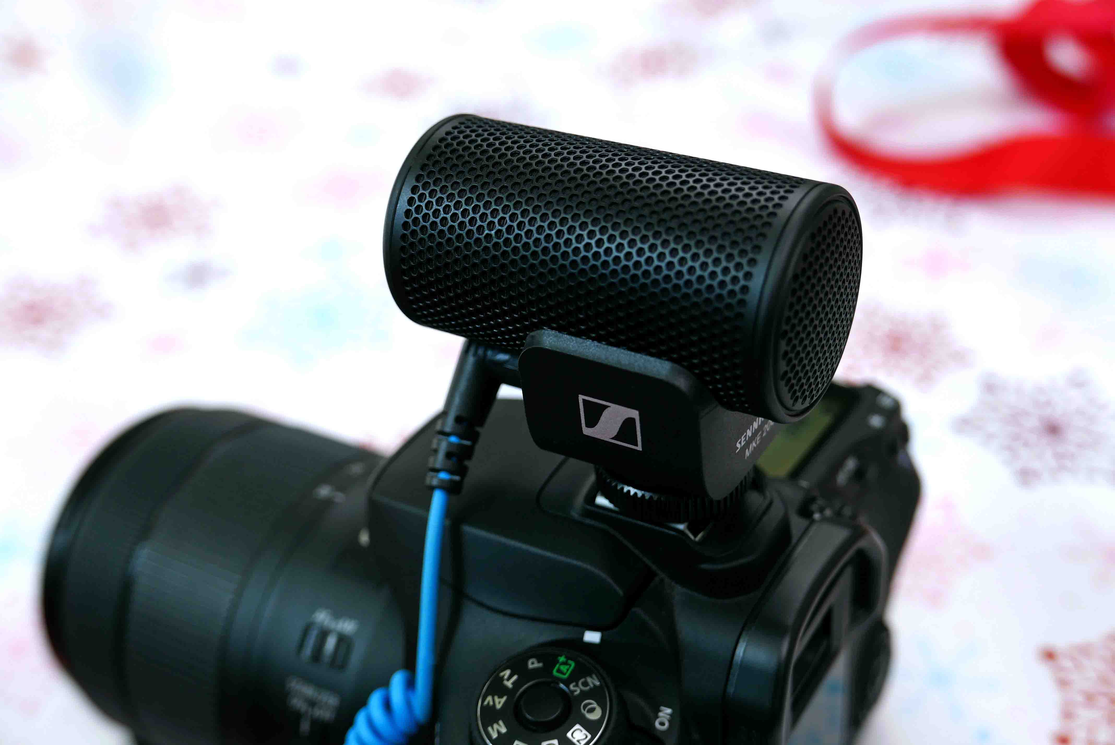

MKE 400  If you’re searching for that perfect on-camera microphone, look no further! The MKE 400 is a compact, highly directional, on-camera shotgun microphone designed to isolate and enhance the audio for your video, and comes with built-in windscreen and shock mount. | 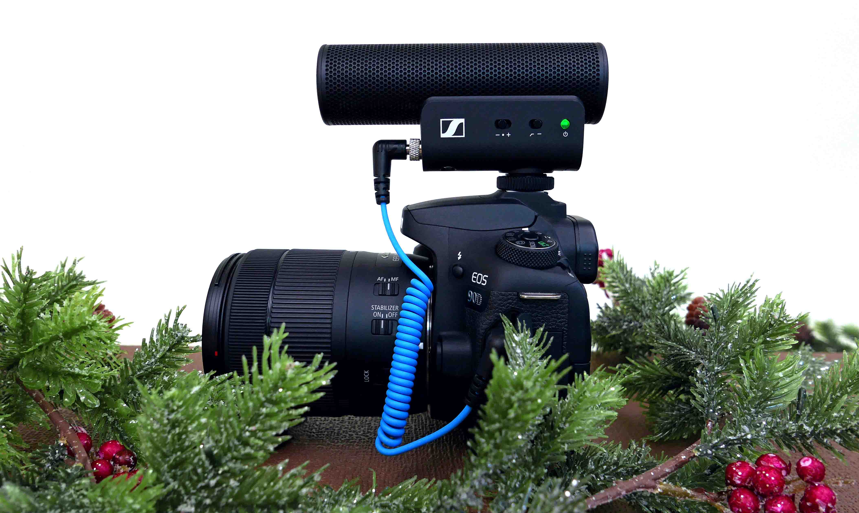

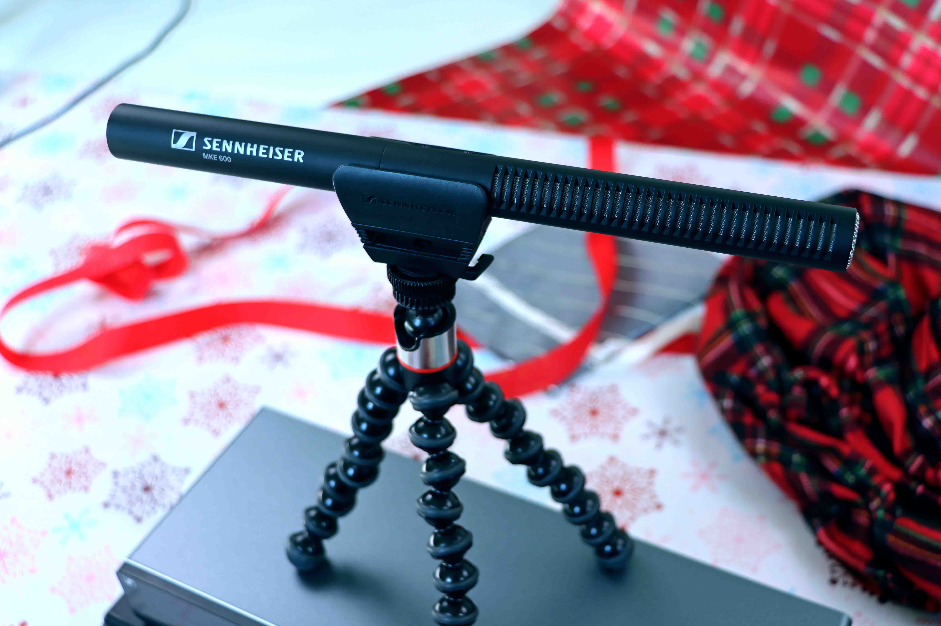 | MKE 600  Even the most demanding filming challenges can be handled with an MKE 600 shotgun mic. Thanks to its high directivity, it picks up sounds from the direction in which the camera is pointing and effectively attenuates noise from the sides.

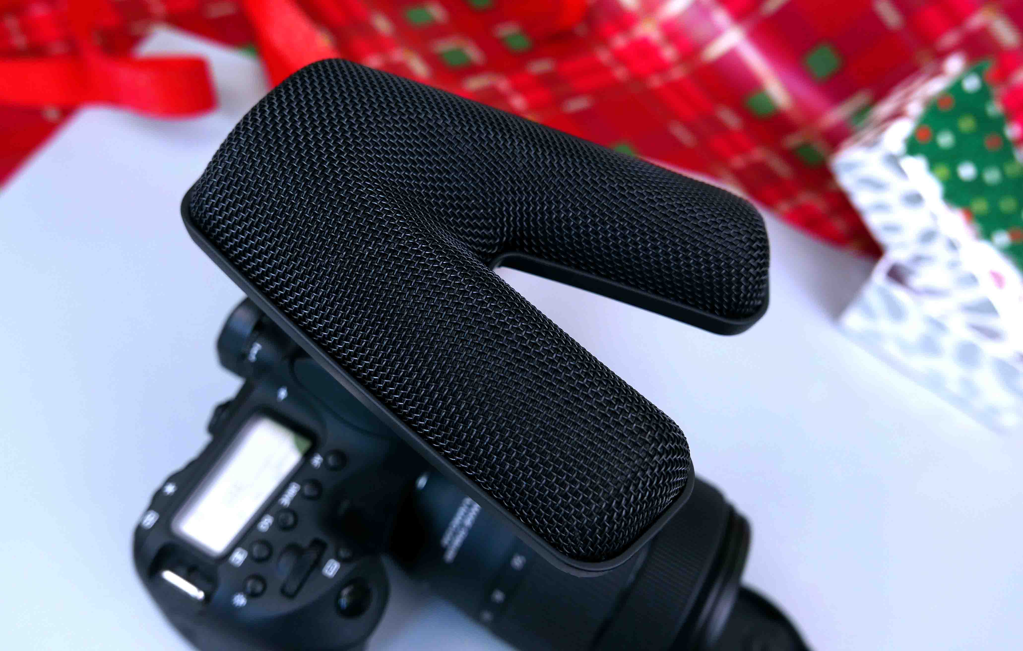 | MKE 440  Prefer stereo sound? The MKE 440 on-camera stereo mic has two aligned and matched mini shotgun mics, so it captures the natural audio you want and rejects off-axis noise.

MKH 416  A classic – Sennheiser’s MKH 416 moisture-resistant interference tube microphone lets you capture superb broadcast-level audio in demanding conditions. Ideal for your next professional film, TV, or location recording. | 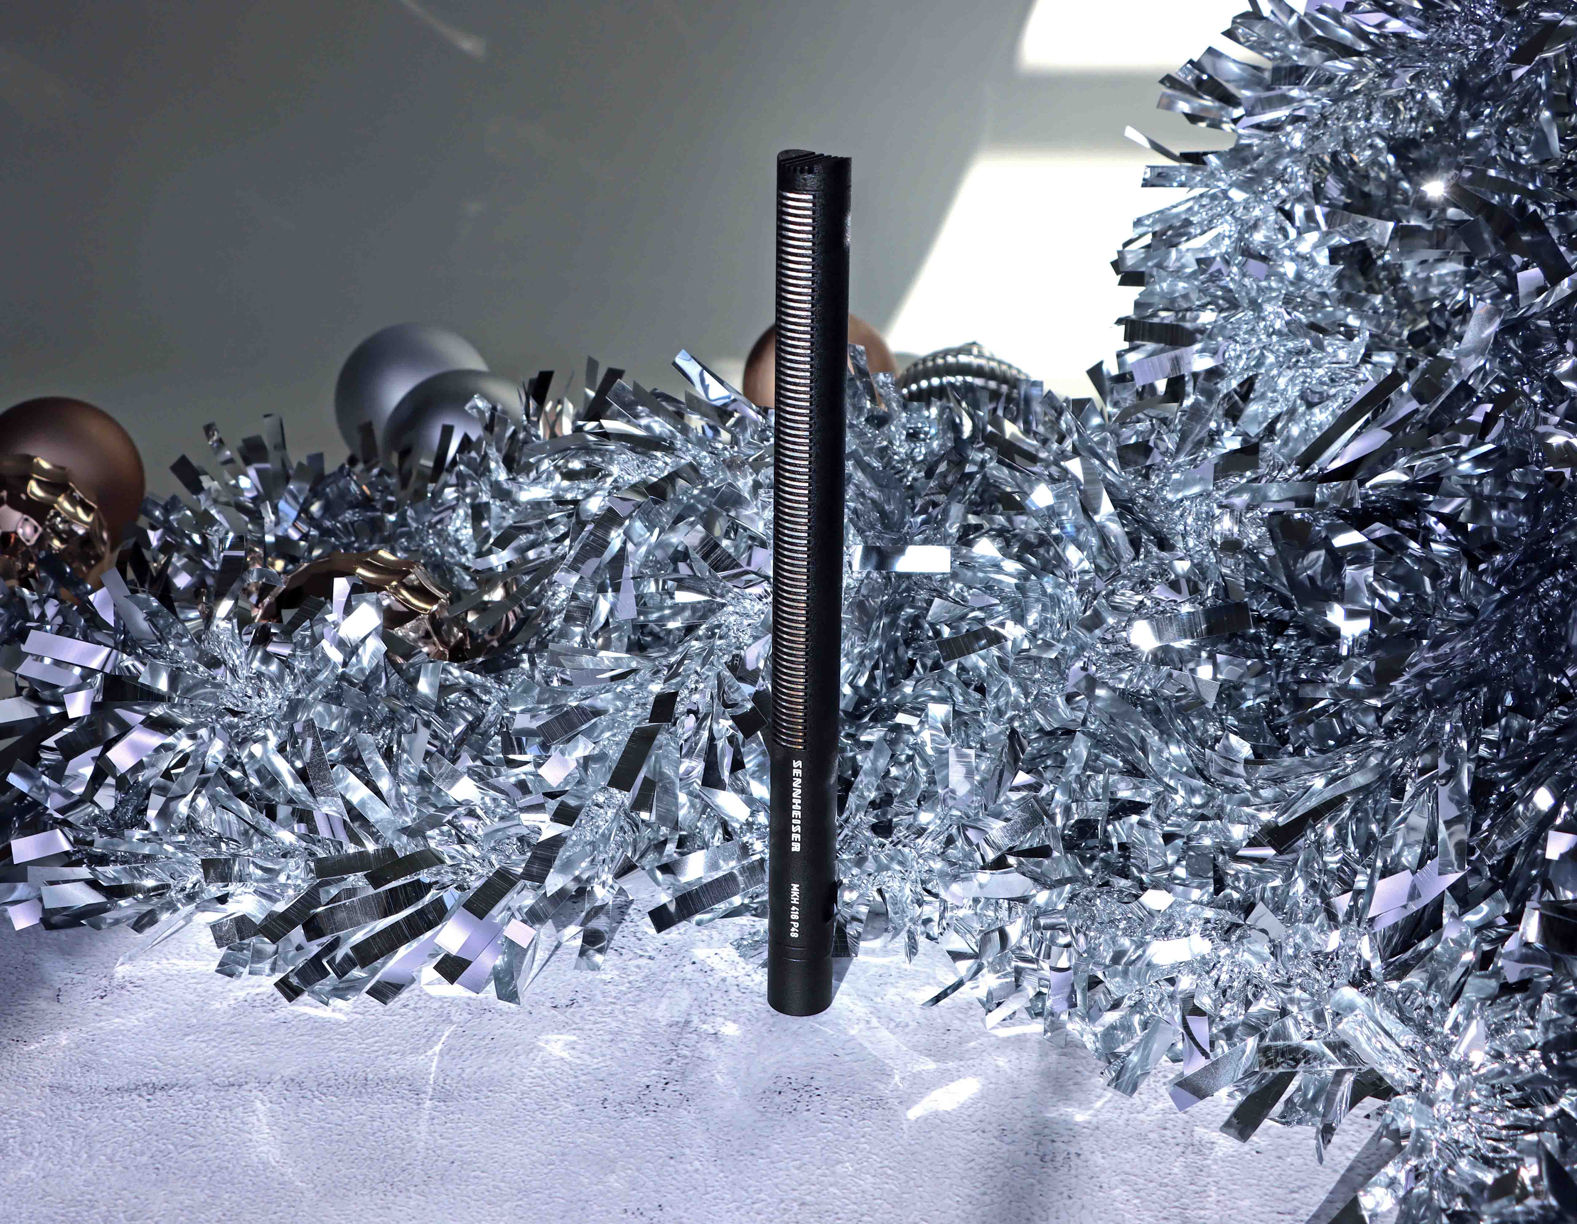

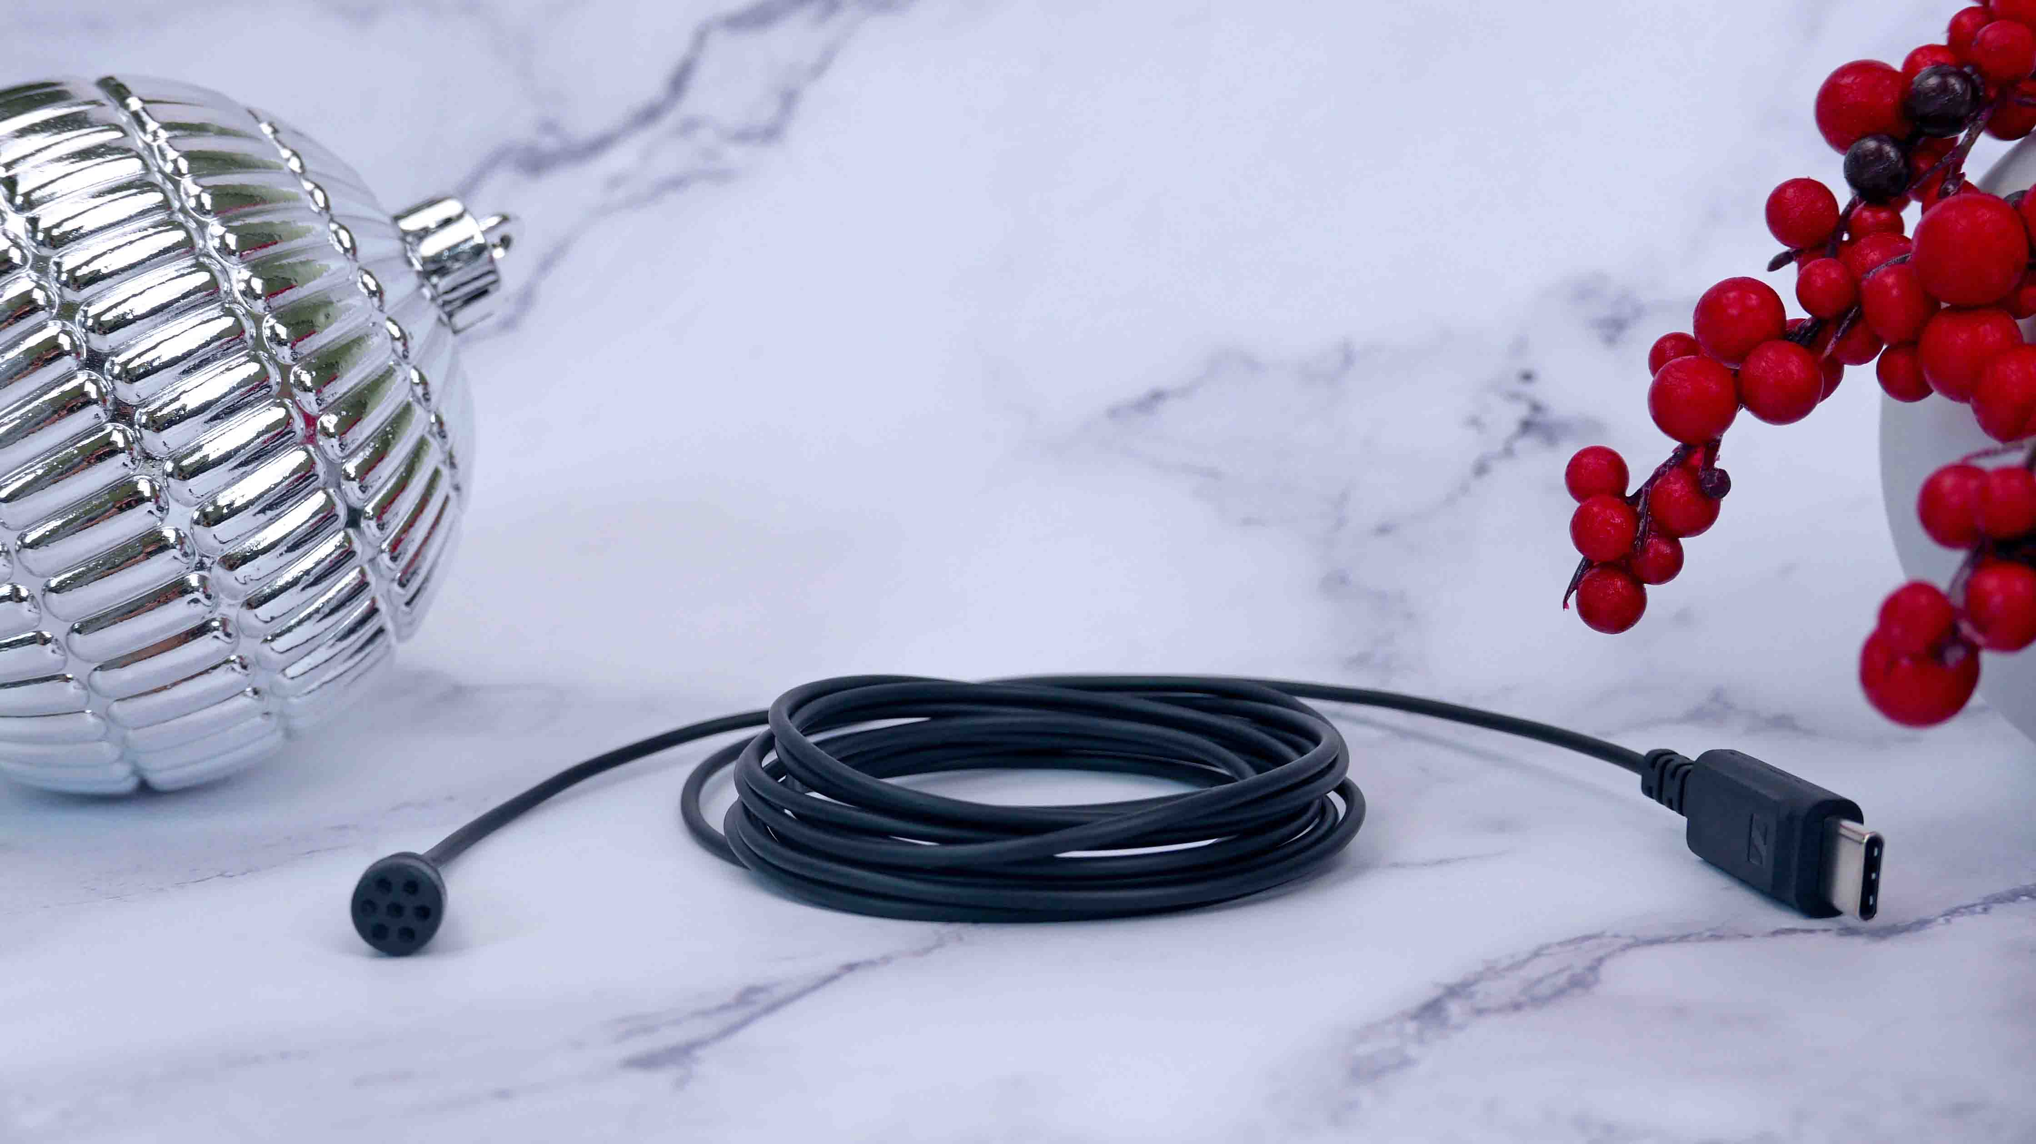 | XS Lav USB-C  Whether connected to a computer or a mobile device with a USB-C port, with XS Lav USB-C you can record yourself simply and effectively, helping you instantly produce better content.

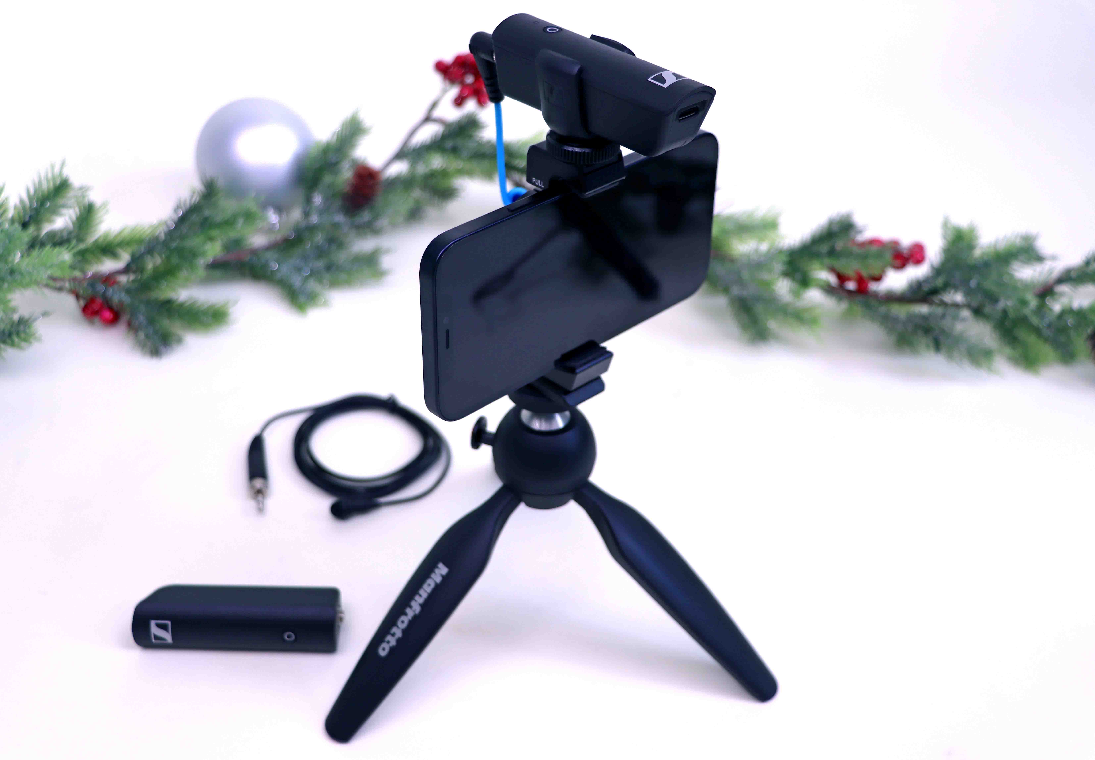 | XS Wireless Portable Lav Mobile Kit  Designed for vloggers, content creators and streamers on the go, the Sennheiser XSW-D Portable Lav Mobile Kit includes everything you need to get high-quality audio into your smartphone videos.

MK 4  With the typical warm sound of a studio condenser mic, the MK 4 is a great all-rounder for podcasting and voice-overs, as well as for recording vocals and instruments. It delivers fantastic sound quality, while still being an affordable choice for home recording. | 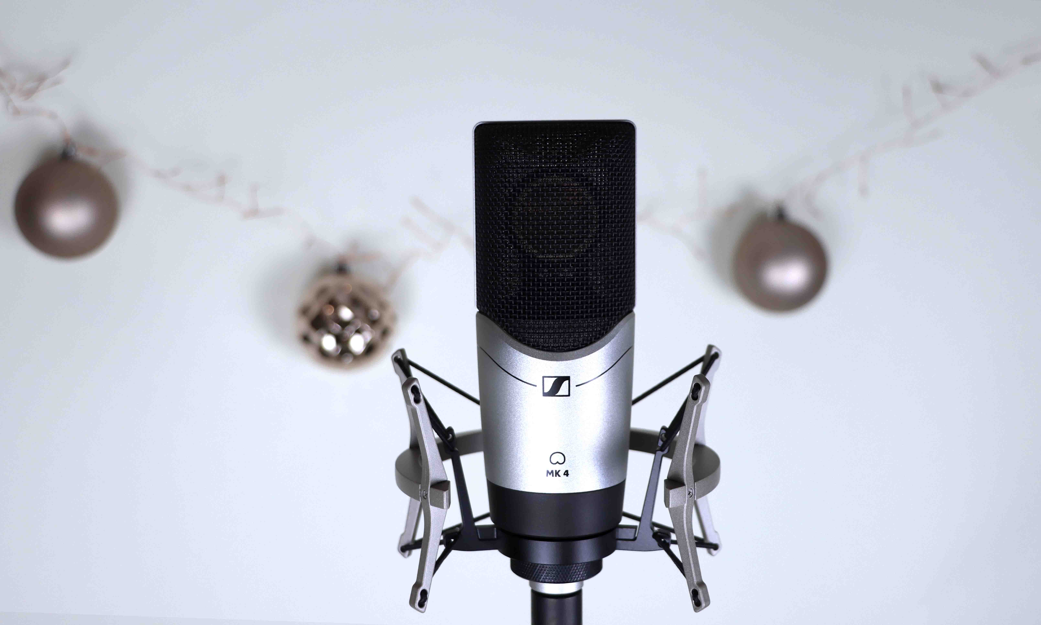  MK 4 pictured with optional MKS 4 shock-mount

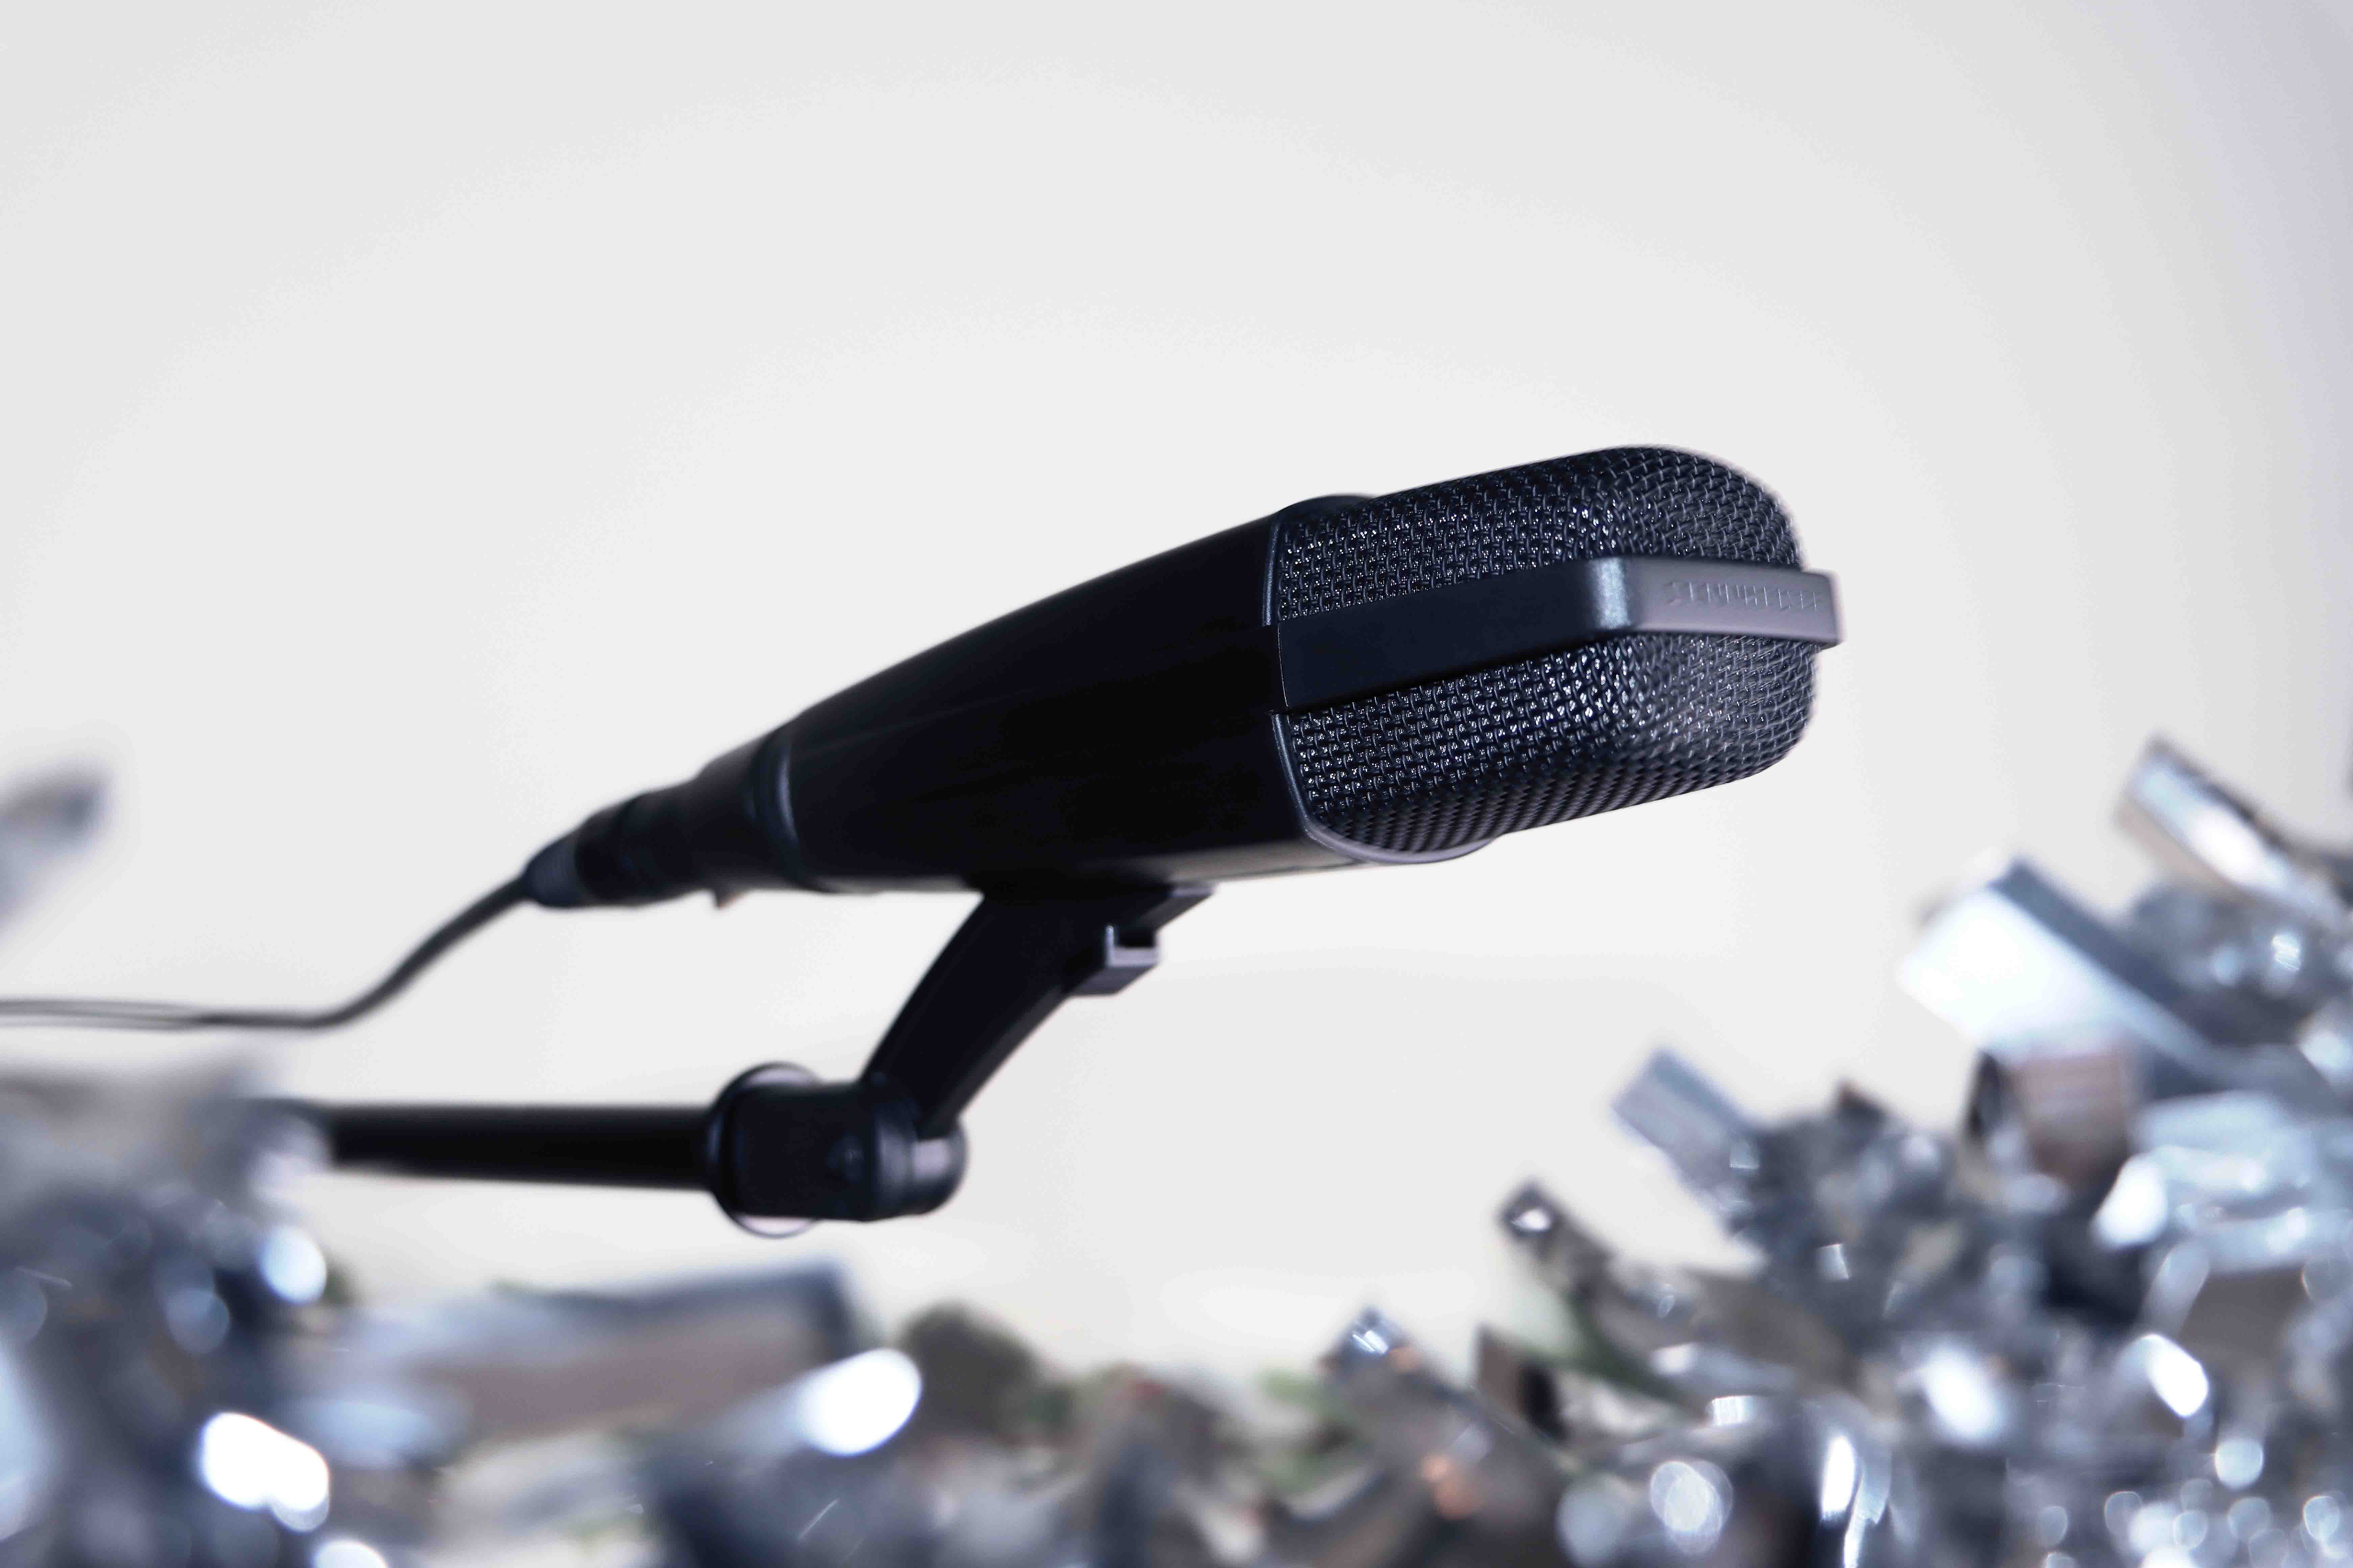 | MD 421-II  One of the best-known microphones in the world, the cardioid MD 421’s full-bodied sound and five-position bass control make it an excellent choice for most instruments, as well as group vocals and radio or television broadcasting.

HD 25  Great sound, super-rugged and lightweight! The iconic HD 25 is one of the most widely used headphones among professionals. It’s ideal for any professional monitoring environment. | 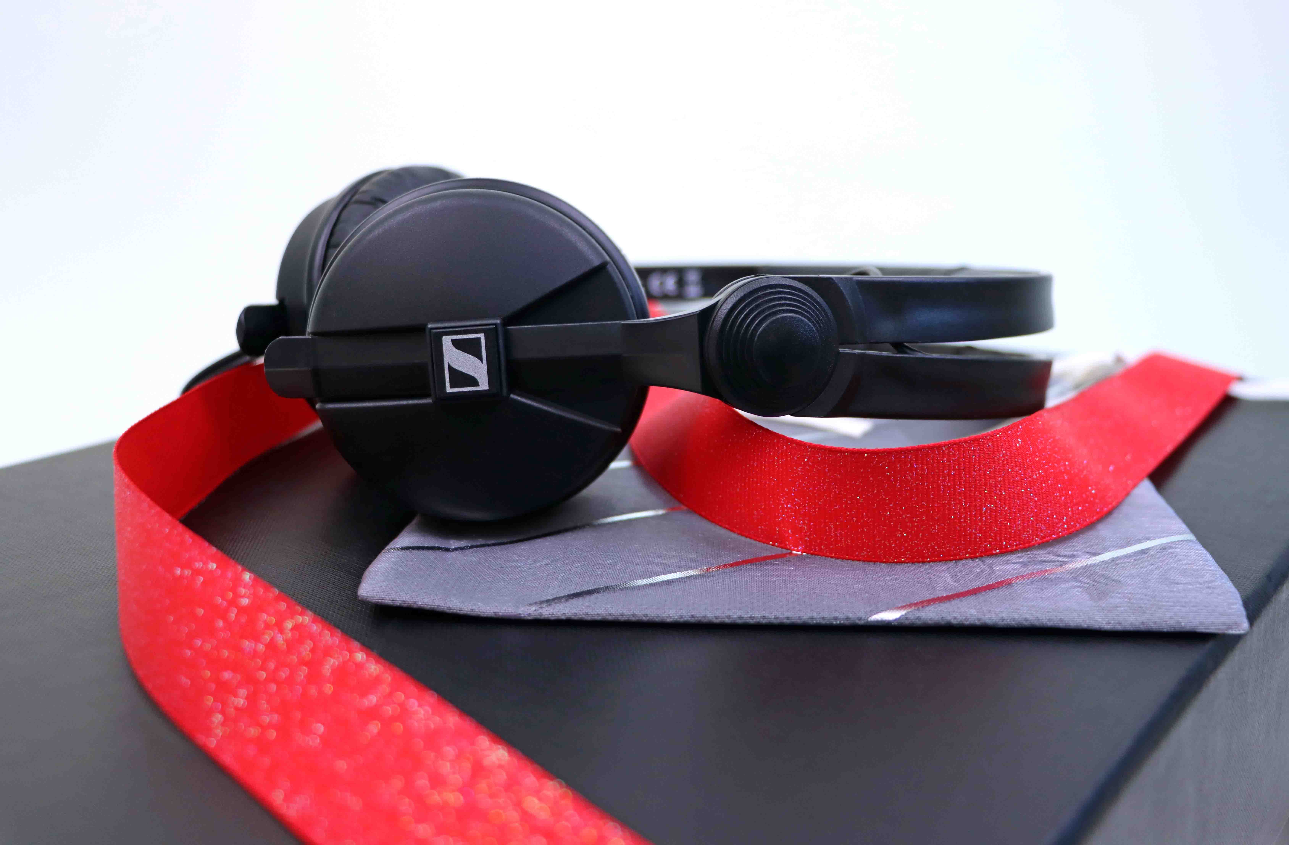

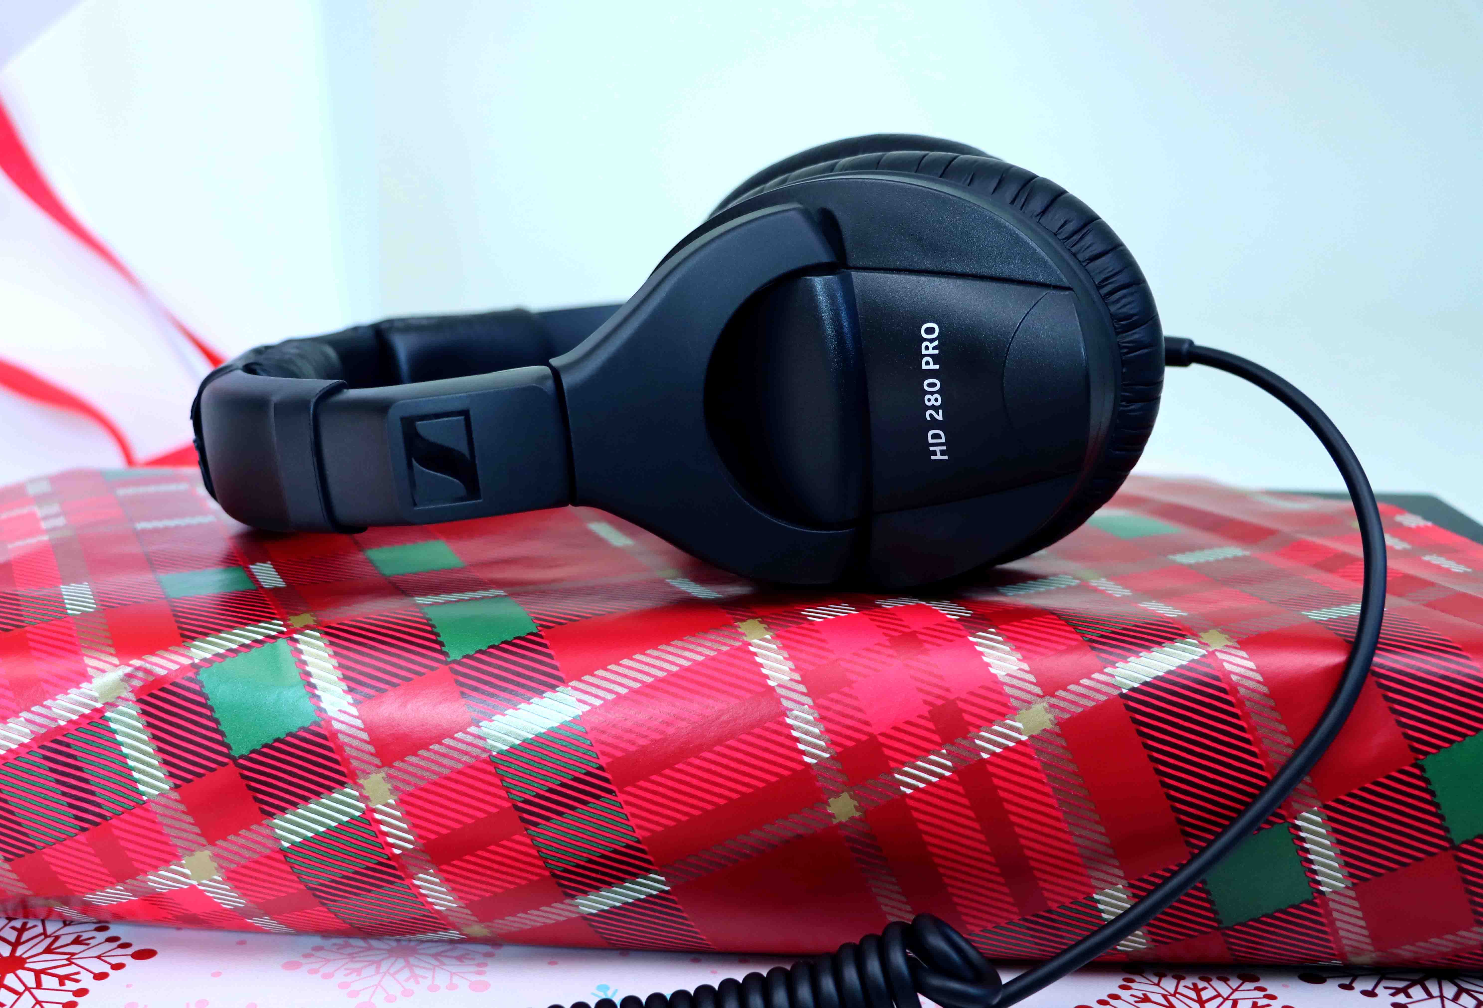 | HD 280 PRO  The HD 280 PRO monitoring headphones boast extremely robust construction combined with the sound quality, modular design, and excellent noise isolation you need in the field.

HD 300 PRO  Modelled on the precise sound reproduction of the legendary HD 250 Linear headphones, the HD 300 PRO delivers a neutral, high-resolution working sound, at the same level of precision you apply to your production. Its sound pattern remains delicate and accurate in every application. | 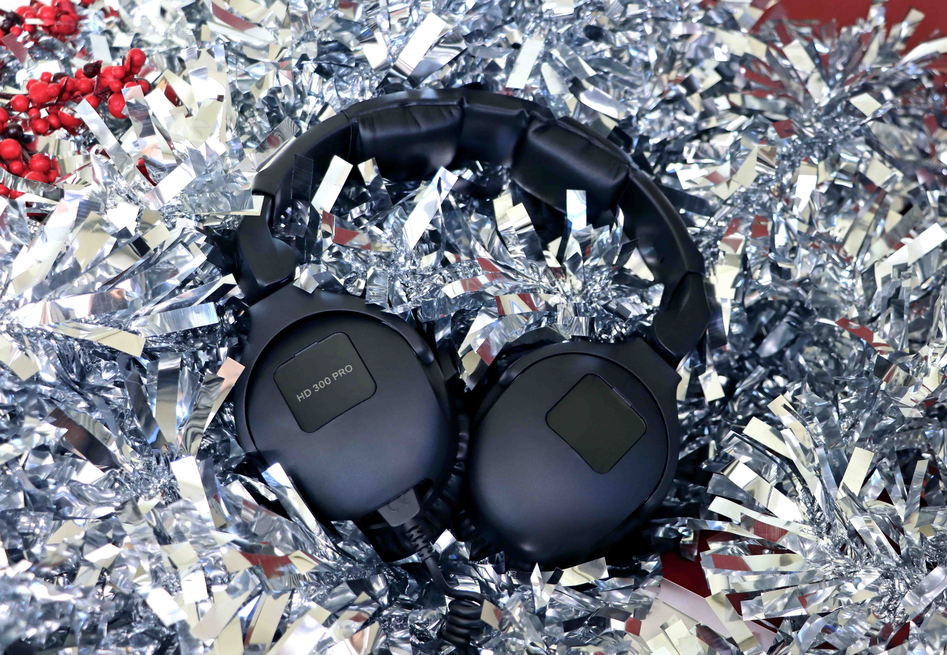

(Ends)

Pricing
MKE 200: EUR 99
MKE 400: EUR 199
MKE 440: EUR 349
MKE 600: EUR 299 (Please note our current A-Cam/B-Cam promo – more details can be found at sennheiser.com/mke-promo)
MKH 416: EUR 999
MK 4: EUR 299; MKS 4: EUR 99
MD 421-II: EUR 399
HD 25: EUR 149
HD 280 PRO: EUR 99
HD 300 PRO: EUR 199
All prices are MSRP incl. VAT.

The high-resolution images accompanying this media release can be downloaded here.
Holiday photography by Jaclyn Slimm.

About the Sennheiser brand
We live and breathe audio. We are driven by the passion to create audio solutions that make a difference. Building the future of audio and bringing remarkable sound experiences to our customers – this is what the Sennheiser brand has represented for more than 75 years. While professional audio solutions such as microphones, meeting solutions, streaming technologies and monitoring systems are part of the business of Sennheiser electronic GmbH & Co. KG, the business with consumer devices such as headphones, soundbars and speech-enhanced hearables is operated by Sonova Holding AG under the license of Sennheiser.

www.sennheiser.com
www.sennheiser-hearing.com

Global Pro Audio Press Contact

Stephanie Schmidt
Stephanie.schmidt@sennheiser.com
+49 (5130) 600 – 1275

