BJOOKS RELEASES UPDATED 2021 EDITION OF ‘PUSH TURN MOVE’, AN
INSPIRING EXPLORATION INTO ELECTRONIC MUSICAL INSTRUMENT DESIGN

Updated version features more than 30 new or updated instruments — including the Polyend Tracker, the new Haken Continuum models, Moog DFAM and Subharmonicon, Sensel Morph, Novation Launchpad X, and others.

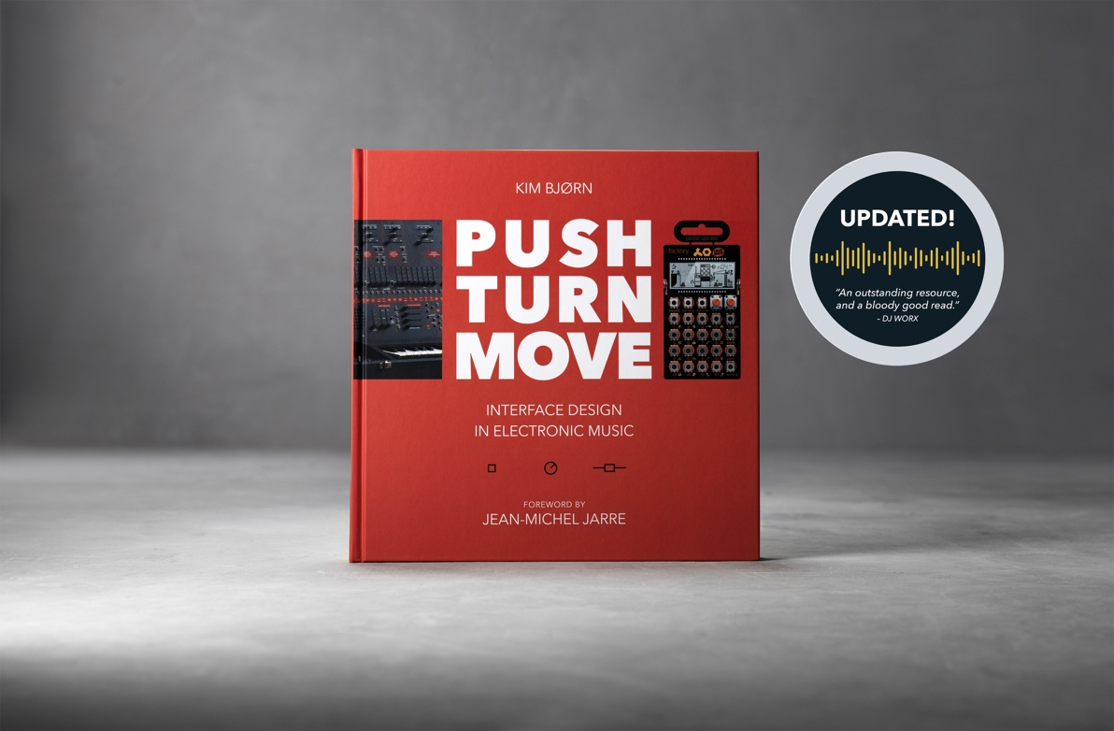

Copenhagen, DK, June 21st, 2021 – Bjooks, publisher of internationally renowned book titles including PATCH & TWEAK, PUSH TURN MOVE, PEDAL CRUSH, and PATCH & TWEAK with Moog, announces the 2021 updated edition of the book that started it all: PUSH TURN MOVE.

An exquisitely designed, photography-rich 352-page hardcover volume that inspires creativity, PUSH TURN MOVE forays into the fascinating world of electronic instrument design and application. The updated edition — a visual feast for both music creators and enthusiasts — features dozens of instruments, artist interviews, essays and descriptive diagrams and a Foreword by electronic music pioneer Jean-Michel Jarre.

Originally published in 2017, the first edition of PUSH TURN MOVE has already sold nearly 10,000 copies across more than 50 countries around the world. It has served as the ultimate reference for those looking to learn more about how electronic music is made, through the eyes of its creators, toolmakers, and innovators.

“PUSH TURN MOVE was the book that started it all for us, and it was truly a labor of love,” commented Kim Bjørn, CEO and Founder of Bjooks. “At the time it was released just four years ago, I had no idea that it would take on a life of its own, or that it would be read by so many electronic music fans around the world. Since its original release, there have been many new innovations in the electronic music industry, so I thought it was time for an update.”
The Book that Started it All
PUSH TURN MOVE — which set the foundation for future Bjooks titles including PATCH & TWEAK, PUSH TURN MOVE, PEDAL CRUSH and PATCH & TWEAK with Moog, focuses on the evolution of electronic musical instrument design. With stunning photography, illustrations, and descriptive text, the book highlights the intersection of electronic artists and the tools they use to create, such as Digital Audio Workstations (DAWs), sequencers, modular synthesizers, drum machines, gestural interfaces, and so much more.

PUSH TURN MOVE also explores the design principles and techniques behind electronic music instrument interfaces and controllers, while explaining how innovative manufacturers continue to solve the challenges of visualizing and controlling sound. In addition to covering the evolution of these tools, the book also explores the current state of the electronic musical instrument industry and where things might be headed in the future.

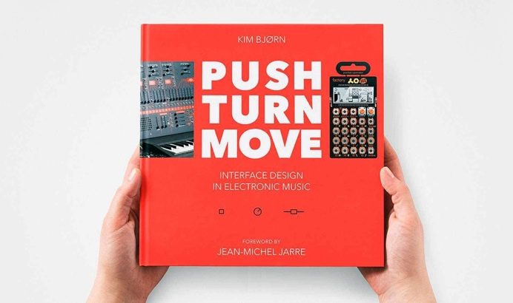 | PUSH TURN MOVE explores the different ways that electronic music instrument manufacturers have solved the challenges of visualizing, creating, and controlling sound.

Some of the updates to PUSH TURN MOVE for this new edition include:
- Stunning new print and paper quality
- An interview with the founder of Artiphon about the new Orba
- Many new products are covered, including:
- Novation Launchpad X
- Moog Music’s latest semi-modular instruments
- Ableton Live 11
- Make Noise Strega
- Mutable Instruments Beads
- Polyend Tracker
- KORG SQ-64
- Native Instruments MASCHINE+
- VCV Rack
- And many others.

Bjooks is an environmentally responsible publisher, and all of its books — including the latest version of PUSH TURN MOVE — are printed on high quality, environmentally friendly paper from responsible sources. For more information on PUSH TURN MOVE or any of the books in the Bjooks portfolio, or to purchase our titles, please visit http://www.bjooks.com.

About Bjooks
Bjooks is the boutique publishing company started and run by author, designer, and musician Kim Bjørn. His first book, PUSH TURN MOVE, was published in 2017. This was followed by PATCH & TWEAK in 2018, which has since been referred to as the 'Bible of Modular Synthesis; PEDAL CRUSH - Stompbox effects for creative music making" was released in 2019, and his most recent book is PATCH & TWEAK with Moog, released in 2020. The mission of Bjooks is to create even more exciting titles about music technology, artists, and makers to document, inspire and explore the world of music creation.

Press Contacts:
Katie Kailus
Hummingbird Media
katie@hummingbirdmedia.com
www.hummingbirdmedia.com

Jeff Touzeau
Hummingbird Media
jeff@hummingbirdmedia.com
www.hummingbirdmedia.com

