eneloop increases its support for environmental organisations
Panasonic helps preserve the environment with the European Photo Challenge

Zellik, 7 July 2016 - Panasonic Energy Europe announces the winners of the third eneloop European Photo Challenge. In addition to the winners’ prizes, Panasonic will be making two donations of €5000 to the environmental organisations linked to the winning photos. This highlights the importance that Panasonic places on sustainability, by not just offering superior environmentally friendly products with its rechargeable eneloop batteries, but also by providing financial support to organizations that share its green vision.

eneloop is Panasonic’s answer for a more environmentally friendly battery that promotes a sustainable lifestyle. The batteries are charged using solar energy and can be recharged up to 2100 times, not only making them more economical, but also helping to reduce the number of batteries that are sent to the world’s landfill sites.

In order to put power behind its sustainable vision, eneloop is supporting organisations that share this philosophy. To further underscore its commitment to the environment, Panasonic is making two contributions of €5000 to environmental organisations as part of the eneloop Photo Challenge – over the course of three editions. In addition the brand has sponsored, among others, the recent EEAwards in Belgium: an Energy and Environmental Award that honours the efforts made by more than 2000 people and organisations to further raise public awareness for the health of our planet.

Support for ecological photographers and environmental organisations
The eneloop European Photo Challenge asks (hobby) photographers from Europe to submit their best photos matching one of the environmental themes. The photographer who gets the most likes internationally for his/her photo wins first prize and ensures that €5000 will be contributed to the environmental organisation to which the photographer has linked the photo. In addition, the two most popular photographs per country will win a prize, and the environmental organisation that has the most linked photos will also win €5000. Check out the list of participating companies here. FYI: interested environmental organisations can still register.

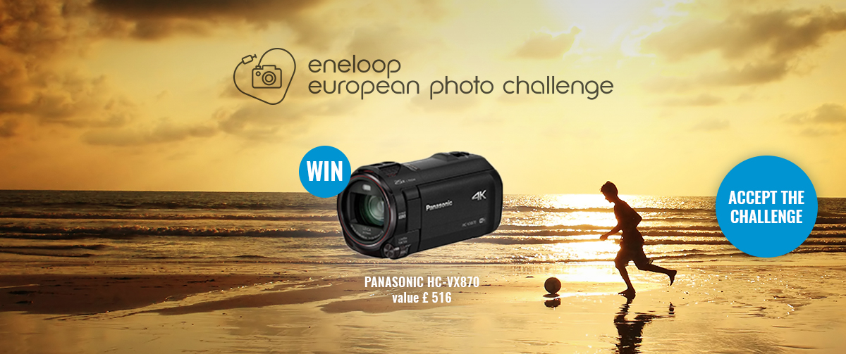

Winners of the SPRING edition and the launch of the SUMMER edition
The SPRING edition ran from 4 April to 30 June 2016 and the overall winner was Grzegorz Wojciechowski from Poland. He is now the proud owner of a fabulous Panasonic Lumix G.DMC-GM5 camera worth €700 and earns €5000 for Natuurpunt, his selected environmental organisation. WWF Belgium also wins €5000 because this organisation had the most photos linked to it in general. The theme of the next edition (from 4 July to 30 September 2016) is SUMMERTIME, with the objective of ‘capturing summer’s most beautiful colours’. The first prize is a Panasonic HC-VX870 video camera worth €680. In addition to this, the two most popular photographs per country will also receive great prizes, and two environmental organisations will also receive €5000 each. All the lucky winners will be announced on 30 September 2016.

Read more about the Photo Challenge here.
Check out the most popular photos to date and discover how you can participate too.

About Panasonic Energy Europe
Panasonic Energy Europe is headquartered in Zellik, near Brussels, Belgium. The company is part of the Panasonic Corporation, a leading global manufacturer of electronic and electrical goods. Panasonic’s vast and lengthy experience in the consumer electronics field has helped make Panasonic the largest battery manufacturer in Europe today. The European production facilities are located in Tessenderlo, Belgium, and Gniezno, Poland. Panasonic Energy Europe supplies ‘mobile’ energy solutions to more than 30 European countries. The company’s diverse product range includes rechargeable, chargers, zinc carbon, alkaline and specialty batteries (such as zinc air, photo lithium, lithium coin, micro alkaline, silver oxide).
For more information, visit: www.panasonic-batteries.com.

About Panasonic
The Panasonic Corporation is a leading company worldwide in the development and manufacture of electronic goods for a wide range of private, trade and industrial uses. Panasonic, based in Osaka, Japan, in financial year ended 31 March 2015 posted consolidated net sales of around 57.28 billion EUR. Panasonic is committed to creating a better life and a better world, continuously contributing to the evolution of society and to the happiness of people around the globe.
More information about the company and the Panasonic brand name at www.panasonic.net.

PRESS CONTACT

ARK Communication
Ann-Sophie Cardoen
Content & PR Consultant
T +32 3 780 96 96
ann-sophie@ark.be
www.ark.be

Panasonic Energy Europe NV
Vicky Raman
Brand Marketing Manager
T +32 2 467 84 35
vicky.raman@eu.panasonic.com
www.panasonic-batteries.com
www.panasonic-eneloop.com

