**Neumann.Berlin and Sennheiser Champion Talent at the 2025 Music Producer and Engineers’ Guild Awards**

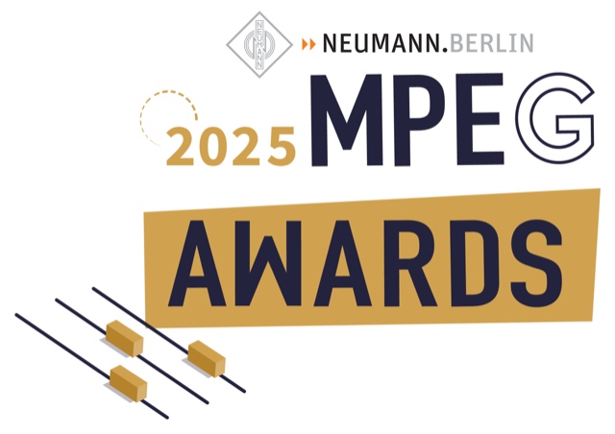

**The Music Producer and Engineers’ Guild (MPEG) Awards once again celebrated the producers, engineers, and creatives behind Australia’s most exciting music. As long-time supporters of the audio production community, Neumann.Berlin and Sennheiser proudly sponsored the Producer of the Year and Breakthrough Producer awards, some of the most prestigious awards in the field, while ensuring an unforgettable night of world-class sound.**

***Sydney, Australia, March XX, 2025* –** Neumann and Sennheiser proudly continued their commitment to the audio production community as sponsors of the MPEG Awards on 26th February at the Aerial, Ultimo in Sydney. The brands’ support reinforces a shared mission to foster creativity, innovation, and the future of music production.

At this year’s event, Neumann sponsored the prestigious Producer of the Year award, recognising outstanding talent making waves in the field. The honour went to Chris Collins, an artist and producer whose journey began as a teenager playing in bands before evolving into a highly respected solo artist and producer, known for his work with Royel Otis, Matt Corby, The Buoys and more.

"Excited to get this MPEG Producer of the Year award,” Collins said when accepting the award. “This means a lot – growing up playing in bands, I had the chance to work with some great Australian producers who really influenced me. To now be in the same pool is something really special. Huge thanks to Neumann for supporting the award, the Producers Guild for celebrating and backing all the incredible production coming out of Australia, and to all the artists I get to work with. I feel very lucky.”

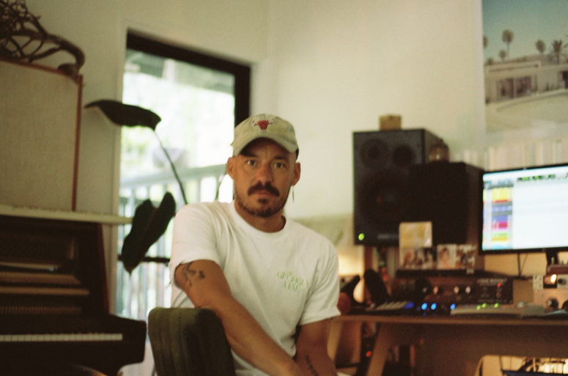Chris Collins at his home studio

Meanwhile, Tasker was recognised as Breakthrough Producer of the Year, sponsored by Sennheiser, celebrating his innovative approach and rising influence in the industry through his work with the likes of 3% and Rum Jungle. “I feel very privileged because there is a lot of great producers that are up and coming – it means a lot to be voted by peers,” Tasker says. “I have become close friends with a lot of the people I work with. Some start out as friends, and they all become family. We push ourselves to become better artists, better creatives, better people, and try to spread the love.”

In recognition of technical excellence, long-time Neumann user [Lachlan Carrick](https://en-au.neumann.com/newsroom/melbourne-studio-features-state-of-the-art-dolby-atmos-set-up-starring-neumann-studio-monitors) was named Mastering Engineer of the Year, highlighting his contributions to shaping the final sound of countless records. Another Neumann collaborator, Stefan Du Randt, took home the award for Mixing Engineer of the Year for his second year in a row.

**Amplifying the Awards with Industry-Leading Audio Solutions**

Beyond their sponsorship, Neumann and Sennheiser ensured the ceremony sounded as outstanding as the talent it celebrated. The night featured stunning live sets from Chelsea Warner and Boy Soda, as well as Michael Carpenter and Paul Hakim, all performing through Sennheiser microphones and Neumann monitors, showcasing the clarity and excellence the brands are known for.

“We're overjoyed to be part of this cohort and to see it grow over the last two years, is phenomenal,” says Chris Smith, Sales Director for Pro Audio at Sennheiser. “For Neumann to be embedded as part of this talented group's own workflows is exactly where Neumann lives and breathes, too.”

**A Commitment to the Future of Music Production**

As leaders in pro audio, Neumann and Sennheiser continue to inspire and elevate the next generation of music producers. Through innovation and sponsorships like the MPEG Awards, they remain at the heart of the global music production community, empowering producers, engineers, and artists at every stage of their careers.

MPEG shares this vision, working to build a thriving, sustainable industry where both established professionals and emerging talent are supported. With a focus on mentorship, collaboration, and innovation, MPEG aims to create a diverse and vibrant community that nurtures career growth and creativity, helping producers and engineers build long-term, fulfilling careers in music.

“I was so incredibly thrilled to see the breadth of talent that was nominated for these awards. Apart from classical, every contemporary genre has been represented ... and truly showcases the production community,” MPEG’s Executive Director Kurt Luthy said on the night of the awards. “In the last 12 months we’ve done so much representation work for producers and engineers that this year it feels more like a collective celebration,” MPEG’s Founding Director Anna Laverty added.

Neumann and Sennheiser congratulate all of this year’s winners, whose work continues to push the boundaries of music production.

For more information on the MPEG Awards, visit [here](https://mpeg.org.au/).

**About Neumann**  
Georg Neumann GmbH, known as “Neumann.Berlin”, is one of the world’s leading manufacturers of studio-grade audio equipment and the creator of recording microphone legends such as the U 47, M 49, U 67 and U 87. Founded in 1928, the company has been recognized with numerous international awards for its technological innovations. Since 2010, Neumann.Berlin has expanded its expertise in electro-acoustic transducer design to also include the studio monitor market, mainly targeting TV and radio broadcasting, recording, and audio production. The first Neumann studio headphones were introduced in 2019, and since 2022, the company has put an increased focus on reference solutions for live audio. Georg Neumann GmbH has been part of the Sennheiser Group since 1991, and is represented worldwide by the Sennheiser network of subsidiaries and long-standing trading partners. www.neumann.com.

**Local Press Contacts**

Daniella Kohan Hotwire Australia

[daniella.kohan@sennheiser.com](mailto:daniella.kohan@sennheiser.com) sennheiseranz@hotwireglobal.com

+1 (860) 227-2235

Kirsten Spruch

[kirsten.spruch@sennheiser.com](mailto:kirsten.spruch@sennheiser.com)

+1 (860) 598-7484