RME Debuts Newly Designed DigiCheck NG, Professional Audio Metering & Analyzing Software
The new preview version is completely rewritten from the former DigiCheck
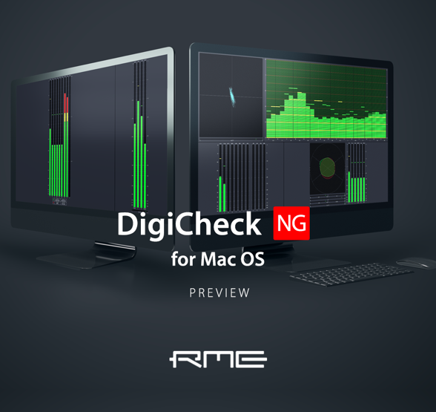
Fort Lauderdale, FL – May 21, 2020 – RME, German manufacturer of premium digital audio solutions, has launched the preview version of its DigiCheck NG professional audio metering and analyzing software for Mac OS with 64-bit support. This preview version is a completely rewritten and newly designed version of the company’s former DigiCheck.
DigiCheck NG is free and is compatible with Mac OS, up to Catalina. Dark Mode is also supported, and a Windows version will be released soon.
“The new preview version of DigiCheck NG is not an updated version of the previous DigiCheck; instead it has been fully rewritten and freshly designed from the ground up,” said Derek Badala, Director of Sales Americas Synthax, distributor of RME. “It’s compatible with all RME interfaces and users will receive the same measurement functions as before with newly added benefits, including full scalability with all modules.”
In addition to being fully scalable, DigiCheck NG allows the main windows to include up to four metering modules with freely adjustable sizes. It can open several main windows at the same time. Any configuration can be stored and recalled as Workspace.
New & Improved
DigiCheck NG is user intuitive with a simple right click providing all options for every module.
The settings of each measurement module are similar to the previous version of DigiCheck and include new extensions, such as Phosphorescence in the Analyzer module. The appearance is also set individually for every instrument and the input selection dialog has extended mouse support and additional buttons for easy setup of multichannel interfaces.
DigiCheck NG is now available as a preview version. Links to the latest and updated preview version can be found on RME USA’s Facebook and Instagram pages here:
https://www.facebook.com/RMEAudioUSA/
https://www.instagram.com/rme_audiousa/

For more info on RME, visit rme-usa.com.
About Synthax, Incorporated
Synthax Inc. is the exclusive USA distributor for RME digital audio solutions, Digigram broadcast audio systems, Appsys digital audio tools, Ferrofish advanced audio applications, myMix personal monitoring systems and ALVA cableware. We supply a nationwide network of dealers with these products for professional audio, broadcast, music industry, commercial audio, theater, military and government applications. For additional information, visit the company online at http://www.synthax.com.

Media Contacts:
Jeff Touzeau
Public Relations
Hummingbird Media
+1 (914) 602 2913
jeff@hummingbirdmedia.com

Katie Kailus
Public Relations
Hummingbird Media
+1 (630) 319-5226
katie@hummingbirdmedia.com

