Give the gift of superior sound this Valentine's Day
For the love of sound - Sennheiser’s Valentine’s Day Gift Guide

Marlow, UK, 26 January, 2022 – As the most romantic day of the year approaches, loved ones can show each other how much they care by giving the gift of sweet sound. For partners who want a more unique gift than roses and chocolates, their Valentine is sure to be swept off their feet with incredible headphones and the perfect symphony of love songs.

With styles to match every lover, Sennheiser has headphones to remind lucky recipients of their partner's love year-round. More than just a celebration for lovestruck couples - Valentine's Day is the perfect excuse to practice self-care and indulge your ears by listening to your favourite tracks.

For the love of me time - CX Plus True Wireless (£129 / €159.90)
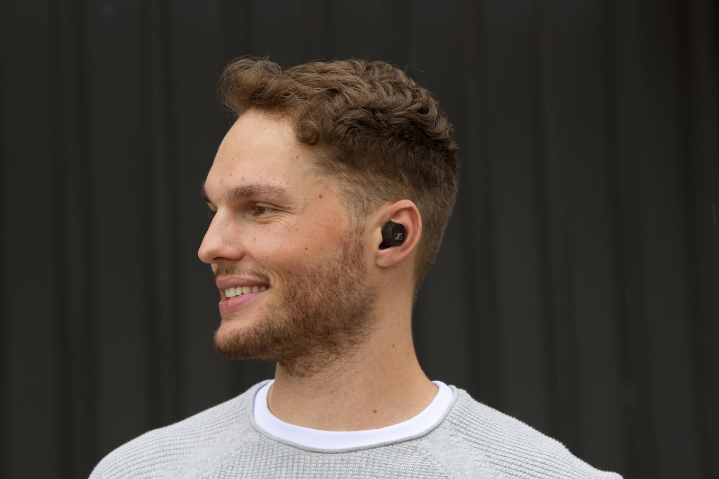
- Active Noise Cancellation for undisturbed listening pleasure
- The bespoke TrueResponse transducer delivers crystal-clear sound
- Personalised sound thanks to Bass Boost and the Built-In Equaliser
- 9-hour battery life (+18 hours with the case)
- Available in black or white from Sennheiser, John Lewis, Amazon, Richer Sounds, Harvey Norman and Arnotts

Fall in love at first sight with the HD 800 S headphones (on sale)

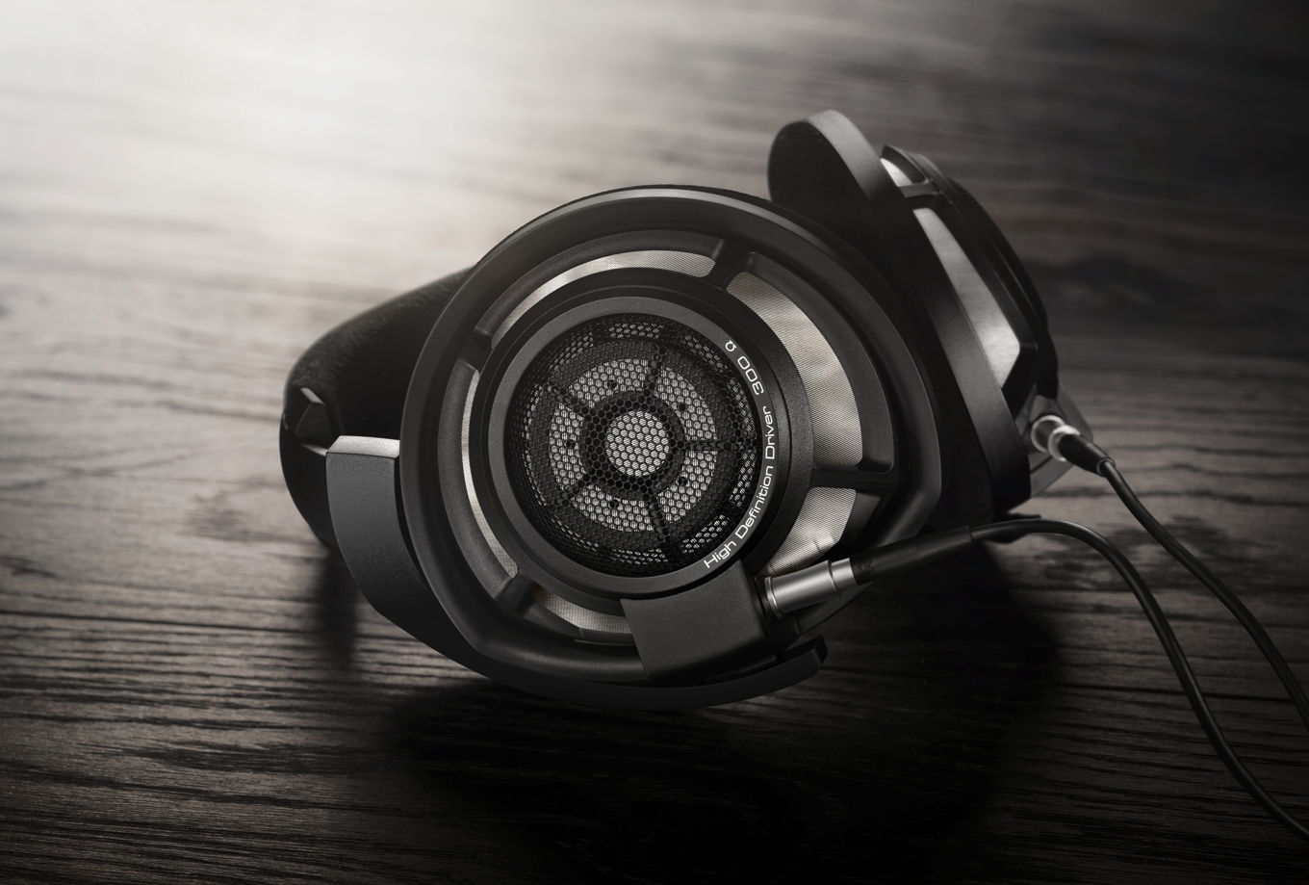
- Mesmerising soundstage for the audiophile in your life
- 56mm Ring Radiator dynamic transducer for incredible sound performance
- Long-term, luxurious wearing experience
- Ultra-ergonomic adjustable metal headband for comfortable listening
- Available in matte black from Sennheiser

Never miss a (heart)beat with the HD 450BT (£159 / €179)

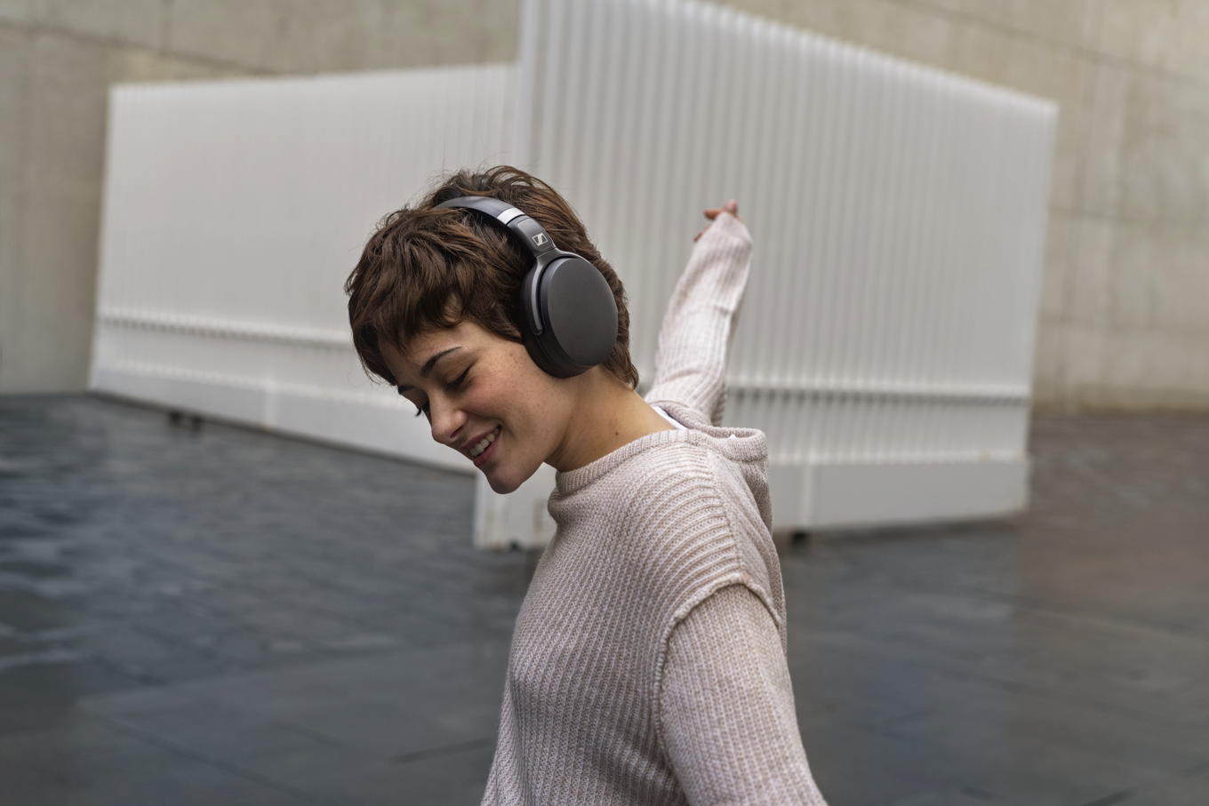
- Great audio experience with deep dynamic bass and Active Noise Cancellation
- Premium around-ear design with wireless freedom
- 30-hour battery life
- Optimum noise isolation to guarantee undisturbed listening
- Available to purchase in black and white from Sennheiser and Amazon

ABOUT SENNHEISER
Shaping the future of audio and creating unique sound experiences for customers – this aim
unites Sennheiser employees and partners worldwide. The independent family company,
which is managed in the third generation by Dr. Andreas Sennheiser and Daniel Sennheiser, is
today one of the world’s leading manufacturers of headphones, loudspeakers, microphones
and wireless transmission systems. In 2020, the Sennheiser Group generated turnover totaling
€573.5 million. www.sennheiser.com

Local Press Contact
Sennheiser electronic GmbH & Co. KG
Milan Schlegel
PR and Influencer Manager EMEA
T +49 (0) 5130 9490119
milan.schlegel@sennheiser-ce.com

Emily Ackland
Harvard
T +44 7393 758442
emily.ackland@harvard.co.uk

