MEDIA ALERT: Xytech to Host MediaPulse Transmission Webinar Targeted for Broadcasters
The January 29th webinar will showcase how the best-in-class operational platform solves transmission issues

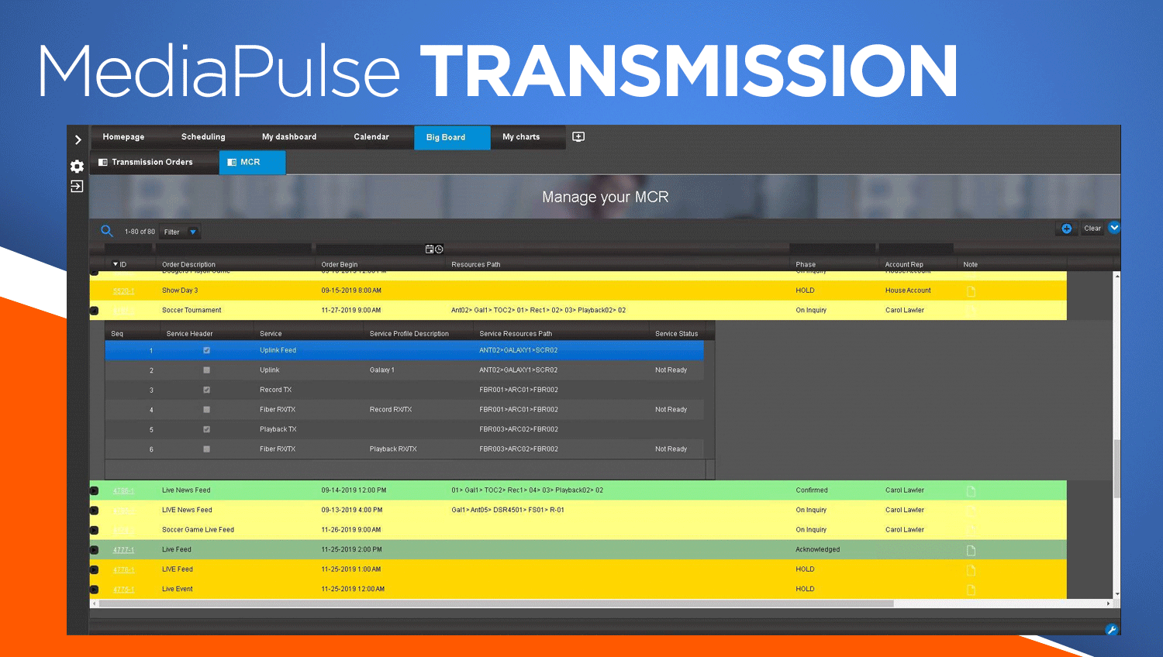
Los Angeles, January 22, 2020 — Xytech, the leader in facility management software for the broadcast and media industries, is highlighting its MediaPulse Transmission during a webinar titled, “MediaPulse Transmission Management,” with Greg Dolan and Sales Engineer Darrel Gardner on Jan. 29, 2020 at 1 p.m. ET/10 a.m. PT.

The webinar will demonstrate how Xytech’s transmission solution delivers complete video circuit management, comprehensive operational dashboards and financial tools optimized for use in any broadcasting operation. To register, visit: https://xytechsystems.zoom.us/webinar/register/3615786060980/WN_bBo85BbxThy01bfcDYdhjQ

“Video transmission and signal management is a dynamically changing environment ,” said Dolan, Xytech’s COO. “MediaPulse now has a series of tools able to automate order onboarding, signal provisioning, status inquiry and service levels with an easy interface to any production platform.”

“MediaPulse allocates out the resources and transmits technical parameters to all relevant subsystems provisioning a circuit, tearing a circuit down and monitoring the circuit’s health,” Dolan continued. “Additionally, we offer tools to handle the federation of transmission orders, so an order created in one MediaPulse system can automatically create orders in other MediaPulse systems, establishing a constantly updated relationship between the two parts.”

These tools are available in both Xytech’s web and mobile clients and work on any browser on any device. This webinar is a perfect fit for anyone interested in solving transmission issues.

To register, for the Jan. 29th webinar, please visit: https://xytechsystems.zoom.us/webinar/register/3615786060980/WN_bBo85BbxThy01bfcDYdhjQ

About Xytech
For more than 30 years, the world’s premiere media companies have depended on Xytech to run their businesses. MediaPulse is the only end-to-end solution for the complete content lifecycle. MediaPulse provides scheduling, automation, asset management, billing and cost recovery for broadcasters, media services companies and transmission facilities in a scalable platform-independent solution. For more information, visit xytechsystems.com.

Media Contacts:

Katie Kailus
Public Relations
Hummingbird Media
+1 (630) 319-5226
katie@hummingbirdmedia.com

Alexis Lipoff
Public Relations - EMEA
Hummingbird Media
alexis@hummingbirdmedia.com

Jeff Touzeau
Public Relations
Hummingbird Media
+1 (914) 602 2913
jeff@hummingbirdmedia.com

