For immediate distribution

Bainz Employs Flock Audio’s PATCH System on Young Thug’s Latest Album ‘Punk’
The digital patchbay system streamlined the chief recording engineer’s workflow, including on Billboard Hot 100 hits like ‘Bubbly’

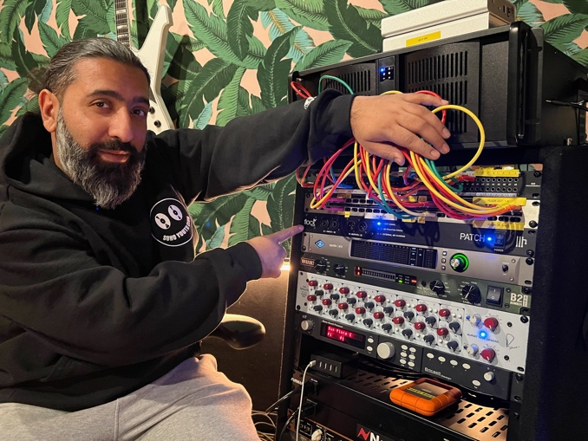
LOS ANGELES — December XX, 2021 — As chief recording engineer for rapper Young Thug and his record label YSL Records, Angad ‘Bainz’ Bains is working on many different projects for many different artists at any given time. While mixing and recording high-profile projects, including Young Thug’s latest album, “Punk,” released in October, Bainz required a patching solution that allowed him to seamlessly move between different pieces of outboard gear without having to make constant trips to the patchbay. Employing Flock Audio’s digitally controlled patchbay routing solution, the PATCH System, a year and a half ago did just this.
“I started using the PATCH System in April 2020, and I’ve found it to be really intuitive,” he said. “What I really like is the ability to swap things around. I have a couple of different EQs and compressors. I used to have to choose what I want, but now I can ‘AB’ what I want really quickly. This way, I have the best of both worlds. Once I’m done with the way I like it, I’ll commit it.”
Bainz said a preset in the PATCH System labeled ‘Default’ saves all his favorite samples, streamlining the entire recording process. “Everything is ready to go right off the bat,” he explained.
Bye-Bye Bad Cables
Bainz has employed the PATCH System on some of Young Thug’s biggest hits over the last year, including the “Silme & B” mixtape collaboration between Young Thug and rapper Chris Brown, as well as their hit “Go Crazy” off the album. Bainz’s recording process always includes running Young Thug’s vocals through an analog chain and back out through the PATCH System.
“When we record, we record really quickly,” he said. “I like to do a lot of cleaning up in the box and get a lot of volume. That’s where the PATCH comes into play.”
The PATCH is also handy when Bainz switches to a project featuring one of YSL Records’ other artists.
“I can have a bunch of settings saved for different stuff,” he explained. “The PATCH allows me to call that up really quickly and keep the recording process moving along smoothly.”
Bainz describes his workflow as a hybrid where “everything is consistently going out of the box and then coming back in.”
“I commit as I go, but it’s cool to be able to swap things in and out,” he said. “Everything doesn’t work on every mix. With the PATCH System, I have the freedom to go back and forth and add things and take things out. Bottom line: It makes everything sound good.”
Bainz added that removing the issue of bad patch cables by using the Flock system has also been key to improving his workflow.
“Bad cables are always a big issue,” he said. “You always have to go with a high-quality, top-level type of cable because it’s all about the speed. If, for instance, I’m going along and maybe a specific compressor doesn’t work, I have to change to another. In the past, that would have meant a lot of patching in and out. And during that you lose your creativity in the process. But with the PATCH System, I can drag stuff up and down and use it like you would inserts in Pro Tools. That’s been huge.”
More Patching Ahead
YSL Records’ home base studio is currently under expansion in Los Angeles, and Bainz said the label has purchased six PATCH Systems for the new space.
“It’ll be great to have one in each studio,” he said. “It’ll continue to streamline the recording process, and I can’t wait to have the PATCH XL in my personal mix room.”
For more on the PATCH System, visit: http://www.flockaudio.com.
About Flock Audio
Flock Audio Inc. is a pro-audio manufacturer based in Kelowna, British Columbia, Canada, founded in 2017. The company is best known for its PATCH System Series, which is a Digitally controlled, 100% Analog Patch bay routing solution for professional audio environments. For more information on Flock Audio and its products, please visit the company website at http://www.flockaudio.com.

Media Contact
Jeff Touzeau
Public Relations
Hummingbird Media
+1 (914) 602 2913
jeff@hummingbirdmedia.com

