Longines Spirit Zulu Time

REFERENCE NUMBERS

L3.802.4.53.2/6

L3.802.4.63.2/6

L3.802.4.93.2/6

CALIBRE

Longines exclusive self-winding movement, L844.4, COSC certified

With silicon balance-spring and magnetic resistant

11½ lines, 21 jewels, 25'200 vibrations per hours

Power reserve of approximately 72 hours

FUNCTIONS

Hours, minutes, seconds and date aperture at 6 o’clock

24 hours hand with time zone mechanism

CASE

∅ 39 mm, 13,50 mm thickness

Lug-to-lug: 21mm

Round, stainless steel

Sapphire domed glass with multi-layered anti-reflective coating on both sides

Screw in crown

Case back with 6 screws

Bidirectional rotating bezel with black, green or blue ceramic insert

Engraved 24-hour scale with lacquered numbers and Super-LumiNova® triangle

DIALS

Black matt, applied Arabic numerals, Super-LumiNova®

Anthracite sandblasted, applied Arabic numerals, Super-LumiNova®

Sunray blue, applied Arabic numerals, Super-LumiNova®

HANDS

Silvered polished, Super-LumiNova®

Gilt polished, Super-LumiNova®

GMT hand: black and blue, black and gilt polished or black and orange

WATER-RESISTANCE

To 10 bar (100 meters)

BRACELET/STRAP

Brown or blue leather strap with folding buckle and micro adjustment

system, with interchangeable system

Stainless steel bracelet with double safety folding clasp and

push-piece opening mechanism, with interchangeable system

*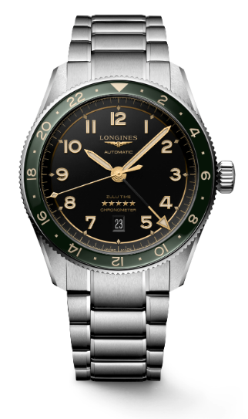*

*L3.802.4.63.6*