For immediate distribution

Sonarworks Receives TEC Award Nomination for Reference 4.3
Riga, Latvia, July 23, 2019 – European audio software developers Sonarworks have announced that their best-in-class audio calibration solution Reference 4.3 has been nominated for the 35th annual Technical Excellence & Creativity (TEC) Awards in the category of Signal Processing Software (Dynamics/EQ/Utilities). Presented by the NAMM Foundation, the TEC Awards are presented annually in celebration of the pro audio community by recognizing the individuals, companies, and technical innovations behind today’s sound recordings, live performances, films, television, video games, and other media.

Following a call for entries across many different categories, a panel comprised of leaders in audio and production carefully evaluated each entry before selecting Reference 4.3. Nominees were announced at Summer NAMM, and winners will be announced during an awards ceremony at the NAMM Show on January 18, 2020.

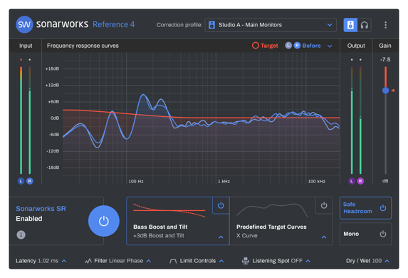
Reference 4.3 digitally calibrates studio monitors and headphones to a consistent flat-frequency Studio Reference (SR) standard, enabling audio engineers and music creators to make more streamlined and confident mixing decisions knowing that they can trust what they are hearing and that their mixes will translate on any device. It has been embraced by well-known mix engineers like Rik Simpson, Mark Needham, and MarioSo DeJesus, and is currently used in over 40,000 studios worldwide.

Reference 4.3 was released earlier this year and included a complete revamp of Reference’s systemwide mode as well as tweaks to its interface for ease of use and a quicker setup time. Sonarworks also added a new mixed filter mode as well as support for several dozen new models of headphones.

For more information about Sonarworks Reference 4, please visit www.sonarworks.com/reference.
About Sonarworks
Sonarworks began in 2012 when two music lovers met a scientist — a perfect storm of acoustic know-how and passion for good sound soon became the software that's currently transforming sound monitoring. Sonarworks’ flagship professional audio product, Reference 4 software, removes unwanted coloration and delivers the same accurate studio reference sound on all speakers and headphones. The software has since been endorsed by many Grammy-award winning mixing and mastering engineers and has won several industry awards and accolades.

Media Contact:
Steve Bailey
Hummingbird Media, Inc.
+1 (508) 596-9321
steve@hummingbirdmedia.com

Jeff Touzeau
Hummingbird Media, Inc.
+1 (914) 602-2913
jeff@hummingbirdmedia.com

