Attachment 5
Partners
Bruce Nauman’s Diamond Shaped Room with Yellow Light was acquired with the support of:
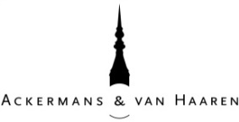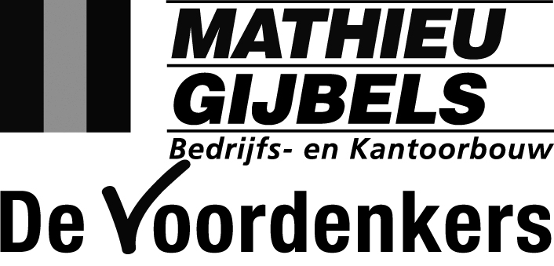

And the Middelheim Promotors
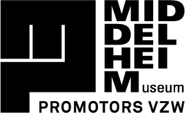
Ackermans & van Haaren, Argo Law, Art Secure by Vanbreda Risk & Benefits, BASF, BNP Paribas Fortis, CMB, Cordeel, Delen Private Bank, Deloitte, Deme, EY, Grant Thornton, Hubo, Hugo Ceusters, inno.com, KBC, Laurius, Leasinvest Real Estate, Pamica, SipWell, Soudal, Havenbedrijf Antwerpen.
Dennis Tyfus’ De Nor was realized with the support of FVWW Architecten.
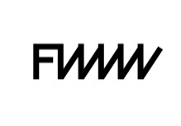
The exhibition Experience Traps was made possible with the support of water-link.
Media partners Subsidizing governments
