Your entryway into a new level of spatial perception
Dear Reality releases new EXOVERB MICRO reverb plugin

Düsseldorf, 28 March 2023 – Elevate your stereo mix with EXOVERB MICRO, Dear Reality’s latest realistic and spacious reverb plugin for stereo production. The compact audio plugin packs a punch, powered by the same proprietary reverb engine as its bigger brother, EXOVERB. Choose from eight expertly hand-crafted acoustic scenes for a truly authentic sound, empowering any modern audio production. Streamline your mixing process with the intuitive triangle pad to perfectly balance late reverberation, early reflections, and dry signals.

EXOVERB MICRO provides the perfect entryway into spacious reverb, offering a selection of EXOVERB’s eight most-loved acoustic presets from four categories: Ambiences, Rooms, Halls, and Plates. Each acoustic scene is based on multiple synthesized impulse responses (IRs) developed with Dear Reality’s proprietary software, allowing you to create rich reverb effects that perfectly match the needs of your mix. Whether you’re looking for a subtle drum room or a deep plate for vocals, EXOVERB MICRO has got you covered.

“With EXOVERB MICRO, we want to enable everyone to benefit from the latest reverb technology,” explains Felix Lau, Product Owner at Dear Reality, adding that “EXOVERB MICRO’s easy-to-use interface with the triangle pad offers a perfect starting point for modern music and postproduction.” The results are natural reverbs with three-dimensional depth perception on all stereo playback systems – both speakers and headphones.

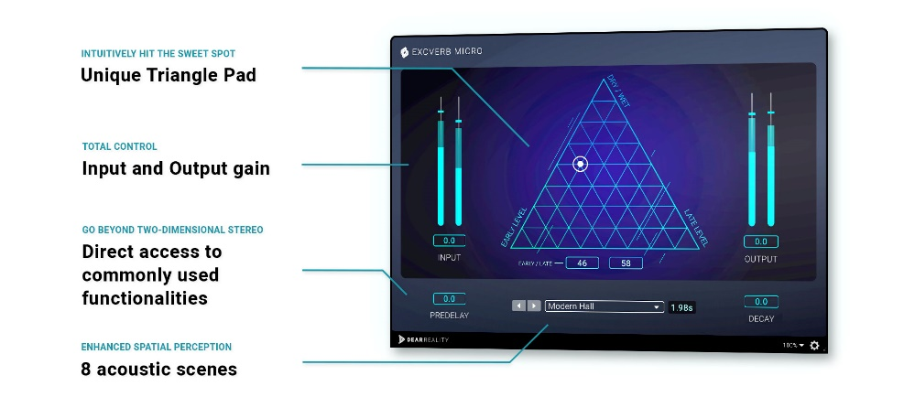 | The EXOVERB MICRO user interface

EXOVERB MICRO features a user-friendly interface that makes adding just the right amount of reverb to any mix as easy as you can imagine. Using the triangle pad, you can simply balance early reflections, late reverberation, and dry signals to create the perfect sound. And like its big brother, EXOVERB MICRO provides instant access to essential parameters like Pre-Delay and Decay without complicated menus or sub-menus. With EXOVERB MICRO, you’ll get all the power and versatility of a professional reverb tool in a compact, easy-to-use plugin.

Speeds up the creative mixing process: EXOVERB MICRO’s innovative triangle pad lets you intuitively hit the sweet spot | 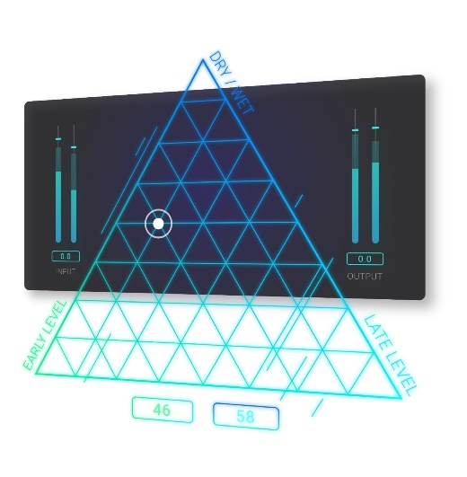

EXOVERB MICRO is available now in the Dear Reality store for EUR/USD 25 (+ local VAT).

(Ends)

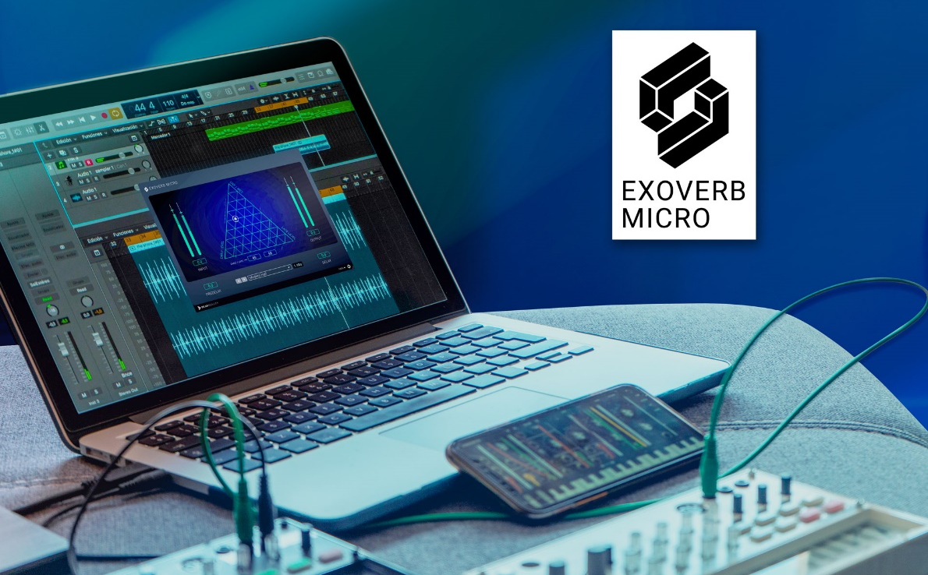

The images accompanying this press release can be downloaded here.

About Dear Reality
Dear Reality is a leading company in the field of immersive audio controllers, best known for its binaural, Ambisonics, and multi-channel encoders with totally realistic room virtualization. The company's products are used worldwide by sound engineers, sound designers, broadcasters, and musicians. Founded in 2014 by Achim Fell and Christian Sander, Dear Reality strives to deliver high-quality, cutting-edge 3D audio software for interactive and linear audio production. Since 2019, Dear Reality has been proud to be a part of the Sennheiser Group.

Local Press Contact Global Press Contact
Kai Detlefsen
press@dear-reality.com

