RME Unveils ADI-2 DAC Interface, TotalMix Remote Software at NAMM 2018
— High -quality two-channel interface delivers mastering-grade conversion —
— TotalMix Remote software enables controlling RME interfaces via tablet or remote computer —

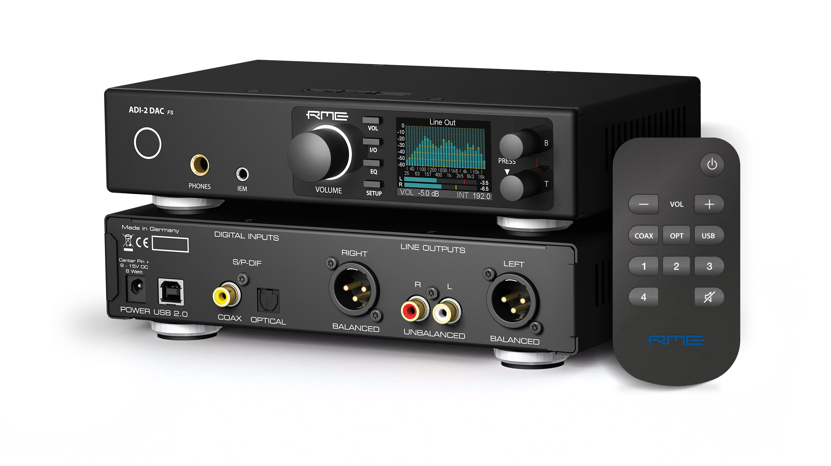
Anaheim, CA – January 23, 2018 – RME Audio, [Booth 14701, Anaheim Convention Center North], German manufacturer of digital audio solutions for the professional and HiFi sector, has announced that it will showcase its ADI-2 DAC converter and its new TotalMix Remote software at the 2018 NAMM Show. The ADI-2 DAC is a compact two-channel high-end digital/analog converter featuring outstanding audio quality designed to meet the needs of studio professionals and audiophiles alike.
Additionally, RME will also highlight its new TotalMix v1.50 update as well as Total Mix Remote, which now supports network remote over TCP. TotalMix Remote, offering full network remote control for all TotalMix and TotalMix FX software, is now available for every RME interface, and will be available for Mac, PC and iOS. The TotalMix Remote is ideal for FOH engineers and recording studios whose workflow requires control of TotalMix from a remote location.
“This year’s NAMM Show is a very exciting one for RME,” Mathias von Heydekampf, managing director of Synthax, distributor of RME. “The ADI-2 DAC is an incredibly flexible two-channel interface that has a range of application possibilities, whether it be for studio recording and playback or HiFi listening. TotalMix Remote opens up scores of new workflow possibilities for RME interfaces by enabling TCP network control of TotalMix FX 1.50, our powerful software mixing and routing application. This allows users to control everything from routing to submixes remotely via tablet or from another computer in a multi-room studio, for example, and it will be available as a free download for all of our customers.”
ADI-2 DAC
The ADI-2 DAC two-channel interface features outstanding audio quality and a wide range of conversion options in an extremely compact 9.5-inch chassis. Despite its diminutive size, the ADI-2 provides top-notch AD/DA-conversion from/to SPDIF, AES and ADAT, at up to 768 kHz, making it a perfect solution for critical listening, mixing and mastering. It features a pair of balanced analog inputs and outputs that utilize the same circuit design as RME's famous ADI-8 DS, guaranteeing exceptionally low noise and distortion. A headphone output with independent volume control is available for monitoring and can combine with TotalMix Remote for a convenient HiFi headphone playback solution with tablet-based volume control. RME’s SteadyClock technology ensures optimal conversion performance, while 3-stage hardware input and output level control helps tweak your signal every step of the way to guarantee perfect headroom and compatibility with any studio environment.
The ADI-2 DAC’s front panel features an easy-to-read 6 LED level meter, as well as push-button control over input and output levels and the ability to select between available clock speeds, and digital input and output paths. The unit also features an external switching power supply in accordance with the 'Universal Power Supply' philosophy of many RME interfaces, ensuring plug and play performance in any environment. The unit's additional internal switching power supply has been specially designed and optimized for audio applications and accepts any voltage from 7 to 30 V, be it AC or DC, and even runs on batteries and rechargeable batteries.
TotalMix Remote
RME’s latest software, TotalMix Remote enhances the power of RME interfaces by enabling remote control via iOS, PC or Mac. With a straightforward set up process — simply enter the IP address of the computer you would like to control with TotalRemix Remote and get going — users can quickly adjust any aspect of TotalMix FX on a host system while walking around the studio with their tablet, or from a control room located elsewhere in the facility. The remote software mirrors the exact state of the host system, including the entire display of the interface, the current input and output routing, and all settings including level meters.
Because TotalMix Remote is TCP-based, it minimizes the burden on both the remote client and the host and boasts a very low system load and minimal latency, besting browser-based network solutions in performance. Even using standard WiFi, TotalMix Remote works quickly and seamlessly, handling rapid fader movements without lag. TotalMix Remote is also compatible with RME’s popular ARC USB, a usb-based remote control with a rotary wheel and 15 freely programmable illuminated buttons.
A powerful way to control your RME system on the move, or manage multi-device, multi-host workflows, or even allow users to tweak their own monitor mixes, the possibilities of TotalMix Remote are numerous and further expand the functionality of the industry’s most capable recording interfaces.
To learn more about the ADI-2 DAC and TotalMix Remote, please visit RME at Booth 14701, Anaheim Convention Center North or visit rme-audio.de.

About Synthax, Incorporated
Synthax Inc. is the exclusive USA distributor for RME digital audio solutions, Ferrofish advanced audio applications, myMix audio products, and ALVA cableware. We supply a nationwide network of dealers with these products for professional audio, broadcast, music industry, commercial audio, theater, military and government applications. For additional information, visit the company online at http://www.synthax.com.

Media contact
Jeff Touzeau
Public Relations
Hummingbird Media
+1 (914) 602 2913
jeff@hummingbirdmedia.com

Katie Kailus
Public Relations
Hummingbird Media
+1 (630) 319-5226
katie@hummingbirdmedia.com

