FESTIVAL OF PERFECT SOUND
Sennheiser holiday gift guide

Wedemark, Germany, September 17, 2020 – The year is not yet over, but it is obvious that 2020 has been really different. Yet some things will remain the same – and the magic of the upcoming holiday season is one of them. Whether baking cookies or wrapping presents: the festival of love has also always been the festival of sound. It is the time when we think of our loved ones during our Yuletide stroll, while singing along to our favorite carols or festive pop songs. A time when we decorate the tree listening to jazzy tearjerkers or watching “Love Actually”, “Groundhog Day” and “Home Alone”. So why not delight your family and friends with brilliant audio gear this year? Whether great-sounding true wireless earbuds for those that are always on the go, a noise-cancelling around-ear headphone to really get lost in the music or a 3D audio soundbar for epic movie nights - audio specialist Sennheiser has the perfect gift in store for all the music and movie lovers on your list.

TRUE WIRELESS EARBUDS FOR THOSE THAT PUT SOUND FIRST

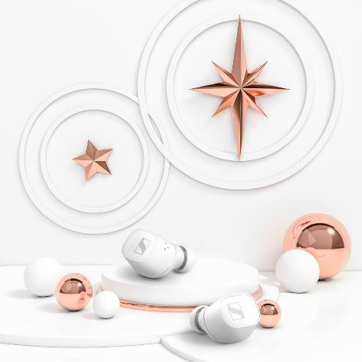
CX 400BT TRUE WIRELESS
+ Astonishing sound thanks to Sennheiser’s 7mm dynamic drivers
+ Personalized listening experience with built-in equalizer
+ Customizable touch controls
+ 7-hour battery life (+13 hours via the case)
+ Available in black or white
MSRP: 199 EUR

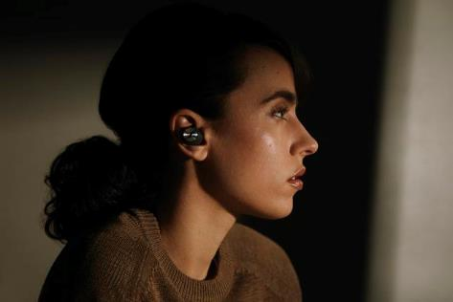
MOMENTUM TRUE WIRELESS 2
+ Exceptional sound featuring Sennheiser’s 7mm dynamic drivers
+ Active noise cancellation
+ Transparent Hearing feature that blends in ambient noise at a touch
+ Customizable touch controls
+ Smart Pause feature
+ Exquisite craftmanship
+ 7-hour battery life (+21 via the case)
+ Available in black, white or as a
special 75th anniversary edition
MSRP: 299 EUR

AROUND-EAR HEADPHONES THAT LET YOU GET LOST IN THE MUSIC

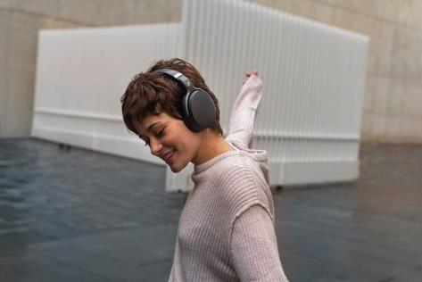
HD 450BT
+ Active noise cancellation
+ Great sound with deep dynamic bass
+ Intuitive controls including voice assistant button
+ Impressive 30-hour battery life
+ Available in black or white
MSRP: 179 EUR

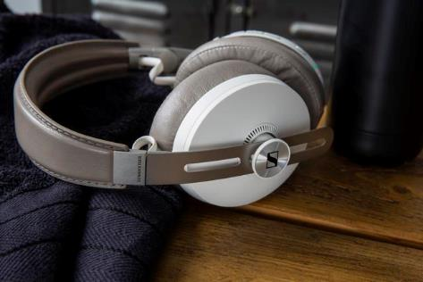
MOMENTUM WIRELESS
+ Outstanding sound performance
+ Three ANC modes and Transparent Hearing function
+ Auto On/Off and Smart Pause
+ Luxurious design with soft leather on the earpads and headband
+ 17-hour battery life
+ Tile Bluetooth tracker makes
them almost impossible to misplace
+ Available in black or sandy white
MSRP: 399 EUR

MUST-HAVES FOR MOVIE LOVERS

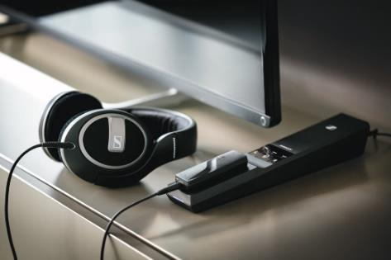
FLEX 5000
+ Smart listening solution that intensifies TV sound for any pair of wired headphones
+ Dedicated profiles enhance TV, movies or music
+ Speech Intelligibility button dynamically reduces TV background noise for crystal clear dialog
MSRP: 199 EUR

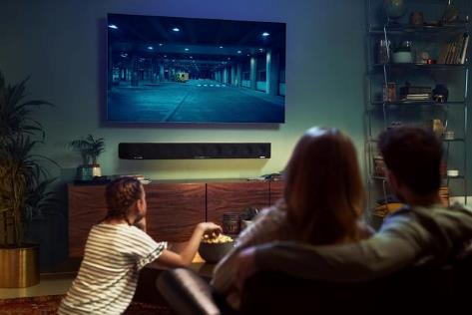
AMBEO SOUNDBAR
+ 3D soundbar that creates immersive sound with powerful bass, without the need for a subwoofer
+ Automated room calibration tailors the sound to the room – placing the listener in the center of the action
+ Supports 3D audio formats such as
Dolby Atmos, MPEG-H and DTS:X
+ Features Upmix Technology to
recreate stereo and 5.1 content in 3D
MSRP: 2,499 EUR

About Sennheiser
Founded in 1945, Sennheiser is celebrating its 75th anniversary this year. Shaping the future of audio and creating unique sound experiences for customers – this aim unites Sennheiser employees and partners worldwide. The independent family company, which is managed in the third generation by Dr. Andreas Sennheiser and Daniel Sennheiser, is today one of the world’s leading manufacturers of headphones, loudspeakers, microphones and wireless transmission systems. In 2019, the Sennheiser Group generated turnover totaling €756.7 million. www.sennheiser.com

Global Press Contact
Sennheiser electronic GmbH & Co. KG
Jacqueline Gusmag
Communications Manager Consumer
T: +49 (0)5130 600-1540
jacqueline.gusmag@sennheiser.com

