Neumann Revives a Legend – The M 50 V Tube Microphone
The Sound of History, Perfected for Tomorrow
Berlin, January 20, 2026 – Neumann proudly announces the return of one of the most iconic microphones in recording history: the M 50 V, a faithful reissue of the legendary tube microphone that shaped the sound of countless classical recordings and film scores.

Introduced in 1951, the original M 50 became the benchmark for orchestral recording and was instrumental in developing the Decca Tree technique, thanks to its unique polar pattern and outstanding transient response. Today, the M 50 V brings this heritage into the modern era with meticulous attention to detail and subtle improvements for contemporary workflows.

Neumann preserved the original acoustical concept, including the small diaphragm omni capsule mounted in a 40 mm sphere, while introducing a titanium diaphragm for improved stability and longevity. This ensures the same vivid imaging and powerful bass response that made the M 50 legendary.

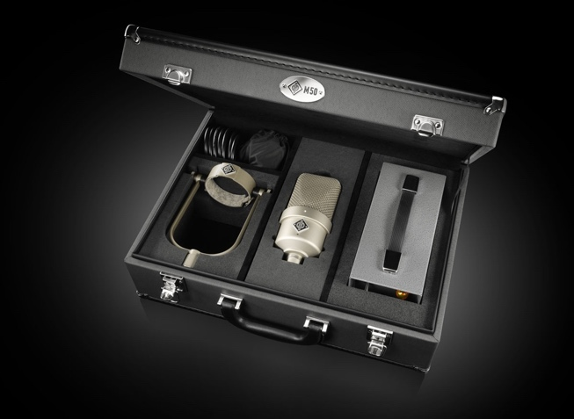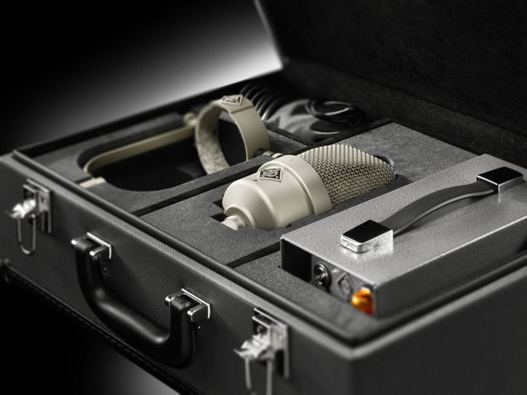
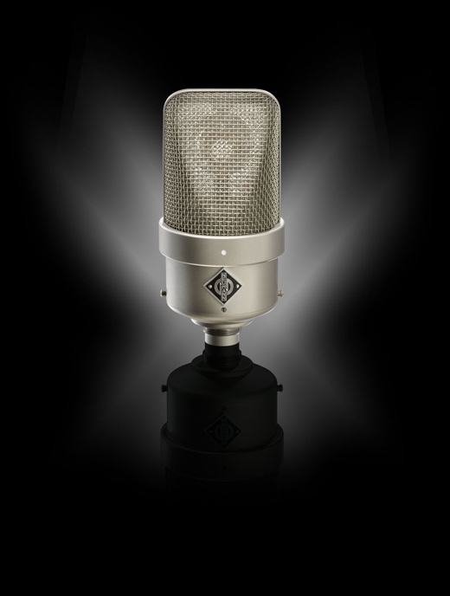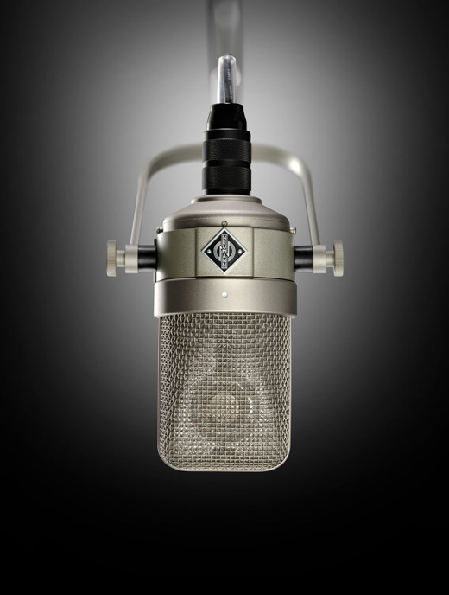

Precision, Heritage, and Sonic Brilliance
The M 50 V combines the original circuit design with a modern, ultra-low-noise subminiature tube and an RF-proof connector to ensure immunity against interference in today’s environments. The included NM V power supply automatically adapts to local mains voltage and supports both the new M 50 V and historical M 50 microphones.

“Our goal was to honor the legacy while meeting the demands of modern recording,” explains Jorma Marquardt, Portfolio Manager at Neumann. “The M 50 V is handmade in Germany to original specifications, but with enhancements like a titanium capsule and improved mechanical decoupling in the yoke mount. It is the ultimate choice for orchestral recordings and film scoring, be it in stereo, surround, or immersive formats”.

Every M 50 V is made to order by Neumann’s dedicated service and quality control team, ensuring uncompromising attention to detail and authenticity. Production is deliberately limited to maintain the highest standards.

“This reissue is not just a microphone – it’s a piece of recording history reborn,” says Medzid Veseli, Head of Neumann Service and Quality Control. “My team and I take immense pride in crafting each unit by hand. Every component is meticulously inspected and assembled to deliver the legendary sound that professionals expect from Neumann.”
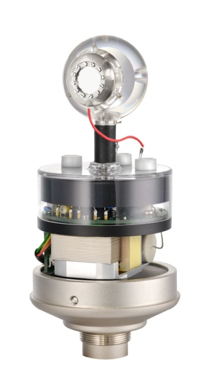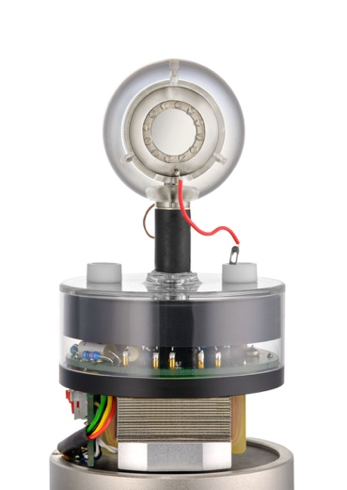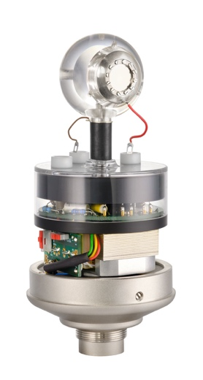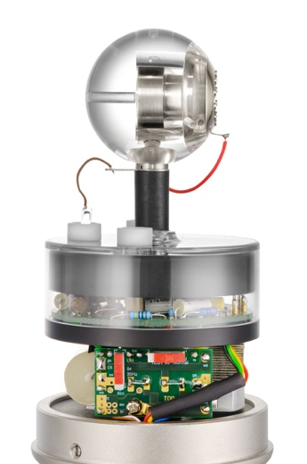

How the M 50 Shaped the Recording Industry
The Neumann M 50 has an illustrious history spanning more than seven decades.
In the 1950s, it became the microphone of choice for the Decca Tree technique, developed by engineers at Decca Records for stereo orchestral recordings. This setup remains the gold standard for classical music and film scoring.

The M 50 defined the sound of countless classical albums, as used extensively by leading recording engineers for orchestral and concert hall recordings. Also, legendary film composers and scoring engineers relied on the M 50 for its vivid imaging and natural depth, making it a staple in Hollywood scoring stages.

Beyond classical, the M 50 found its way into pop and jazz sessions as a room mic for drums, brass sections, and ensembles, thanks to its unique omni capsule and smooth high-frequency rise.
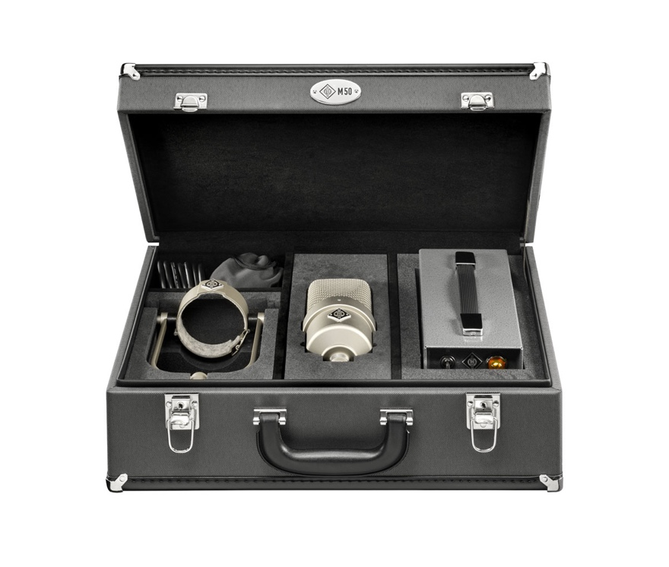

A Complete Set of Classic Sound
The M 50 V Set includes:
- M 50 V microphone with titanium capsule, handmade in Germany
- NM V power supply with automatic voltage adaptation
- Iconic yoke mount with mechanical decoupling
- RF-proof connectors and cable (33 ft/10 meters) for interference-free operation
- High-quality case, handmade in Germany
- Matching is included for orders of two or more M 50 V microphones
With its unique sonic signature and uncompromising build quality, the M 50 V continues Neumann’s tradition of excellence – a true legend reborn for the next generation of audio professionals.

Availability
The M 50 V is now in handmade production in Germany. Customers and distributors can place pre-orders now, and shipping will begin in Europe, North America, and select APAC markets in February 2026.

For more information, visit https://www.neumann.com/en-gb/products/microphones/m-50-v

About Neumann
Georg Neumann GmbH, known as “Neumann.Berlin”, is one of the world’s leading manufacturers of studio-grade audio equipment and the creator of recording microphone legends such as the U 47, M 49, U 67, and U 87. Founded in 1928, the company has been recognized with numerous international awards for its technological innovations. Since 2010, Neumann.Berlin has expanded its expertise in electro-acoustic transducer design to also include the studio monitor market, building upon the legacy of the legendary loudspeaker innovator Klein + Hummel. The first Neumann studio headphones were introduced in 2019, and since 2022, the company has increased its focus on reference solutions for live audio. With the introduction of the first audio interface MT 48, and its revolutionary converter technology, Neumann now offers all the necessary technologies needed to capture and deliver sound at the highest level. Georg Neumann GmbH has been part of the Sennheiser Group since 1991 and is represented worldwide by the Sennheiser network of subsidiaries and long-standing trading partners. www.neumann.com
Stay up to date and follow us on: FACEBOOK I INSTAGRAM I YOUTUBE

Press Contact Neumann:
Raphael Tschernuth
raphael.tschernuth@neumann.com
+49 (030) 41772467

