For immediate distribution

Ferrofish’s A32 Dante is Hand Picked for ‘So You Think You Can Dance’ U.S. Tour

The Dante-compatible interface used as a primary interface, offering flexible routing for the nationwide tour
Fort Lauderdale, FL – October 30, 2017 – Ferrofish’s A32 Dante, the German-manufactured AD/DA converter with support for Dante audio networking, has been selected by Front of House Mixing Engineer Michael Conner for the current “So You Think You Can Dance” Tour, which features contestants from the popular FOX television show and hits 35 U.S. cities this fall, including Boston, Atlanta and Los Angeles.

Conner is currently using two A32 Dante interfaces as his primary interface with one unit located on-stage and another at Front of House. “The features available in the A32 Dante allow me to not only route 32 channels of audio down a pair of Cat5 cables, but also assign them to multiple locations at FOH,” Conner explains. “The Ferrofish units allow me to send the same redundant feeds to all my devices, and the dual power supplies make using the A32 Dantes in a live situation extremely reliable.”

A32 Dante: Set and Forget
Now in its 14th season, “So You Think You Can Dance” has been one of the top-rated reality shows on FOX as well as the recipient of seven Primetime Emmy Awards for Outstanding Choreography. Conner, who transition from another live FOX TV show-based tour, “American Idol Live,” to “So You Think You Can Dance,” worked with live touring production support company Clair Global on this current tour. Clair Global supplied cases, speakers and cabling. With a tour that requires compact and clean audio, Conner used just six channels of input.

“I’m out here alone so I need to be able to get things done without labor if necessary," Conner continued. "I’m not carrying a main P.A. or any power distribution — everything is designed to operate on Edison power. I have the new Clair Cohesion-6 self-powered box combined with the fairly new Cohesion-18 Sub systems for stage monitoring both running full tilt on a single 20amp circuit. The setup is small by design, but built to the Clair standard of extreme reliability.”
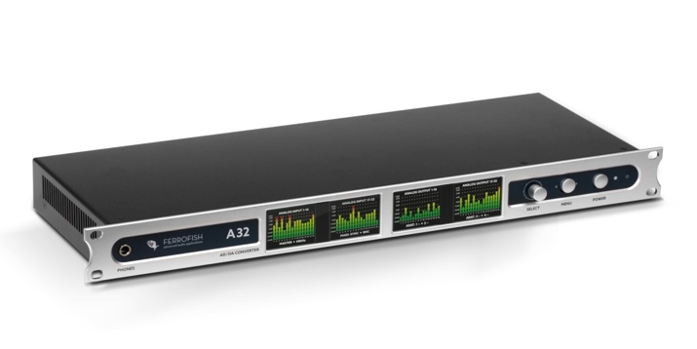
In this context, the A32 Dante plays an integral role: “It’s all about the flexible routing in this setup,” Conner said. “Being able to route a single Dante input to multiple analog outputs keeps this show bulletproof.”

Conner appreciates the Ferrofish A32 for its standalone capabilities, and for being able to operate the unit entirely from the front panel. “It literally is a set-it-and-forget-it device that powers up and requires no attention,” he added.

Multiple Formats and Plenty of Room to Spare
Conner's two A32 Dante units have brought him plenty of mileage — both in interconnectivity and channel count. This means that he can scale to just about any project on the road.

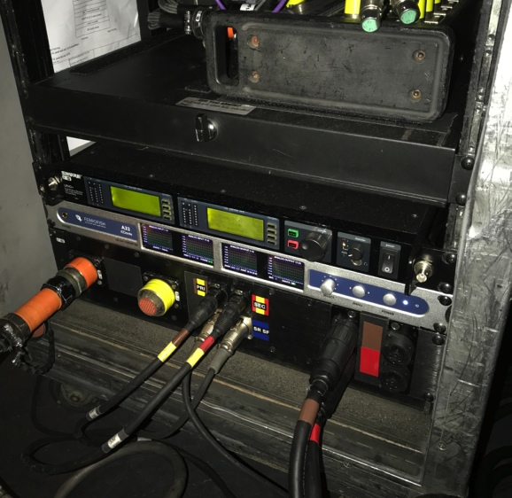
“My primary reason for purchasing two of the A32 Dantes is to provide analog inserts in my FOH rack that are accessible via MADI or Dante,” Conner explained. “I have a pile of go-to gear for my work with Paul Simon and other artists that — thanks to the A32s — I can use with any professional desk. Two of these units give me 64 channels of inputs and outputs at 96k in two rack spaces. They're the perfect solution for connecting my high-end analog gear to any digital system.”

For more information about the A32 Dante, visit ferrofish.com.

About Ferrofish
Known for its precision-engineered German technology, Ferrofish manufacturers high quality, innovative advanced audio applications. From its class-leading A16 MK-II and A32 AD/DA converters to its Verto Series of intuitive Dante converters, Ferrofish is known for its premium conversion solutions that are ideal for a wide range of applications. For additional information, visit the company online at http://www.ferrofish.com.

Media Contacts:
Jeff Touzeau
Public Relations
Hummingbird Media
+1 (914) 602 2913
jeff@hummingbirdmedia.com

Katie Kailus
Public Relations
Hummingbird Media
+1 (630) 319-5226
katie@hummingbirdmedia.com

