THE EMBODIMENT OF 75 YEARS OF OUTSTANDING SOUND

Sennheiser releases special Anniversary Edition of acclaimed HD 800 S headphones

Wedemark, September 15, 2020 – Since its formation in 1945, Sennheiser has shaped the future of audio. Its innovative products and audio solutions create outstanding sound experiences for customers the world over. A shining example is Sennheiser’s audiophile reference model HD 800 S, cherished by audio enthusiasts for its brilliant sound reproduction and impressive spatiality. To celebrate 75 years of audio history, Sennheiser releases a collector’s edition limited to 750 units worldwide. The HD 800 S Anniversary Edition comes in an exclusive matte gold colorway, each unit made truly unique by a laser engraving with the individual serial number on the headband.

“Our 75-year history has not only been shaped by exceptional ideas and innovations, by taking on challenging projects and achieving numerous successes – above all, we are celebrating an enduring passion for great sound this year,” said Dr. Andreas Sennheiser, co-CEO of Sennheiser, who alongside his brother Daniel Sennheiser is the third generation of the family to manage the company. “Our reference headphones HD 800 S are a testament to this passion that has been driving us for 75 years. They are cherished by audiophiles all over the world, so we wanted to celebrate our anniversary with a collector’s edition of this very special model,” added Daniel Sennheiser, co-CEO.

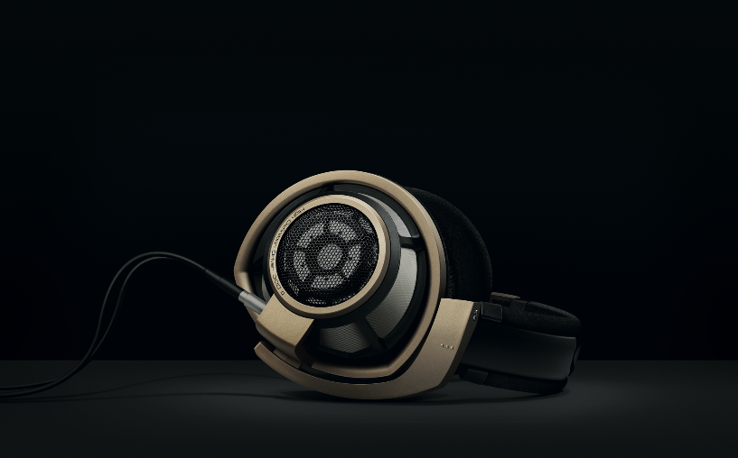 | Limited to 750 units, the HD 800 S Anniversary Edition comes with an exclusive matte gold colorway and a laser engraving with the individual serial number on the headband
Hearing the difference in every detail
Brilliant trebles, precise bass reproduction and a particularly clear sound image combined with a frequency range of 4 to 51,000 Hz make the HD 800 S a firm favorite among the audiophile community. The diaphragm of the headphones’ 56-mm transducer is made of Sennheiser’s patented duofol-transducer material to ensure exact music reproduction and reduction of resonances, keeping total harmonic distortion to less than 0.02 percent. Additionally, Sennheiser’s innovative absorber technology reduces the so called “masking effect”, an acoustic phenomenon that arises as the human ear is unable to perceive higher-pitched sounds that have low-volumes, while significantly louder sounds in a lower frequency range occur. The patented technology neutralizes the energy of the resonances, thus preventing any unwanted peaks in the frequency response and ensuring that even the finest nuances of music remain audible across the entire frequency range. The circum-aural earcups were developed with meticulous attention to detail as well, as the design directs the sound waves to the ears at a slight angle, thus creating an impressively natural and spatial sound experience.
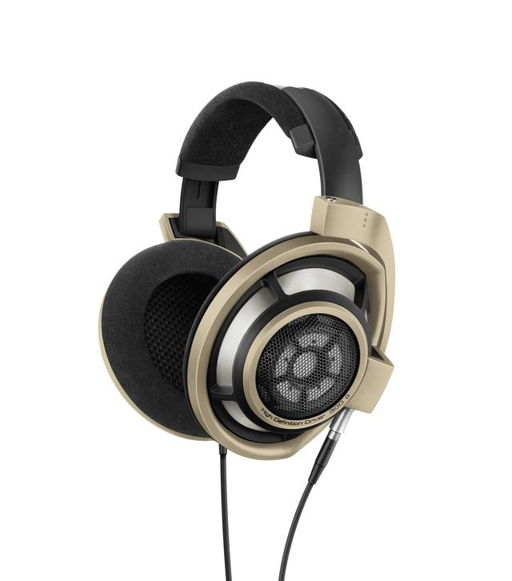

The HD 800 S Anniversary Edition delivers the same natural and spatial acoustics found in the acclaimed HD 800 S

Luxurious design for luxurious sound
The HD 800 S Anniversary Edition is handcrafted at the audio specialist’s headquarters in Wedemark, Germany. Sennheiser uses glass-fiber strengthened plastic, a material valued in the aerospace industry, for the headphones’ housing, making them particularly durable yet lightweight. The earpads are made from a soft vegan velour material for optimal wearing comfort, while the grid and grills have been crafted from a stainless-steel mesh. The matte gold yoke, decor ring and shell ring give the HD 800 S Anniversary Edition a uniquely elegant look that is every bit as exceptional as their sound. Each of the 750 units in the collector’s edition has its serial number laser-engraved on the headband.

The HD 800 S Anniversary Edition will be avaible from September 22 for 1,599 EUR at the Sennheiser webshop, Sennheiser stores and at selected retail partners.

About Sennheiser
Founded in 1945, Sennheiser is celebrating its 75th anniversary this year. Shaping the future of audio and creating unique sound experiences for customers – this aim unites Sennheiser employees and partners worldwide. The independent family company, which is managed in the third generation by Dr. Andreas Sennheiser and Daniel Sennheiser, is today one of the world’s leading manufacturers of headphones, loudspeakers, microphones and wireless transmission systems. In 2019, the Sennheiser Group generated turnover totaling €756.7 million. www.sennheiser.com

Global Press Contact
Jacqueline Gusmag
Communications Manager Consumer
jacqueline.gusmag@sennheiser.com
T +49 (0)5130 600-1540

