Wijchen, May 2017

Nooteboom PowerUp
Load-sensing lift axle for axles with hydraulic suspension
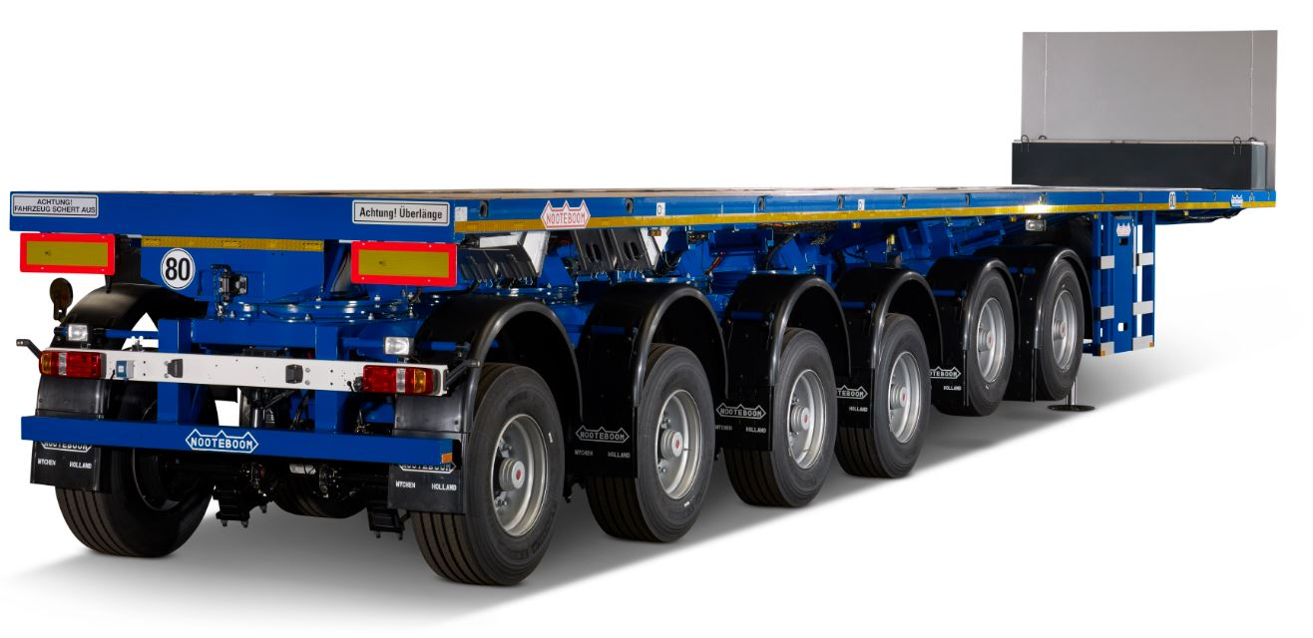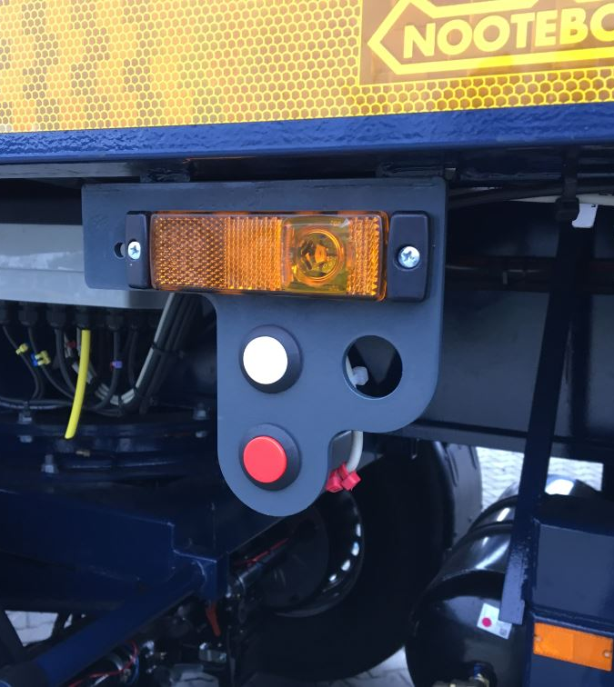
The Nooteboom PowerUp is a newly developed lift axle, including a starting-off aid, for semi-trailers with axles that are equipped with hydraulic suspension. Lift axles have already been widely used for years on axles with air suspension, but for axles with hydraulic suspension the possibilities were limited. The core of PowerUp is a clever hydraulic controller, combined with software that was developed by Nooteboom. It makes PowerUp reliable and very simple to operate.

The advantages of the PowerUp
In retracted position the lift axles contribute towards less tyre wear, reduced fuel consumption and improved manoeuvrability of the vehicle. The PowerUp also has a starting-up aid which – as an option – can be controlled from the cab. The PowerUp prevents driving with an axle load that is too high. This means overload protection for both the trailer and the road surface. Whenever the maximum legal axle load is exceeded, the PowerUp function will lower one or more axles. For safety reasons Nooteboom has elected to only let the automatic lowering function of the axles operate when the trailer is moving. This is to eliminate the risk of being trapped.

PowerUp starting-off aid
When moving off the PowerUp can lift the front axle(s) of the loaded semi-trailer up to a speed of 20 km/hour. At that moment the fifth wheel weight and load on the driving axles of the tractor increases and will temporarily improve the traction. The PowerUp is controlled via push buttons on the trailer or from the cab (optional).

Build in later on
The PowerUp lift axle can be fitted on all Nooteboom semi-trailers with hydraulic suspension, such as the Multitrailers, Teletrailers, Ballast trailers and Eurotrailers. Trailers with pendle axles don’t need this feature. The PowerUp can also be fitted on Nooteboom trailers later on.

European regulations for lift axles
The reliable Nooteboom PowerUp lift axle fully meets the international regulations. Regulation 1230/2012, Official Journal of the European Union L353/62, states the obligation to automatically lower a lift axle on the ground surface whenever the other axles are loaded to the maximum. When moving off on a slippery surface or to improve the manoeuvrability, the axle-lift device may be exceeded by no more than 30%. After driving off the axles must automatically be lowered again on the ground surface whenever the speed exceeds 30 km/hour. When it is delivered the PowerUp has been adjusted to the maximum legal axle load in the country where the trailer is registered.

Photo caption: Nooteboom PowerUp: Load-sensing lift axle for axles with hydraulic suspension

+++++++++++++

Note to the editor (not for publication): Digital photographs in high resolution are attached and free for publication.

