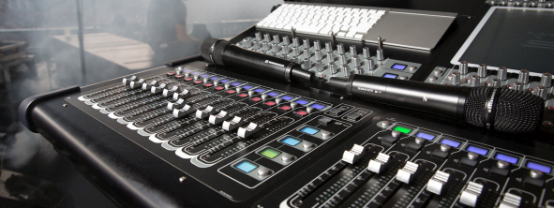Sound expertise and fascinating looks behind the scenes

Access recordings of Sennheiser SoundAcademy seminars anytime, anywhere

Wedemark, November 5, 2020 – The entire #DontStopTheEducation series of online seminars and live roundtables from the Sennheiser SoundAcademy are now available to watch on demand – anytime and anywhere. The series, which started streamed live from March 2020, lets viewers benefit from a wealth of expertise from both Sennheiser engineers and international industry luminaries.

Early during the pandemic, the Sennheiser team created #DontStopTheEducation, transforming their professional face-to-face training services into free online courses. In addition, live round tables were organized where notable industry professionals shared their expertise or gave behind-the-scenes insights from live tours such as Ed Sheeran’s Divide Tour.

“Over time, we aggregated a host of exclusive content and valuable educational material, covering diverse audio topics from live mixing to streaming to touchless audio,” said Volker Schmitt, Manager Technical Application Engineering at Sennheiser. “This can now be accessed via the SoundAcademy platform and the Sennheiser YouTube channel. We are extremely grateful to all the engineers who have shared their knowledge and helped to create exceptional content for the industry.”

Recordings of Live Seminars
The online courses and seminars on specific Sennheiser topics such as wireless microphones, antenna system design, Neumann microphone basics, touchless audio etc. are available at https://en-de.sennheiser.com/seminar-recordings. Simply complete the registration and watch for free.

Recordings of Live Round Tables and Crew Calls
A total of 16 Live Round Tables has been made available online to date on Sennheiser’s YouTube channel, allowing you to benefit from the topical expertise of industry professionals and learn about:
- Mixing for Live Sound -Mixing IEMs and Monitors
- Mixing Monitors Masterclass
- Mixing Live Sound – FOH
- Live Sound Round Table – Theatre
- Live Sound APAC Round Table
- Behind the Console: Women of Sound
- Live Sound Round Table – Podcast Special
- House of Worship Round Table
- Live Streaming Round Table
- Emerging online conferencing and distance-learning trends post Covid-19

The Crew Calls with members of the live touring crews of various bands and artists also enjoyed huge popularity. The links at a glance:
- Crew Call – Tom Walker
- Crew Call – Blake Shelton
- Crew Call – Mahalia
- Crew Call – Harford Sound
- Crew Call – Ed Sheeran

Volker Schmitt, Manager Technical Application Engineering | 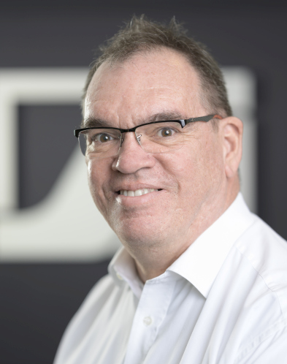

Some facts and figures
“To date, we have created and hosted 475 seminars with a total watch time of more than 50,000 minutes and more than 41,000 participants from 139 countries,” explained Volker Schmitt. “The top participating countries were India, followed by Japan and the USA. The top three #DontStopTheEducation seminars were ‘The Live Sound Monitoring Masterclass’, ‘Mixing Live Sound – Front of House’ and ‘Neumann Microphone Basics 1-3’. We want to say a huge thank you to all participants, and hope that the recorded content will find just as much enthusiastic participation as the live sessions.” |  | Created with Canva

The images in this press release can be downloaded at https://sennheiser-brandzone.com/c/181/AsQBPGLV.

About Sennheiser
Founded in 1945, Sennheiser is celebrating its 75th anniversary this year. Shaping the future of audio and creating unique sound experiences for customers – this aim unites Sennheiser employees and partners worldwide. The independent family company, which is managed in the third generation by Dr. Andreas Sennheiser and Daniel Sennheiser, is today one of the world’s leading manufacturers of headphones, loudspeakers, microphones and wireless transmission systems. In 2019, the Sennheiser Group generated turnover totaling €756.7 million.
www.sennheiser.com

Global Press Contact

Stephanie Schmidt
Stephanie.schmidt@sennheiser.com
+49 (5130) 600 – 1275

