Embargoed until 2 November, 2021: 20:00 (AEDT) / 22:00 (NZDT)

Turn your headphones into a world-class mix room
Dear Reality releases latest monitoring plugin dearVR MIX

- Plugin for headphone mixing suited for all professional studio headphones
- New Spatial Headphone Compensation feature, supporting the 44 most used professional studio headphones
- 3 virtual reference stereo mix rooms with 4 selectable loudspeaker positions
- 6 additional, non-studio listening environments

Sydney, Australia, 2 November 2021 – With dearVR MIX, immersive audio expert Dear Reality is bringing its iconic room virtualisation to the stereo world. The dearVR MIX AAX/VST3/AU plugin turns any professional studio headphones into an ideal stereo mixing environment, placing the user in the sweet spot of carefully designed mix rooms – all through spatial audio technology. With dearVR MIX and the built-in Spatial Headphone Compensation (SHC) feature, audio producers, artists and content creators can ensure that their stereo productions translate reliably to any sound system – regardless of production type or music genre. Whether you’re in the studio or on the road, dearVR MIX lets you create outstanding sound experiences and assess positions, stereo width, reverb, and low-end frequencies with total reliability, anytime and anywhere.

“When developing dearVR MIX, it was all about creating ultimate virtual acoustic environments for headphone mixing,” says Christian Sander, CEO of Dear Reality. “All the experience we have gained in the field of spatial audio comes together in one stellar plugin. dearVR MIX puts this technology in the hands of everyone.”

The plugin offers three world-class reference mix rooms with four selectable mono and stereo loudspeaker positions. Furthermore, each mix room can be adapted to the user’s taste by controlling the amount of diffusion and setting the perfect balance between overall colouration and localisation based on the patented Clarity algorithm from Sennheiser AMBEO.

dearVR MIX provides you with a reliable and consistent monitoring experience, no matter whether you’re in the studio or on the road

dearVR MIX also lets users easily and accurately monitor their production in six non-studio acoustic environments, such as a car or a club – all without leaving the workstation.

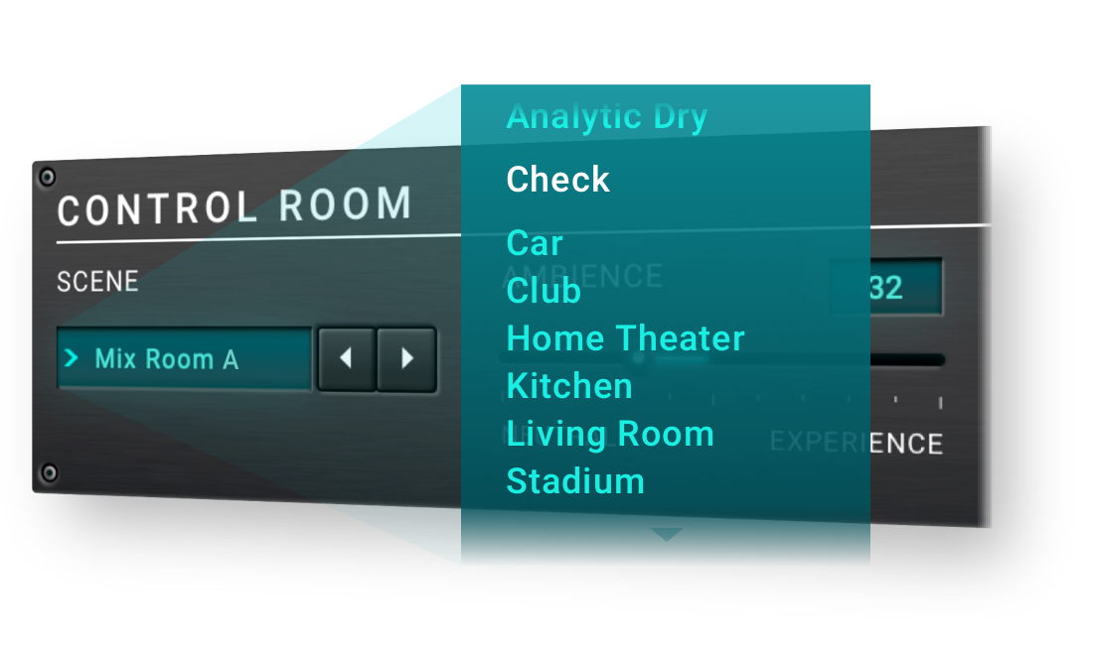 | Check how your mixes will translate to typical listening environments

Together with dearVR MIX, Dear Reality is also introducing its Spatial Headphone Compensation (SHC) feature to all dearVR virtual monitoring plugins. The unique technology adapts the 44 most used professional studio headphones to the virtual mixing room, enabling a model-independent and stable simulation of a perfect acoustic environment. “By carefully compensating for the sound characteristics of individual headphones, dearVR MIX ensures the best binaural playback experience with the highest degree of out-of-head localisation,” explains Christian Sander. Each model has been carefully optimised by Dear Reality and expert mastering engineers to create a target frequency curve that perfectly matches the room virtualisation.

Together with dearVR MIX, Dear Reality is also introducing its Spatial Headphone Compensation (SHC) feature to all dearVR virtual monitoring plugins | 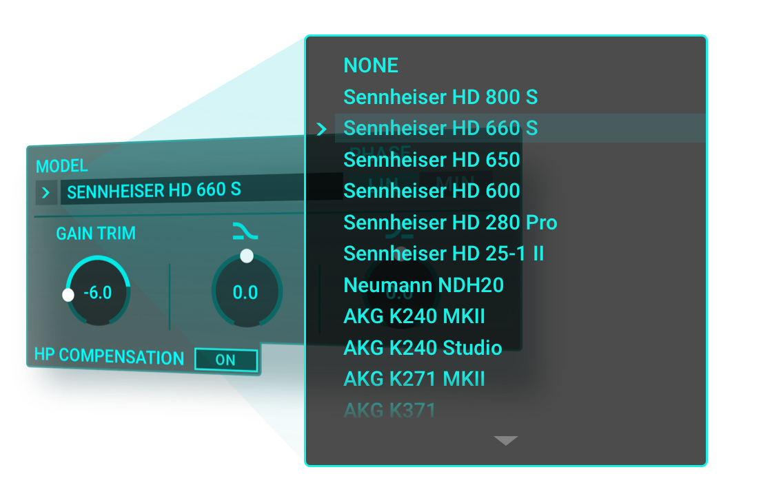

dearVR MIX is available for $132.66 AUD / $143.55 NZD only at www.dear-reality.com. Until 30 November, 2021, users benefit from a special introduction price of $105.86 AUD / $114.55 NZD. Dear Reality offers a free 14-day trial at www.dear-reality.com. Discover more insights at the Dear Reality blog.

Benefit from a special introduction price for dearVR MIX until 30 November, 2021

Watch the dearVR MIX video here.

(Ends)

The images accompanying this press release and additional GUI and feature images can be downloaded here.

About Dear Reality
Dear Reality is the leading company in the field of immersive audio controllers, best known for its binaural, Ambisonics, and multichannel encoders with totally realistic room virtualisation. The company’s products are used worldwide by sound engineers, sound designers, broadcasters, and musicians. Founded in 2014 by Achim Fell and Christian Sander, Dear Reality strives to deliver high-quality, cutting-edge 3D audio software for interactive and linear audio production. Since 2019, Dear Reality has been proud to be a part of the Sennheiser Group.

Local Press Contacts

Gabby Wallace
gabby.wallace@groundagency.com
+61 431 045 932

Caitlin Todd
caitlin.todd@groundagency.com
+61 410 781 849

Daniella Kohan
daniella.kohan@sennheiser.com
+1 (860) 598 7514

Global Press Contact

Kai Detlefsen
press@dear-reality.com

