Central African Republic: Personal accounts of a forgotten health emergency
These interviews with patients, caregivers and community leaders shed light on the critical health situation in Central African Republic (CAR). This includes a lack of preventive care for malnutrition, leading to children being admitted to hospital with life-threatening severe acute malnutrition; villagers unable to access clean water, resulting in high levels of waterborne diseases; hospital staff struggling to provide a minimum standard of care without even the most basic equipment ; impoverished men and women unable to afford medical consultations or treatment near their homes; women giving birth in deplorable conditions and without skilled medical attendants, leading to unnecessary deaths.
These interviews also highlight the actions of courageous individuals striving to improve the lives of their fellow citizens, despite having minimal resources and working in the most dire of circumstances.
This reality unfolds every day in Mbomou prefecture, as well as in many other parts of CAR.

Dr Louis-Marie Sabio: "It's like falling into a void"
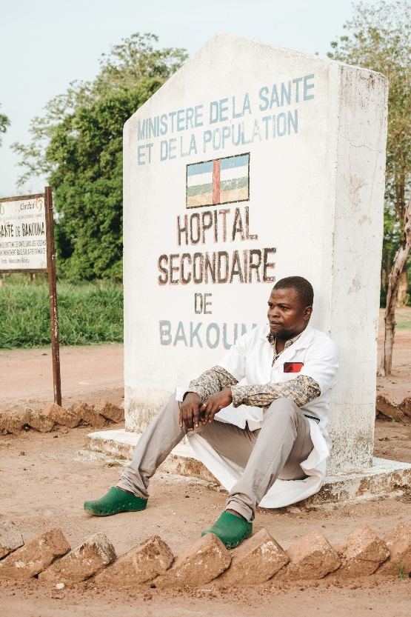
In early 2023, Dr Sabio took over the management of Bakouma hospital, a supposedly high-level health facility able to handle complicated surgery. On arrival, this former MSF doctor from Bangassou was shocked at the magnitude of the task that awaited him.
"For 12 years, not a single doctor has been present in this hospital," says Dr Sabio. "When we talk about a hospital, that's a generous term: the facility lacks everything. There's no electricity, not enough mattresses, no ambulance… and no fence. Animals can roam around in the rooms. When I arrived, I felt like I was falling into a void: there wasn't even a thermometer, a blood pressure monitor or a pulse oximeter. There was no glucose meter. We have one solar panel to power two light bulbs in the operating room, which is also lacking in everything. Without electricity, we can't even do X-rays or ultrasounds. And the pharmacy, let's not even discuss it..."
Despite the state of this ghostly hospital, Dr Sabio is doing his best to turn things around. He is the only staff member with medical training, as the rest of the team comprises first aid workers and traditional birth attendants.
"The only thing I can do, for now, is to train the team and advocate for others to help us improve things, so that one day we can recruit qualified staff. In the meantime, we do what we can, but we can't even fulfill the basic function that a hospital should perform of stabilising patients."
Bakouma hospital is one of 18 health facilities in Mbomou prefecture. MSF provides support in the form of supplying vaccines to the hospital and funding referrals of patients to Bangassou hospital, some 130 km away. No other medical organisations work in this area near Nzacko, which is known for its chronic insecurity. Bakouma hospital has been looted several times over recent years.
"Sometimes we have to refer patients without knowing if they'll survive,” says Dr Sabio. “The other day, I had to urgently transfer a baby to Bangassou by motorcycle, as we don't have an ambulance. We couldn't stabilise the baby here. He died a few km away from here, on the motorcycle. All because the technical capacity here didn't allow us to stabilise him."
The task awaiting Dr Sabio and his team seems titanic. However, the doctor feels no sense of defeatism.
"When I left MSF to come here, I knew I would lose all the working comfort I had at that time,” he says. “In Bangassou, I had everything at hand to treat people. But to know that a hospital was operating without a doctor, that's not acceptable. That's what motivated me to come here. I can't imagine giving up the fight. To abandon it would be like telling this entire population that they don't matter, that we're abandoning them. That's not possible. It's not humane."
[Pictures of Bakouma hospital: MSB164224]

Annie Guemba: "When I can't afford to feed him, he relapses"
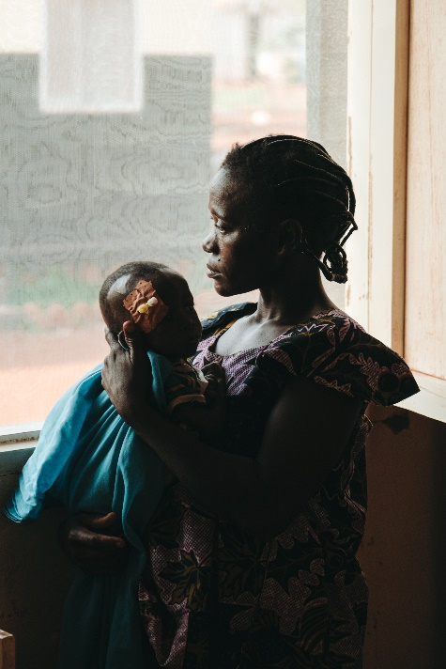
Annie's baby has been admitted to Bangassou hospital three times in its short life for severe acute malnutrition.
"At birth, he couldn't breastfeed," says Annie. "The medical team here treated him and gave me nutritious milk until I could breastfeed him. But I couldn't manage because I was weak. I had very little to eat myself. When the milk supply ran out, I was able to buy one more tin, but I couldn't afford more. I just didn't have the means. I tried to feed him porridge, but it didn't work..."
Malnutrition is a major health problem in CAR for both adults and children, leading to numerous health complications. According to the UN, nearly 300,000 children under the age of five and more than 140,000 breastfeeding women are malnourished enough to require treatment.
"Malnutrition is the leading cause of admission to the paediatric intensive care unit at Bangassou hospital," says Dr Cyrille-Dieu Veille Zongo, who heads the unit. "There used to be an NGO that ran nutrition programmes and cared for children with moderate malnutrition in Bangassou. But they stopped and no one else is doing this work now. As a result, many children who have been stabilised at the hospital and discharged back into the community return to the hospital due to a lack of preventive measures outside. It's an endless cycle."
"It's only at the hospital that he gains weight, thanks to the treatment," says Annie. "As soon as I can't afford to feed him, he relapses. So I'm forced to come back again and again."

Odette Yohoro: "The women are isolated, with no one trained to look after them"
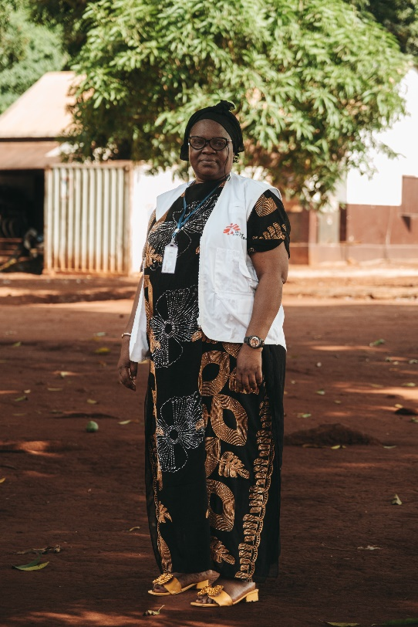
Odette Yohoro is a midwife supervisor with MSF’s mobile team in Bangassou, providing essential support to maternal and child healthcare in various health facilities assisted by MSF.
“This work is vital, as women in these areas often lack access to qualified caregivers,” says Odette. “The situation is dire, with a shortage of skilled staff, medicines and proper equipment. In some health posts, there aren't even beds, forcing women to bring their own mats for childbirth.”
Earlier this year, MSF started renovating and equipping birthing units in six health posts in Mbomou prefecture, with the aim of ensuring that women can receive improved antenatal care and give birth in a clean environment and attended by trained staff.
“Traditional birth attendants are also receiving training,” says Odette. “Many of them lack medical expertise, leading to potentially life-threatening situations, as they may not recognise complications and respond appropriately. Training is essential to equip them with basic knowledge and essential skills.”
For many years, Central African Republic has had some of the world’s highest rates of maternal and infant mortality.
“I remember one woman who was transferred to Bangassou hospital,” says Odette. “She had experienced a uterine rupture, but the midwife in her village only provided oxytocin for pain relief. Her condition worsened and she died on arrival at hospital. Unfortunately, the lack of trained staff and essential resources leads to such devastating outcomes.”
Sometimes, even the presence of health staff is no guarantee of safety for pregnant women.
“I remember one woman in Gambo, around 80 km from Bangassou, the wife of a health worker there. She had also experienced a uterine rupture, but no one noticed it. I checked her during a routine visit to the hospital there and called the ambulance to come from Bangassou. We brought her to the operating theatre and saved her life, but her baby couldn't be saved. I have seen this kind of drama too many times in my career.”
The presence of MSF’s medical teams in the Bangassou region has undoubtedly made a difference, but women and children’s needs for medical care are vast and more assistance is required.
“Poverty remains a significant challenge too,” says Odette. “When childbirth services are provided free of charge, women are more likely to seek care, even if the facilities seem under-equipped or in poor condition. Therefore, support and help for these health centres are crucial to make a meaningful impact on the health of mothers and children in the region.”
[Pictures related to maternal health: MSB164310 ]

Nadia Sasango: "I had no money, so they chased me away and insulted me"
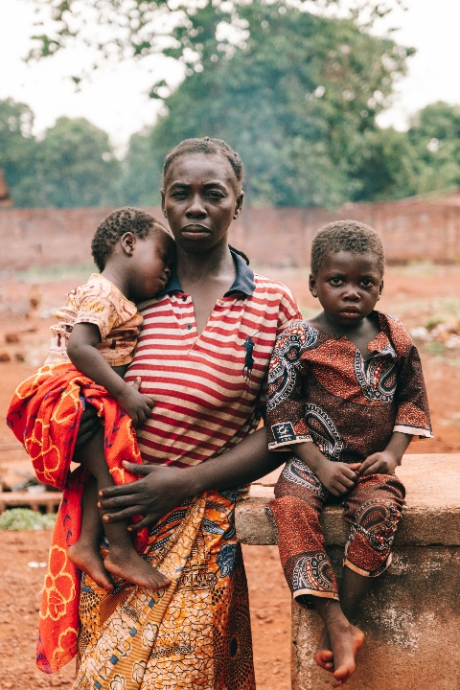
Nadia and her two children are preparing to leave Bangassou regional university hospital (HRUB), where four-year-old Guy has been receiving treatment after falling into a coma.
"This is the second time we've been here," says Nadia, a farmer from Bao, a village more than 100 km from Bangassou. "Guy has type 1 diabetes and no one at home can treat him. The first time he had an attack, he fell into a coma, and I came here. MSF treated him and gave me insulin to take to the hospital near my home so that they could keep it cool and administer his injections. But when I got there, they refused because they wanted me to pay. I had no money, so they chased me away and insulted me.”
More than 70 per cent of CAR's population live below the poverty line, on less than US$2 per day, and financial barriers to healthcare are a massive problem in the country. According to the UN, almost 40 per cent of the population say they are unable to afford healthcare.
"Later, Guy fell ill again,” says Nadia. “I thought he had malaria. I took him to the village health post, but when they saw him, they referred him to Gambo hospital [which is supported by MSF]. The staff there immediately referred him to Bangassou hospital. He was in a coma again."
Guy spent two days in intensive care before being transferred to Bangassou hospital’s paediatric ward. After several weeks of treatment, the child is ready to leave for home with his mother and younger brother. He will need insulin for the rest of his life, a hormone that is only available at Bangassou hospital through MSF. From now on, MSF teams will send supplies of insulin to Gambo hospital for Guy. Nadia has decided to move her family closer to the hospital to prevent her son from experiencing any further relapses.
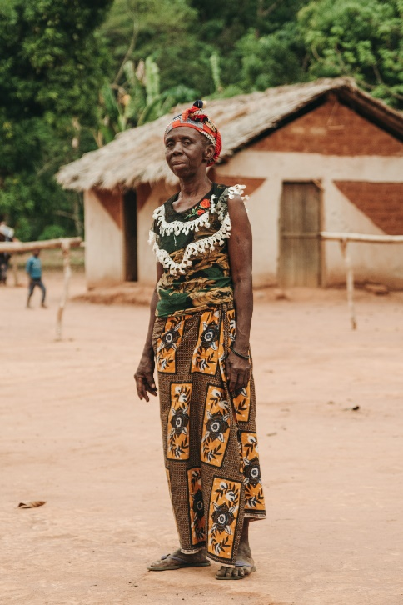
Brigitte Ganda: "We built our health post without help from anyone”
Brigitte Ganda is chief of the village of Lengo, 10 km from Bakouma hospital. Faced with the challenge of transporting sick villagers who don’t have access to motor vehicles to Bakouma, the community came together to construct a health post in September 2022, building it out of traditional bricks and thatching its roof with dried leaves.
"Nobody assisted us; everything was done voluntarily,” says Brigitte. “The men made the bricks, the sheet roof and the cement, while the women provided food for the workers and contributed to the cost of the bed. We would like to build a more decent centre with proper facilities, but with what resources? And with whose support?"
The only indication that the small building is a health post is the sign outside. Inside, the only furniture is a traditional bed on the dirt floor. This health post is typical of those in the region that are not supported by MSF.
The health post manager, a volunteer with only basic first aid training, conducts consultations when he is free from other commitments. Today he is busy working in the fields. The villagers cannot afford to pay him. He charges 100 CFA francs (15 euro cents) for a consultation, which he uses to purchase essential drugs from Bakouma.
"There are many health issues in the village, but Bakouma is too far to reach," says Brigitte. "When we attempt to transport a pregnant woman there, she may end up giving birth on the road or even dying. That's why we wanted to reduce the distance by having our own health centre. But we have very limited resources. Some still prefer to risk the travel to Bakouma as they are aware that conditions here are not good."
Because of its distance from the nearest hospital, the village has experienced a number of health-related tragedies. Before the health centre was established, several women died during childbirth after experiencing complications which went undetected until too late. The village has little infrastructure. A water point was installed in the village by one NGO, but beyond that, little has been done to improve people’s living conditions and access to healthcare.
"As you have come here today, you can witness our problems,” says Brigitte. “It's up to you to advocate for help. If we receive assistance here, we will no longer have to send our people to Bakouma.”
[Pictures from Lengo and its health post : MSB164302 ]

Pelé Kotho-Gawe: “We often feel very alone in the region”
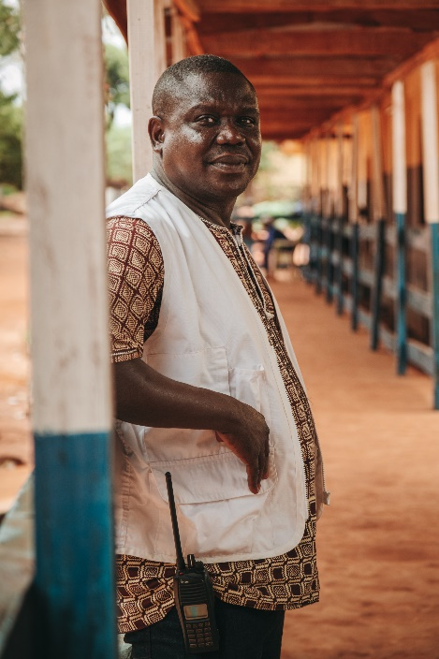
A trained nurse, Pelé Kotho-Gawe has been working with MSF since 2014. His first assignment was in Ouango region, 130 km southwest of Bangassou.
“We went there after a series of killings in which the attackers burned everything and killed many inhabitants," recalls Pelé. "Originally, MSF planned to set up a six-month response in Ouango. However, we soon realised that there were massive needs elsewhere, particularly in Bangassou, where the project was eventually established. I became a nurse supervisor for mobile activities and emergency interventions.”
After violent events in CAR in 2013 and 2014, the Bangassou region experienced a period of relative calm. However, this peace did not last: clashes between the main armed groups erupted in Bakouma in 2017 before spreading to Bangassou.
"Violence erupted in Bangassou, people were killed in front of the hospital and our base was looted,” says Pelé. “Consequently, we had to suspend our support and were only able to return in April 2018. Since then, things have improved, although insecurity and movements of armed groups are still a reality."
While Bangassou has seen a relative reduction in armed violence, the needs of the local population are still acute and there remains a serious lack of humanitarian presence in Mbomou prefecture.
"We're supporting 18 health facilities to improve healthcare provision at all levels: providing vaccines, providing treatment for priority diseases and organising referrals to Bangassou hospital. But we often feel quite isolated," says Pelé.
"Sometimes other non-governmental organisations come through, but they are not frequently seen. The reality is that we have health posts with no access to water, leading to waterborne diseases affecting the population. On our side, we can treat children suffering from diarrhoea but, without anyone drilling boreholes, the problem persists. The same goes for malaria: we visit health centres where 90 per cent of children’s malaria tests are positive, and we treat the children, but no one is working on prevention or distributing mosquito nets. It's a never-ending cycle. We’re here but, clearly, MSF can't do everything alone."
[Pictures of Pelé Kotho-Gawe: MSB164314]
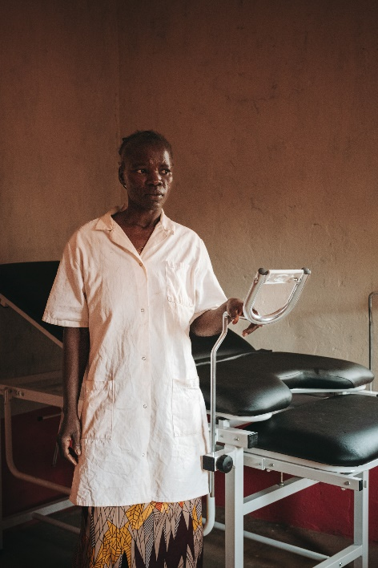
Sonia Natbil: "The new health post will help us, but our problems are still immense”
Sonia Natbil works as a traditional birth attendant at the health post in Nganzi, a small village 1.5 hours’ drive from Bangassou, which can only be reached via a bumpy track barely wider than a car.
In March 2023, MSF finished constructing and equipping the new health post. The old building, a single room with a sheet roof, was too run-down for health staff to provide proper care for the local population.
“The conditions for giving birth in the old building were really challenging, especially during the rainy season, as the roof was completely damaged and everything got soaked,” recalls Sonia. “Women had to give birth on a traditional bed with no hygiene. It was unacceptable.”
Rising beyond the ruins of the old building, which was recently knocked down, the new health post has six rooms: a pharmacy, a waiting room, a consulting room, an inpatient ward, a delivery and maternity care room, and a post-partum rest room.
Today, the visiting MSF team has arrived with an impressive amount of equipment, including a delivery table, scales, medicine cabinets, delivery kits, anti-malaria drugs and HIV test kits.
In addition to providing equipment, the MSF team is training health centre staff in patient care. This support is crucial as the nearest health centre is in Niakari, 18 km away.
Like many health facilities in the region, Nganzi health post has no running water. Its only source of water is a traditional well, located around 100 metres away, which dries up between November and May every year. Despite this situation, no specialist organisations are addressing the area’s water problems.
“People suffer from water-related illnesses all the time,” says Sonia. “We can treat the children in the village because MSF support financially these activities, but we have no supplies to treat the adults. Nobody supports us. The new health post will undoubtedly help us, but our problems are still immense."
[Pictures of Nganzi health post: MSB164097]
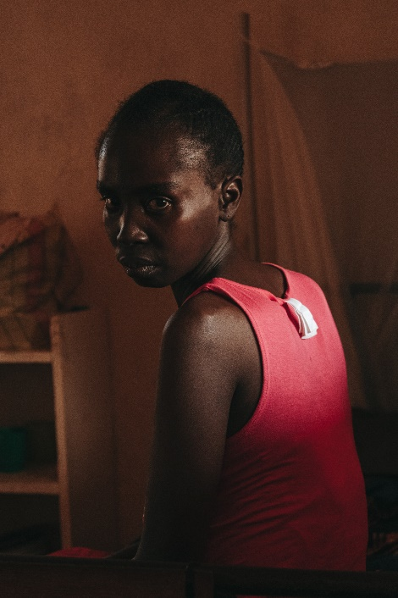
Fanny Moussa: “There wasn’t enough medicine at Bakouma hospital”
Fanny arrived at Bangassou hospital at the end of January. A farmer from Bakouma, 130 km away, Fanny had a wound on her back that had become infected due to a lack of timely treatment.
"In Bakouma, you have to pay for hospital treatment," Fanny says. "My husband and I make a living from farming and a bit of hunting. So when I got my wound, I tried to treat it myself to avoid the costs. But it got infected and I ended up going to the hospital there.”
Bakouma hospital is a hospital in name only. Intended to treat emergency cases and patients needing surgery, in reality it can provide the bare minimum of medical care. The hospital has no electricity, and for 12 years it had no doctors, being staffed instead by first-aiders and traditional birth attendants. It was only in early 2023 that Dr Louis-Marie Sabio, a former MSF doctor from Bangassou hospital, took over the management of the hospital, which he has been trying to turn around ever since.
"The doctor gave me a prescription for some medicines," says Fanny. "As he didn't have everything, I bought some on the spot and some at the market and then I came back. He tried to treat me for a week but there wasn't enough medicine at Bakouma hospital. So he referred me to Bangassou.”
After two months of treatment, Fanny’s infected wound has almost healed, although she will still need a skin graft.
"In a normal situation, we should be able to treat patients like Fanny at my hospital," says Dr Sabio. "But because of all that is missing there, I'm still obliged to refer patients elsewhere who logically shouldn't be referred. Because of the lack of resources, I even have to refer patients without being able to stabilise them beforehand, not knowing whether they will survive. The other day, I had to make an emergency transfer of a baby to Bangassou by motorcycle, as we don't have an ambulance. We couldn't stabilise the baby here. He died a few km away from here, on the motorcycle."
[Photo: MSB164285]
David Bapaï: " We are in over our heads"
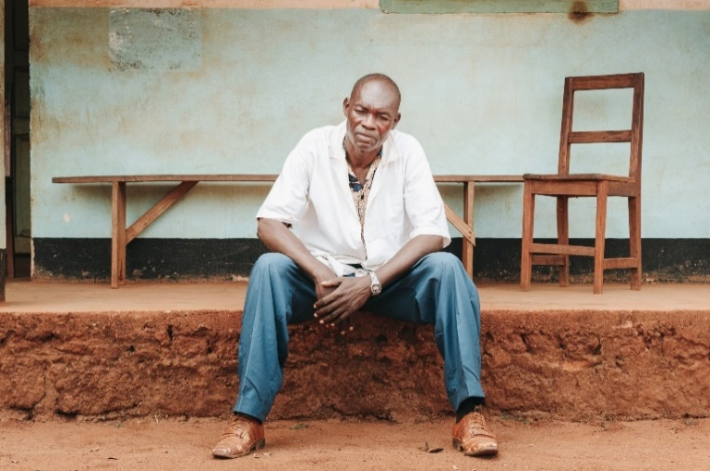
David Bapaï is manager of Yongofongo health centre, 19 km from Bangassou. MSF has supported the health centre since 2015, constructing a new building, setting up a solar-powered cold chain and supplying it with medicines.
After eight years, MSF has changed its focus to other health centres with more significant needs, although MSF continues to provide Yongofongo health centre with vaccines and funding for transferring patients to Bangassou hospital.
"We are grateful for MSF's support, as no one else is helping us, but we clearly need more assistance," says David. "We face challenges with the supply of essential medicines and equipment. The borehole stopped working six months ago and we lack the means to repair it. Consequently, we must draw water from traditional wells in the villages, but the villagers are against it. We are in over our heads. The population in this area is very poor and many cannot afford to pay for healthcare."
Dieudonné Nengbi: "Patients bring traditional healers to my local hospital”
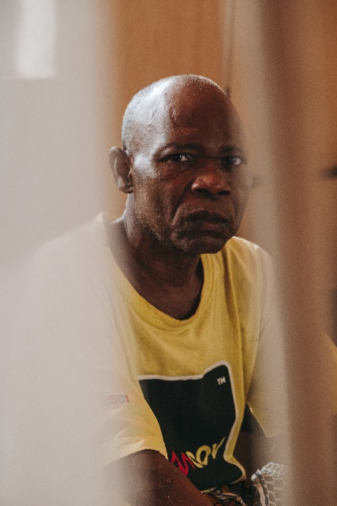
Dieudonné Nengbi has been receiving treatment for an infection in his leg at Bangassou hospital for more than two months. A general supervisor at a secondary school some 135 km from Bangassou, his leg wound from a road accident became infected as a result of inappropriate medical treatment at a hospital near his home.
“The taxi-motorbike that was carrying me fell and my leg bore the brunt of the impact,” recalls Dieudonné. “The villagers tried to treat me with traditional remedies but I insisted on going to the hospital. They provided me with a stick and I walked there.”
On arrival, the hospital staff examined his leg briefly then kept him in bed for four days. “They didn’t even have an X-ray machine to check for any possible fractures,” he says. “All they did was perform regular blood pricks.”
After four days, the infection in his leg had worsened significantly and he had lost all movement in his foot. Hospital staff transferred him to Bangassou hospital.
“I’m being treated well here,” says Dieudonné. “But we need MSF in my locality. The doctor there has deserted the hospital and patients even bring in traditional healers to treat them. As a civil servant, I can afford to come to Bangassou, but think about the villagers and the farmers: they have no choice."
[Pictures of Dieudonné: MSB164111]
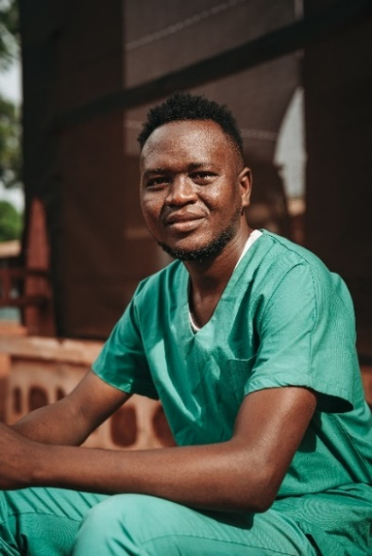
Gilles Ayigoa: "We need to reinforce basic clinical nursing skills"
Originally from Bangui, Gilles has been working with MSF for 10 years and has been stationed in Bangassou since July 2022, carrying out medical training activities for the ‘MSF Academy’ – a programme intended to strengthen the skills of local medical staff in the cities of Bangassou, Bangui, Bambari and Bossangoa.
"The level of basic training for healthcare workers in the area, and in CAR in general, is very low," says Gilles. "Most have only received first-aid training, so we need to reinforce basic clinical nursing skills, such as administering injections, understanding protocols, effective communication with patients, and even proper handwashing."
CAR is one of the countries with the lowest number of qualified medical staff worldwide – a major challenge being addressed by the MSF Academy. In Bangassou, 34 healthcare workers are currently enrolled in the programme.
"The curriculum typically lasts between 18 and 24 months," says Gilles. "The learners are also caregivers who work in various departments, so we must adapt to the constraints associated with their roles within the hospital. However, due to the substantial volume of admissions, it's not always easy for them to be available at all times."
Jean-Baptiste Kpakamira-Wilété: “Without help, there's no way out”
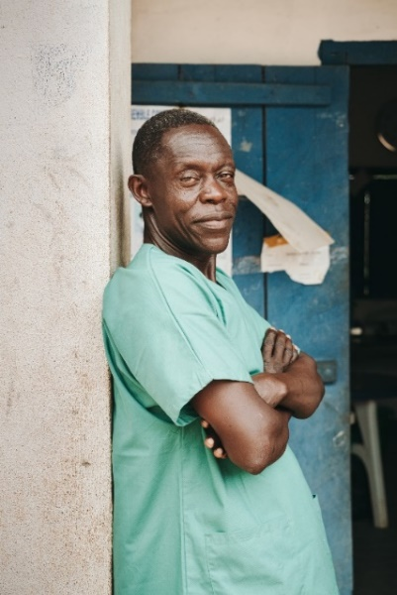
Jean-Baptiste Kpakamira-Wilété is manager of the health post in Ndegue Douma, a village around 25 km from Bangassou. The health post is crucial to the wellbeing of the almost 3,700 people who live in the four nearest villages, as well as to a significant number of Congolese people who cross the river from Democratic Republic of Congo seeking medical care.
"MSF has been supporting us since 2020," says Jean-Baptiste. "Before that, we had to send most of our patients to Yongofongo health centre, 8 km from here."
Built by the community, the building contains a pharmacy, a maternity ward, a consultation room and an observation room with two beds. Outside, a small shelter serves as a waiting and triage room.
"MSF helps us to vaccinate the children and provides us with medicines to treat them for malaria, diarrhoea and respiratory diseases," says Jean-Baptiste. "This helps us enormously because these diseases are very prevalent in the area, especially malaria and diarrhoea. Before, we had to find the means to buy these medicines, but this was often not possible. The children became weak and had to be transported far away. Things are much better now and the parents are happy that the medical care is free-of-charge."
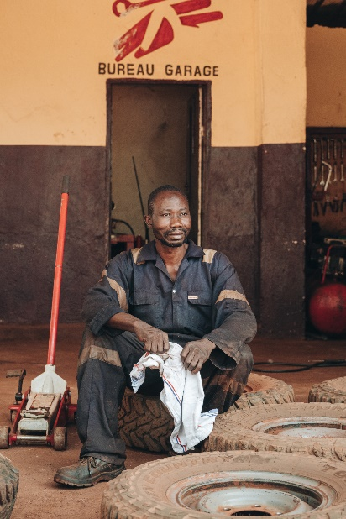
"But it's not just children who fall ill,” he adds. “What should we do for the others? Local people live off subsistence farming and often don't have the means to look after themselves. So what can be done? Without more help, there's no way out..."
[Photos of Ndegue Douma : MSB164277]

Kalil Djouma: “We're used to fleeing”
Kalil Djouma is MSF’s chief mechanic in Bangassou. He has worked for MSF since 2014.
"Before joining MSF, I worked as a driver all over the country. I became familiar with MSF because I had already seen their vehicles in Bossangoa. When I applied here, I knew we'd be doing a lot of driving in sometimes difficult areas, but I wanted to join the team and support its work. Driving was my way of contributing to the care of the population."
Kalil started as one of a team of six MSF drivers. However, his knowledge of the mechanical needs of the vehicles and equipment led to him becoming the team's mechanic.
In 2017, Kalil's life took an unexpected turn. Violence against Muslims committed by an armed group forced him to leave his home and seek shelter on a site protected by UN peacekeepers in front of Bangassou’s cathedral.
"Suddenly, I found myself living on a site where my MSF colleagues were running mobile clinics to treat people," says Kalil. "I didn't want to stay confined to that site, so I travelled back and forth to the hospital every day to go to work."
Along with thousands of others, Kalil and his family stayed in the camp for three years out of fear of renewed violence. In 2020, the situation improved for a while, but in January 2021, his family had to flee again – this time to Democratic Republic of the Congo – as a coalition of armed groups advanced towards Bangassou.
"We're used to fleeing" Kalil says wearily. "Fortunately, everything is fine now. And I hope it will remain this way."

Achille Kouandjo: “I feel pride in contributing to people's wellbeing”
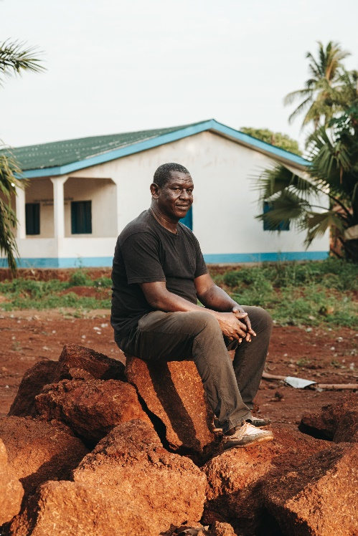
Achille Kouandjo has been working as a driver for MSF in Bangassou since 2016.
"You need stamina and a true humanitarian spirit for this job," says Achille. "Of course, the state of the roads is often very challenging, especially in the north of the prefecture. It can be a real ordeal, and then you witness difficult situations, like blood and injured people. But, at the end of the day, I feel a sense of pride in contributing to people's wellbeing."
CAR has just 600 km of paved roads, out of a total road network of 25,000 km, according to the UN. As in many other countries in the region, poor roads make it harder for people to reach health facilities, and harder for aid organisations to get assistance to where it is needed. Travelling in CAR is complicated further by persistent insecurity.
"I remember our first return movement to Nzacko, which had been inaccessible for months due to insecurity," says Achille. "The population came en masse – people who had travelled from far away, leaving their fields behind, to get medical treatment. They had been cut off from any help due to the violence. Many were in a bad condition given all the time they had spent in the bush. People’s needs were immense and the team worked non-stop to treat people until late at night. The mayor even had to ask people to let us sleep at night..."
In April 2024, Achille plans to stop working and enjoy his retirement. However, the next generation of his family is also committed to helping others.
"My youngest daughter is training to be a first-aider here at Bangassou hospital,” says Achille. “My eldest daughter works for the Central African Red Cross, and my sons want to become driver-mechanics, like me. I hope they pursue their careers with MSF!"

