upgrade to a smarter travel experience
Sennheiser Introduces PXC 550-II Wireless at IFA 2019

Wedemark/Berlin, September 5, 2019 – At IFA 2019, audio specialist Sennheiser is introducing the next generation of its acclaimed PXC 550 Wireless headphones. The new PXC 550-II Wireless builds on the exceptional comfort and sound quality of its predecessor to offer an even more sophisticated and intuitive experience for the frequent traveler. Upgrades include Bluetooth 5.0 compatibility and AAC codec support for superior wireless listening, while a new Voice Assistant button provides one-touch access to voice assistants such as Siri, Google Assistant and Amazon Alexa. The headphones’ adaptive noise cancellation seamlessly adjusts to suppress ambient noise – even in challenging outdoor environments, thanks to a new Anti-Wind ANC setting.

“Whether you’re relaxing in flight or staying in touch in the city, the new PXC 550-II Wireless has been created to upgrade every journey with unrivalled sound quality and wireless freedom,” said Dr. Christian Ern, Manager Portfolio Consumer Headphones at Sennheiser. “The original PXC 550 Wireless offered an exceptional premium experience that cosseted the user with a fusion of performance and comfort and made every interaction intuitive by anticipating their needs. The successor extends this experience by allowing voice interaction with digital assistants at a touch.”
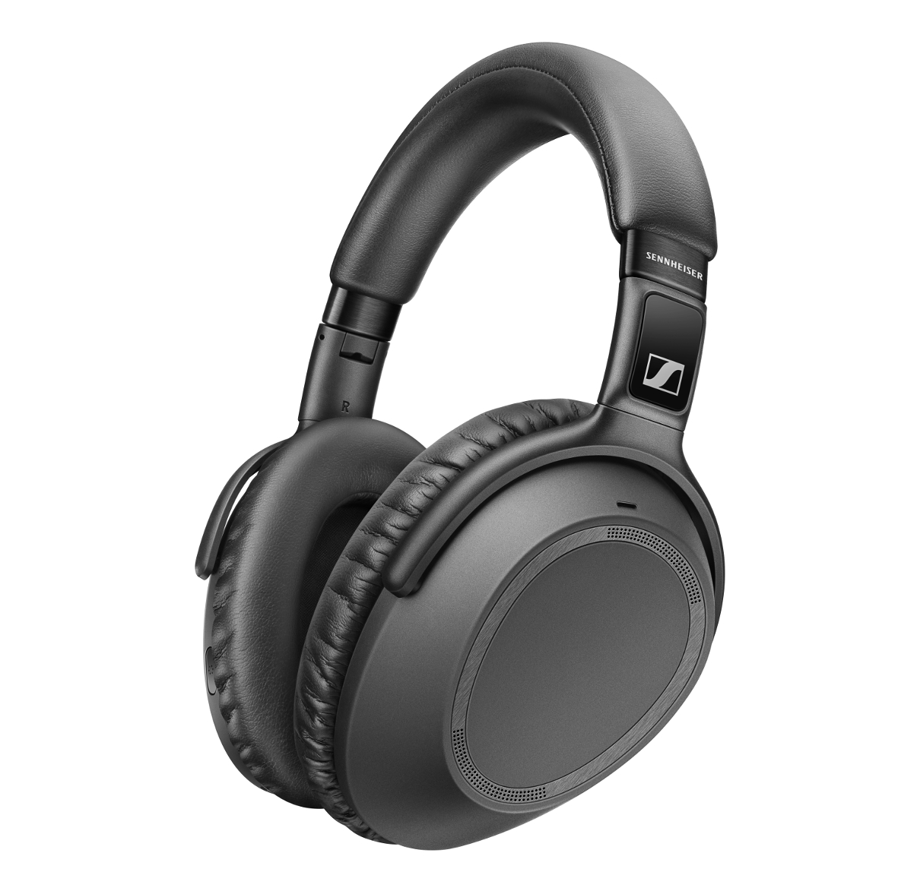

The new PXC 550-II Wireless builds on the exceptional comfort and sound quality of its predecessor, while a new Voice Assistant button provides one-touch access to voice assistants.

Travel with superior audio
The new PXC 550-II Wireless is upgraded with Bluetooth 5.0 compatibility and support for the high-quality AAC codec. Alongside aptXTM support, these enhancements help to deliver uncompromised Sennheiser sound quality. Music and movies can be enjoyed with outstanding clarity, balance and dynamics, while support for aptXTM Low Latency ensures audio stays in perfect sync with onscreen media. And no matter where a journey takes the listener, the headphones’ active noise cancellation seamlessly adapts to ambient noise levels to provide the exact level of suppression needed – even in challenging outdoor environments, thanks to a new Anti-Wind ANC setting.

The PXC 550-II Wireless also features a triple microphone array that makes it easy to stay connected while on the move: Sennheiser’s expertise in microphone technology ensures unrivalled speech clarity when giving voice commands or making calls – even in busy locations.

Enjoy a smarter, connected experience
The PXC 550-II Wireless has been designed to anticipate the user’s needs and to make every interaction utterly intuitive: Take control via a touch pad on the right earcup to adjust volume, play, pause or skip tracks, or to accept calls at a touch. The headphones automatically turn on and connect via Bluetooth as they are unfolded. Similarly, the Smart Pause feature senses when the listener takes off the PXC 550-II Wireless and automatically pauses the audio – resuming without missing a beat when put back on.

The PXC 550-II Wireless has been designed to anticipate the user’s needs and to make every interaction utterly intuitive.

As part of a new generation of smart, connected headphones from Sennheiser, the PXC 550-II Wireless seamlessly connects to personal devices to enhance the user experience. It features a Voice Assistant button that offers convenient, one-touch access to voice assistants such as Siri, Google Assistant and Amazon Alexa. Sennheiser’s free Smart Control app also makes it possible to tailor the sound for a more personal audio experience: listeners can either choose from a selection of presets for different types of audio or customize the sound to their taste via the intuitive equalizer. The app also allows the user to adjust noise cancellation and keep the headphones up to date with the latest firmware.

Engineered for more comfortable journey
With up to 20 hours of battery life with headphones connected via Bluetooth and ANC switched on, and up to 30 hours when using ANC and a wired connection, the PXC 550-II Wireless can travel the world on a single charge. To ensure comfort during long trips, the advanced ergonomic design includes a padded synthetic leather headband, and rotating earcups that make it easy to achieve a perfect fit. Premium, lightweight materials such as the brushed black stainless steel used on the robust hinges and sliders prevent fatigue when wearing – and also help make the PXC 550-II Wireless effortlessly portable. With a fold-flat design and a compact travel case created to slip into a bag or airline seat back, it’s the perfect companion for travelling in style.

The PXC 550-II Wireless will be available from October for 349 EUR (MSRP).

About Sennheiser
Shaping the future of audio and creating unique sound experiences for customers – this aim unites Sennheiser employees and partners worldwide. Founded in 1945, Sennheiser is one of the world’s leading manufacturers of headphones, loudspeakers, microphones and wireless transmission systems. Since 2013, Sennheiser has been managed by Daniel Sennheiser and Dr. Andreas Sennheiser, the third generation of the family to run the company. In 2018, the Sennheiser Group generated turnover totaling €710.7 million. www.sennheiser.com

Global Press Contact
Sennheiser electronic GmbH & Co. KG
Jacqueline Gusmag
Communications Manager Consumer
T +49 (0)5130 600-1540
jacqueline.gusmag@sennheiser.com

