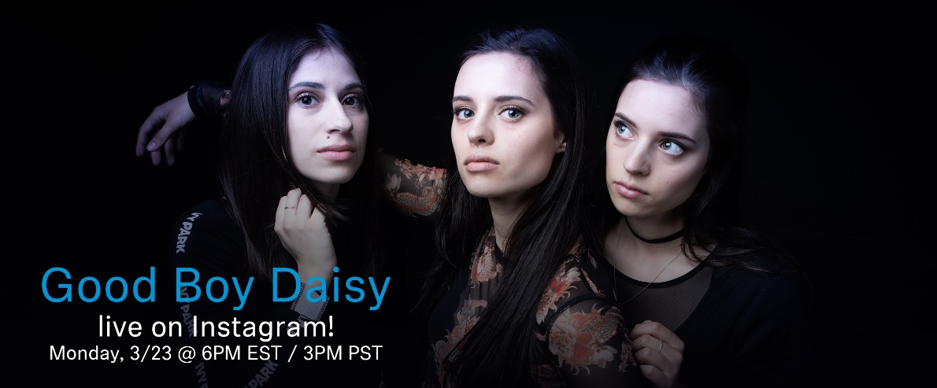#DontStopTheMusic
Sennheiser’s #DontStopTheMusic continues with exclusive, streamed concerts by Good Boy Daisy, Katie Cole and Luciano

Wedemark/Germany, March 23, 2020 – Following concerts with Mousse T., Love Fame Tragedy, Logan D. and Madoc, #DontStopTheMusic, Sennheiser’s exclusive streamed concert series, continues with rock band Good Boy Daisy, singer-songwriter Katie Cole and Swiss-Chilean producer and DJ Luciano. More than ever, when many artists have had to cancel or postpone their live tours and with public life as we know it on hold, the music must not stop! To keep the beat going, Sennheiser has launched a series of streamed concerts on its Instagram account, which will be broadcast via Instagram livestream.

Live concert streams from Monday, March 23, to Wednesday, March 25:
- Good Boy Daisy (@goodboydaisy): Monday, March 23, at 6 p.m. EST / 3 p.m. PST
- Katie Cole (@katiecoleofficial): Tuesday, March 24, at 3 p.m. EST
- Luciano (@magikluciano): Wednesday, March 25, at 10 a.m. EST / 3 p.m. CET

Please follow @Sennheiser on Instagram as dates and artists may change at short notice.

Further dates will be announced soon at http://www.sennheiser.com/anniversary. As well as the latest livestream dates, this site provides a great selection of music videos, ranging from immersive jazz club recordings, to living room electro sets, to live takes from recording studios. Just put on your headphones (or turn up the speakers) and immerse yourself in the music!

For your social media channels:
Enjoy your favorite artists at home and check out the exclusive concerts in Sennheiser’s (@Sennheiser) streaming concert series – live on Instagram! #DontStopTheMusic #TogetherAtHome

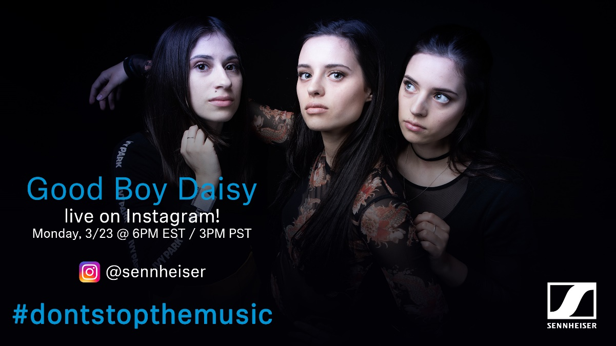

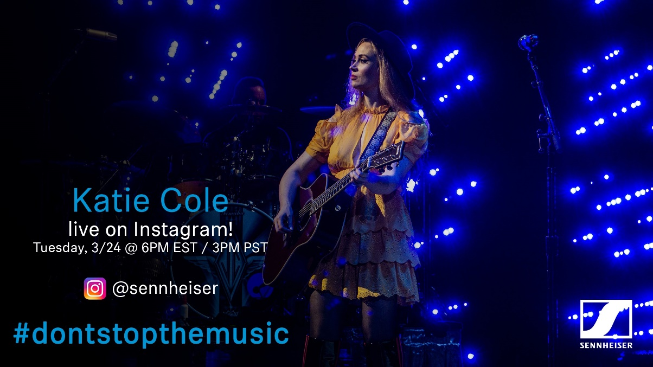

about Sennheiser
Founded in 1945, Sennheiser is celebrating its 75th anniversary this year. Shaping the future of audio and creating unique sound experiences for customers – this aim unites Sennheiser employees and partners worldwide. The independent family company, which is managed in the third generation by Dr. Andreas Sennheiser and Daniel Sennheiser, is today one of the world’s leading manufacturers of headphones, loudspeakers, microphones and wireless transmission systems. In 2018, the Sennheiser Group generated turnover totaling €710.7 million. www.sennheiser.com

Press Contacts

Mareike Oer Stephanie Schmidt
mareike.oer@sennheiser.com stephanie.schmidt@sennheiser.com
T +49 0(5130) 600 – 1719 T +49 0(5130) 600 – 1275

