Perfect audio surprises for our own personal heroes
Sennheiser gift guide for Mother’s Day and Father’s Day

Marlow, UK, April 23, 2021 – Our parents are so often our greatest cheerleaders, our most important teachers, role models, and personal heroes. After the unusual year that’s behind us, delighting our parents with the gift of quality audio is a perfect way to say “thank you”. Whether your parents enjoy listening to music or make their own videos, why not spoil them rotten with one of Sennheiser's perfect audio presents that will surely make them feel extra special.

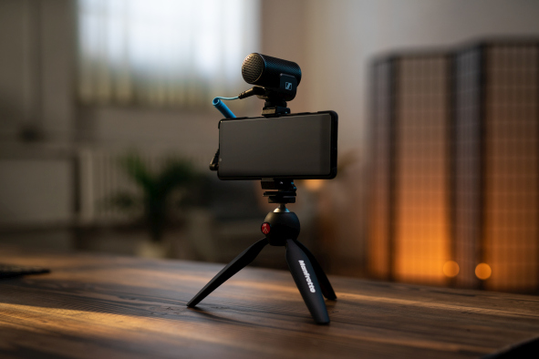

Video and audio equipment for creators who are always on the go
MKE 200 Mobile Kit
- The perfect kit for vloggers and creators to be prepared in all situations
- Directional microphone captures clean and crisp audio
- Compact and lightweight, with internal shock mount
- For use with DSLR/M cameras and mobile devices
- Comes complete with a Sennheiser Smartphone Clamp and Manfrotto PIXI Mini Tripod, two 3.5mm jack connection cables (TRS and TRRS), furry windshield for outdoor recording and a draw-string pouch for storage
- Also available as MKE 200 without smartphone clamp and mini tripod
MSRP: EUR 99 (MKE 200), EUR 129 (MKE 200 Mobile Kit)

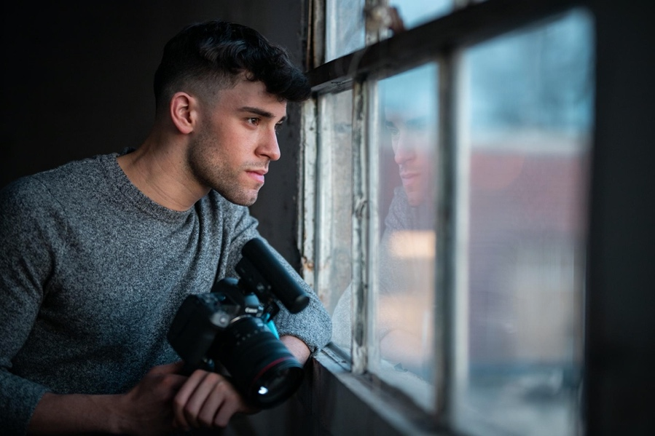
The ideal camera microphone for audio-capturing parents
MKE 400
- A compact shotgun mic that delivers the professional features demanded from a camera microphone
- For vloggers, videographers, mobile journalists and anyone who enjoys premium-quality voice recording
- Highly directional microphone eliminates background noise
- Shock-mounted capsule minimizes handling noise
- Microphone housing doubles as a standard windscreen, additional furry windshield included
- Full control over the sound thanks to a 3-step sensitivity switch and low-cut filter
- Headphone monitoring output with 8-step digital volume control
- Manual or automatic power on/off
- Low-battery indicator
- With locking cables for DSLR/M cameras and mobile devices
- Also available as MKE 400 Mobile Kit with additional Sennheiser Smartphone Clamp and Manfrotto PIXI Mini Tripod
MSRP: EUR 199 (MKE 400), EUR 229 (MKE 400 Mobile Kit)
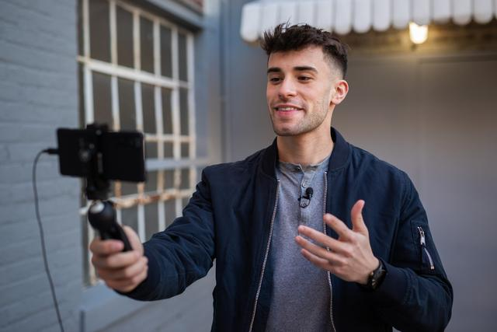
The fastest, simplest, high-quality audio addition for high-quality parents
XS Lav USB-C
- An omni-directional mic that delivers high-quality voice recording for podcasting, voice-overs, interviews, or vlogs
- Hassle free, the XS-Lav USB-C switches effortlessly from the device’s internal mic to the external mic upon detection
- Includes a microphone clip, removable foam windshield, a draw-string storage pouch
- Also available as XS Lav USB-C Mobile Kit with additional Sennheiser Smartphone Clamp and Manfrotto PIXI Mini Tripod
MSRP: EUR 59 (XS Lav USB-C), EUR 99 (XS Lav USB-C Mobile Kit)

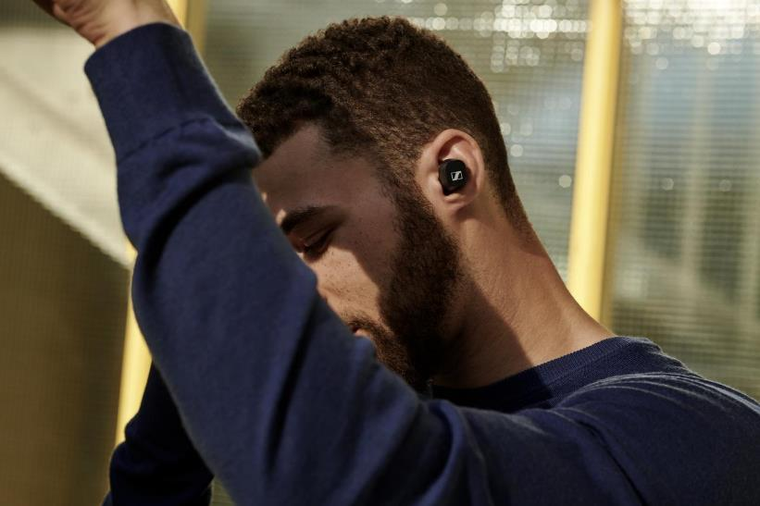
Everyday true wireless audio companions
CX 400BT True Wireless
- True wireless earbuds with exceptional sound thanks to Sennheiser’s 7mm dynamic drivers
- Personalized listening experience with built-in equalizer
- Customizable touch controls
- Great passive noise attenuation
- 7 hours of battery life on a single charge, and up to 20 available via the charging case
- Available in black and white
Promotional price: EUR 99
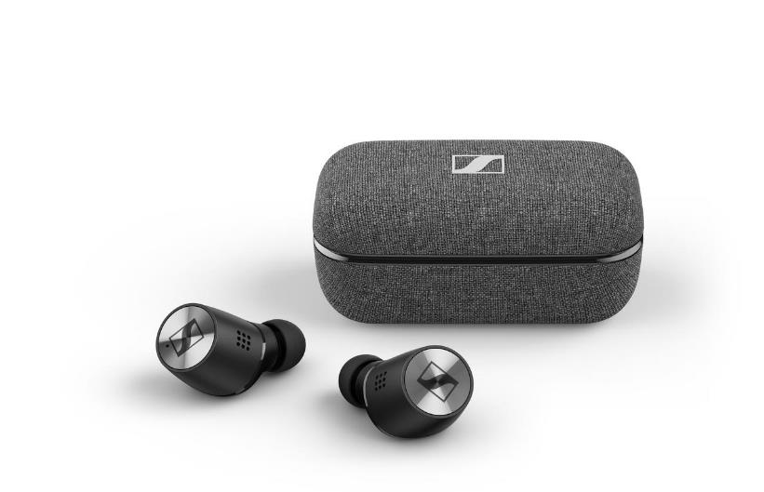
Premium true wireless earbuds with ANC for the best possible listening experience at any time
MOMENTUM True Wireless 2
- Best-in-class sound featuring Sennheiser’s 7mm dynamic drivers
- Active Noise Cancelling
- Transparent Hearing feature that blends in ambient noise at a touch
- Customizable touch controls
- Smart pause feature
- Exquisite craftsmanship
- 7 hours of playback time, and up to 28 hours by charging on-the go with the supplied case
- Available in black and white
MSRP: EUR 299

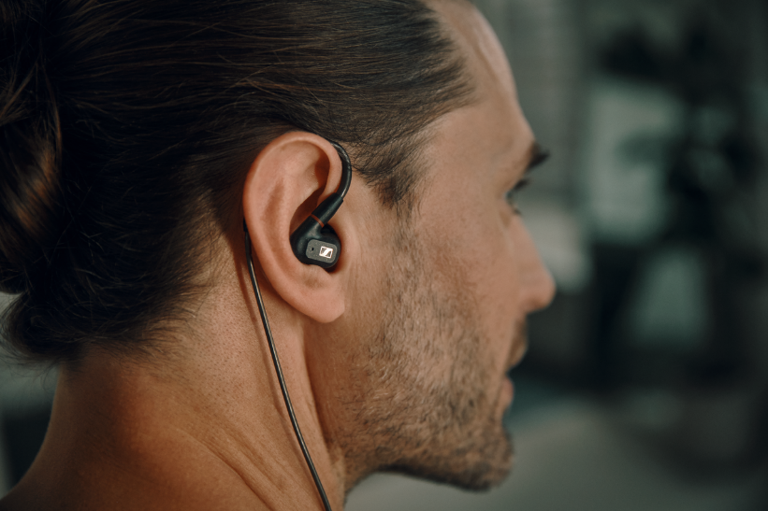
Detailed sound everywhere for audiophile in your life
IE 300
- Wired earphones that create an effortless audiophile listening experience at home and on the go
- Powered by a refined version of Sennheiser’s 7mm Extra Wide Band (XWB) transducer ensuring a well-balanced sound signature and excellent sonic accuracy
- Optimized membrane foil that minimizes natural resonances and total harmonic distortion
- Resonator chamber to remove masking resonances ensuring refined, detailed treble, subtly warm mids, and clean bass response
- Ergonomically designed features including individually adjustable flexible ear hooks
- 3,5mm cable, reinforced with para-aramid for outstanding stability even after thousands of bend cycles, easily replaced for optimal flexibility
MSRP: EUR 299

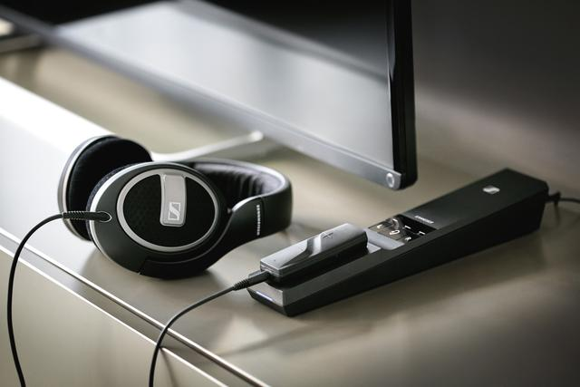
An enhanced TV listening experience for movie lovers
FLEX 5000
- Smart listening solution that intensifies TV sound for any pair of wired headphones
- Customizable audio with three hearing profiles to enhance TV, movies or music
- Speech Intelligibility button that dynamically reduces TV background noise for crystal clear dialog
- Wireless freedom thanks to a 30-meter range and 12 hours of battery life
- Comes with Sennheiser’s MX 475 earphones, but can be used with their favorite wired headphones
MSRP: EUR 199

About Sennheiser
Shaping the future of audio and creating unique sound experiences for customers – this aim unites Sennheiser employees and partners worldwide. Founded in 1945, Sennheiser is one of the world’s leading manufacturers of headphones, loudspeakers, microphones and wireless transmission systems. Since 2013, Sennheiser has been managed by Daniel Sennheiser and Dr. Andreas Sennheiser, the third generation of the family to run the company. In 2019, the Sennheiser Group generated turnover totaling €756.7 million. www.sennheiser.com

Local Press Contacts

Sarah James Maik Robbe
sarahj@gasolinemedia.com maik.robbe@sennheiser.com
+44 (0) 1483 223333 +44 (0) 7393 462484

