For more information, please contact Marta de Paco
On +34 670 780 664 or email press@comunicahair.com

Important:
These images are only available for editorial content.
Credits must be included.
Notification of their publication is expected.

MIKEL LUZEA
LATIN OH! Collection

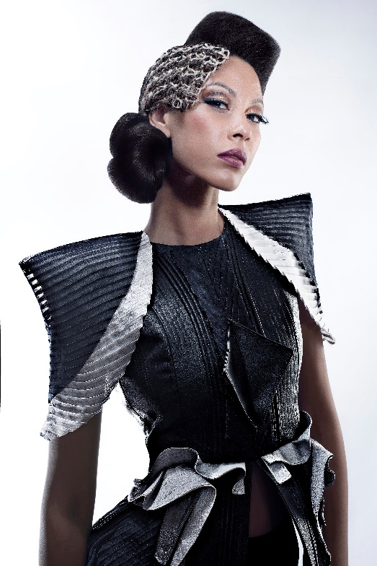
Firm: Mikel Luzea @mikelluzea
Hair: Alberto Manchado @albertomanchadom, Alicia Navarro and Ione Erice
Photography: David Muñiz @davidmunizf
Make up: Alicia Najera
Styling: Visori FashionArt @visorifashionartstudio
Products: Revlon Professional @revlonprofessional_es
Video: 601 Producciones @601producciones

MIKEL LUZEA
LATIN OH! Collection

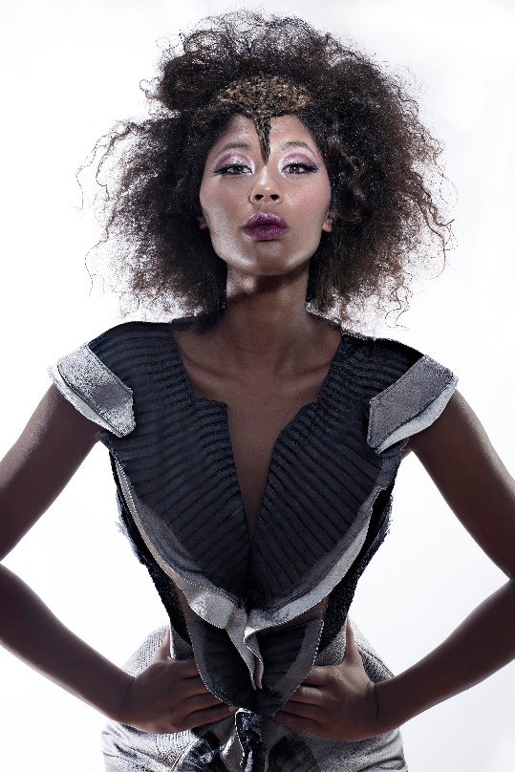

Knitting and macramé are the protagonists of this collection, which, when applied to hair, allows both to reach a new dimension. Different textures are combined to get closer to the headdress, turning hair into a new object of desire, an artistic piece loaded with messages. These weaving techniques give it the value of the artisan, the exclusive and, therefore, the luxurious. They also bring to the present ancient techniques that are refreshed with a new image and show that they are more alive than ever in sophisticated and avant-garde looks.

Video Collection: https://www.youtube.com/watch?v=y3BMRPicLrU&feature&ab_channel=MikelLuzea

