Digital Revolution: Sonarworks CEO Wins Top Prize in EMMA Sound Competition using Sonarworks Core Technology
Sonarworks software proves to be the ‘secret sauce’ in international car audio competition
Pori, Finland– September 10, 2019 – The European Mobile Media Association (EMMA) has grown into one of the most prestigious organizations for car audio enthusiasts in the world, boasting chapters in over 40 countries. The association is most known for its regular competitions to determine the best and most innovative implementations of car stereo systems, which have brought together more than 20,000 competitors per year and growing. This past August’s EMMA Finland Sound Competition saw an innovative entry from Helmuts Bems, the CEO and Co-Founder of Latvian sound software developers Sonarworks. Although a typical competitor will spend thousands outfitting their vehicles with top of the line speakers, subwoofers, and power amplifiers, Bems managed to impress the judges with a relatively modest speaker and amplifier setup by digitally correcting his system with his company’s Reference 4 sound calibration software and walked away with the top prize in the extremely competitive Master Category.

The best competitors in the world
Bems had originally attended his first EMMA event as a spectator, being an enthusiast for car audio on his own and having an appreciation for the problems inherent in adapting audio systems to the interior acoustics of a car. Realizing that these competitions were a chance to meticulously test Reference 4 in a challenging new environment, he decided to outfit his car accordingly and enter. “EMMA has a lot of credibility in the automobile industry because of how rigorously and objectively they evaluate car audio,” he explained. “They have very high standards and attract some really tough competition, so I thought it was a great chance to test digital calibration against some of the best hardware in the world.”

Bem’s competition-winning vehicle, a 2007 Saab 9-3, was outfitted with Focal TNV2 Tweeters, Dayton Audio RS52AN 2” Dome Mid and DSA215 8” Bass Speakers and a JBL W12GTI 12” Sub. The system was powered by a Kenwood KAC-PS501F power amp and a Pioneer GM-29701. “Compared to other entrants the hardware is honestly kind of pedestrian,” Bems admitted. “People definitely scoffed a bit when they saw it, but at the same time my car has about a thousand times more processing power than any of the others, which I used to run plugins of Reference 4 to calibrate all of my speakers.”

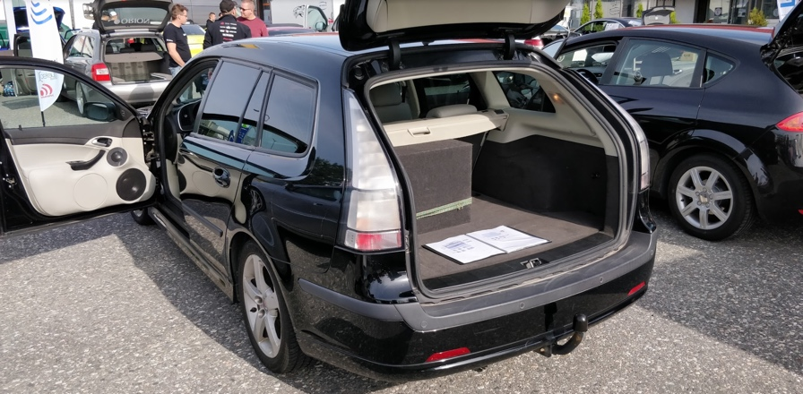
Reference 4 provides the secret sauce
Although Reference 4 is mostly known in the professional recording realm -- where it digitally calibrates headphones and studio monitors for accurate sound and improved device translation -- Sonarworks has recently been pursuing implementing the same technology in consumer audio applications, including their consumer mobile app True-Fi. Bems’s car was outfitted with a powerful dual-core Intel i5 based computer to run multiple instances of Reference 4. This allowed him to carefully calibrate all of the components in his car stereo system for the most accurate sound possible and ultimately scored him 286 out of a possible 316 points, noticeably above fellow entrants with much more expensive hardware. “The real secret sauce of this setup was the DSP,” explained Bems. “All of the drivers are being individually filtered to account for their various shortcomings, and I ran two separate instances of Reference 4; one to the mid and tweeter, the other to the bass driver which ensured it would sound its best.”

The fact that Bems was able to win despite being up against the stiff competition is something he attributes to the overall effectiveness of digital calibration, something that he says will become a fact of life in all sound systems before too long. “My car installation was honestly pretty mediocre, I was using really inexpensive speakers and amps when most of my fellow competitors had systems by high-quality manufacturers like ScanSpeak and Accuton,” he said. “I think this is proof that digital calibration is extremely effective and the fact that it gave me that much power to make last-minute adjustments over otherwise typical hardware is what was the deciding factor here, and it’s real praise to the power of Reference 4.”

Read full interview with Helmuts Bems here: https://www.sonarworks.com/blog/product-news/car-audio-gurus-schooled-by-dsp

For more information about Sonarworks Core Technology, please visit: https://www.sonarworks.com/standard

About Sonarworks
Sonarworks was founded in 2012 when two music lovers met a scientist and embarked on a mission to deliver the ultimate sound experience for anyone creating or listening to music. Sonarworks is the leading sound calibration company in the sound recording industry. The company’s technology is in use by more than 40,000 recording studios worldwide, including more than 35 Grammy winners who enjoy and endorse Sonarworks. Now we are on a mission to take this even further - deliver the ultimate sound experience to all music listeners, regardless of the device used, be it headphones, speakers, or car stereo, - individually personalized.

Media Contact:
Steve Bailey
Hummingbird Media
+1 (508) 596-9321
steve@hummingbirdmedia.com

Jeff Touzeau
Hummingbird Media
+1 (914) 602-2913
jeff@hummingbirdmedia.com

