

Biuro prasowe better. gaming agency
bettergamingagency.prowly.com

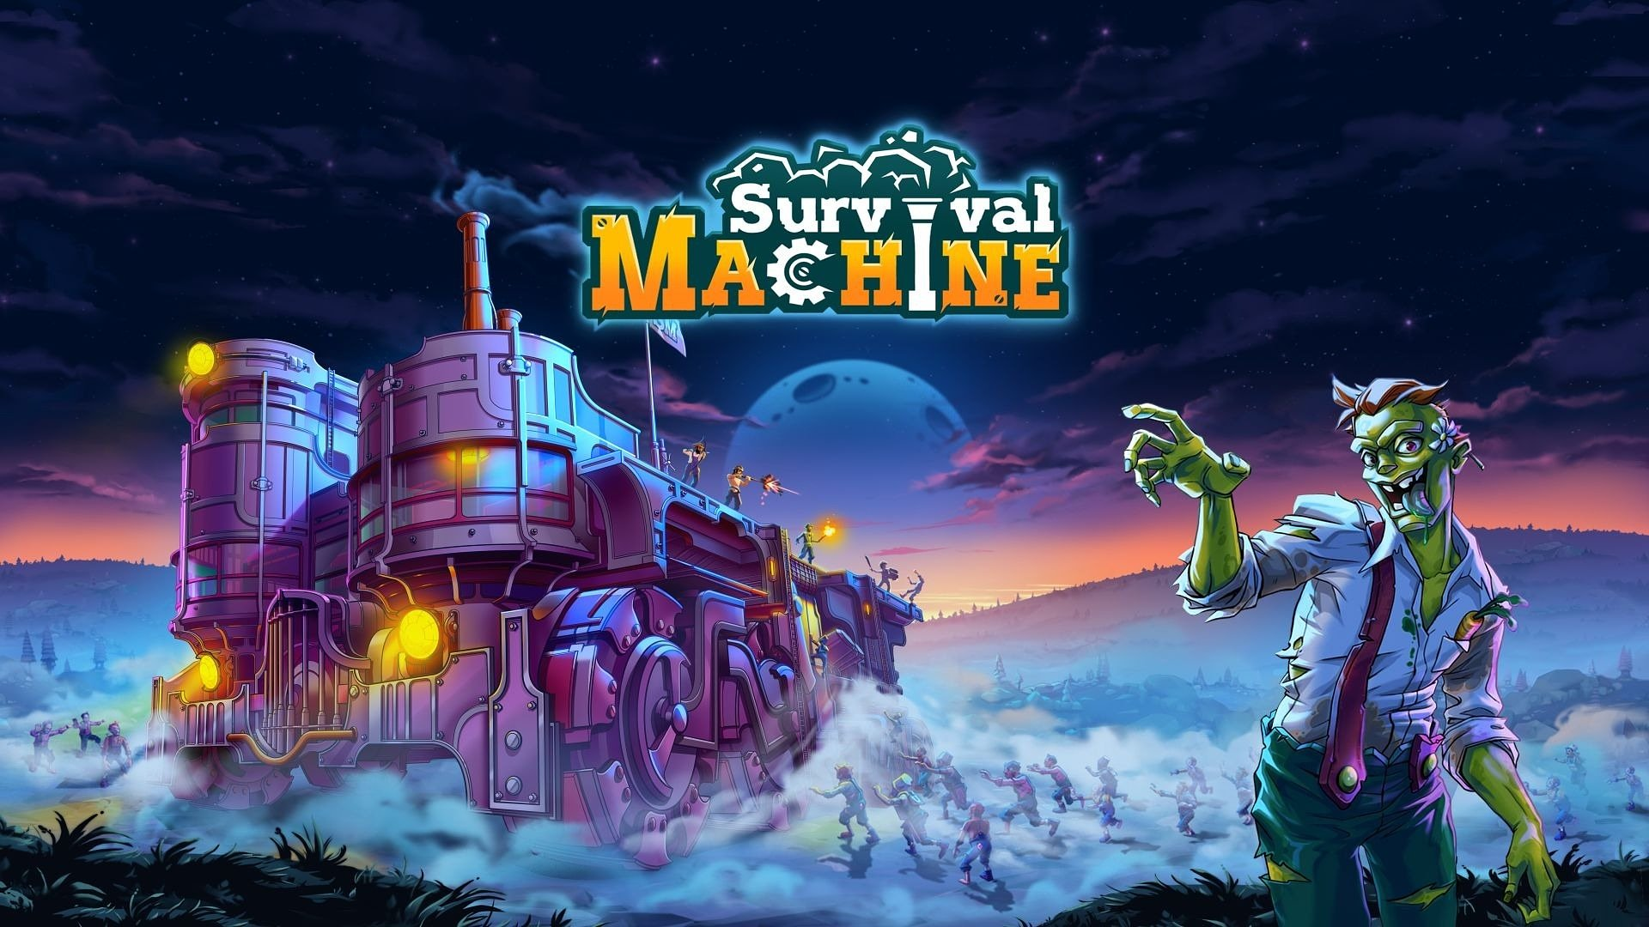

Survival Machine – hordes of zombies will attack on May 7th. It's time to build a moving fortress!

On May 7th, players will have the chance to face hordes of ravenous zombies, hungry for fresh bodies and tasty brains. The developers at Grapes Pickers, together with the publisher - Games Operators, recommend starting preparations today! Step one – adding Survival Machine to your Steam wishlist. This crazy, cooperative survival-adventure game will launch first in Early Access, where it will be tailored under the watchful eye of the community. To see what challenges await aboard the mobile fortress, check out the latest trailer.

What did pop culture teach us? That zombies are slow and, to be polite, not particularly intelligent. The most effective strategy against them appears to be either heavily fortifying your position or constantly being on the move. But what if you did both? This is the idea the developers at Grapes Pickers started with. In Survival Machine, players will fight for life aboard a massive, mobile fortress. This, however, doesn't mean they'll remain untouchable, sipping drinks while zombies take over the world.

Survival Machine – release date announcement

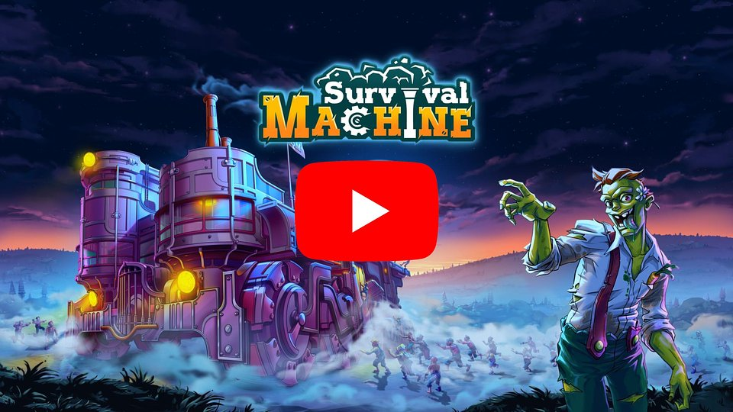
https://www.youtube.com/watch?v=NnhFfnSf-pQ&ab_channel=SurvivalMachine

The gameplay in Survival Machine can be divided into two main phases – day and night. You have until dusk to properly prepare for what's coming your way — gather resources, strengthen defenses, craft weapons and tools, and explore in search of valuable treasures and secrets. After nightfall, zombies take the initiative, and players' task is to protect the fortress from the incoming hordes and survive until the day comes.

Naturally, the apocalypse is easiest to survive in the company of loyal allies! The challenges awaiting in Survival Machine can be tackled alone, but gameplay becomes much more exciting when friends join in. The cooperative mode offers fun for up to 4 players simultaneously, and there will be enough work and tasks for everyone both aboard the mobile fortress and in the areas it travels across.

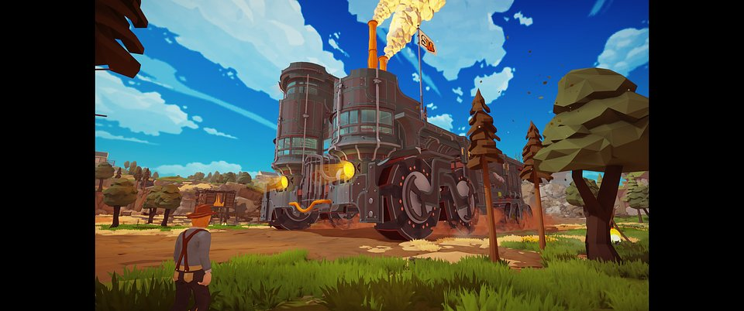

Survival Machine – key features:

🧟 Fortress on wheels – build, upgrade, and defend the massive mobile stronghold. A combination of constant movement and solid fortifications is the best chance for survival in a world overrun by zombies.

🧟 When night falls, day rises – Survival Machine offers two completely different gameplay phases: explore, gather resources, and craft tools during the day, while at night withstand relentless attacks from hordes of the undead. Survival depends on strategy and proper preparation.

🧟 United we stand, divided we fall – survive alone or side by side with friends! The cooperative mode for up to 4 players offers shared challenges, division of tasks, and even more excitement in the fight for survival.

🧟 Into the unknown – the diverse world is not only full of resources and dangers, but also puzzles to solve, secrets to uncover, and treasures to collect. Exploration is just as important as fighting the endless waves of zombies. Search the unknown to gather everything needed to survive and upgrade your fortress.

🧟 Play Smart, play deadly – surprise the undead! The game features a wide array of traps – from simple but effective mechanisms to complex structures that call for both creativity and precision.



Survival Machine will launch in Early Access on Steam on May 7th. We encourage everybody interested in the game to add it to their Steam wishlists.

The full press kit is available here.

About Games Operators

Games Operators is a publishing company that invests in, releases, and promotes video games. Known for supporting innovative titles like 911 Operator and Infection Free Zone, Games Operators collaborates with developers from concept through to release to deliver unique and immersive gaming experiences. http://www.gameops.pl

