Xytech to Host ‘Virtual NAB Web Series’ May 19 & 20 Targeted at Broadcast, Media & Transmission Companies

The series will touch on how Xytech’s MediaPulse system streamlines company operations

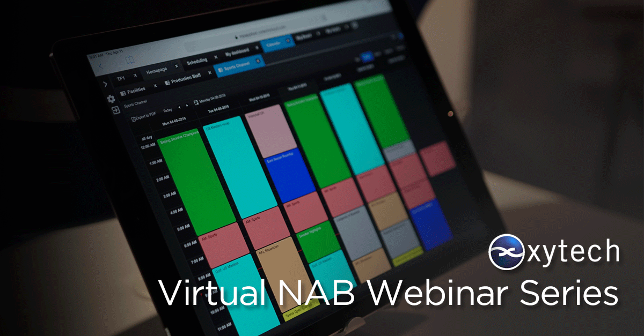
LOS ANGELES, May 12, 2020 — With the cancellation of the Las Vegas NAB Show due to Covid-19, Xytech, the leader in facility management software for the broadcast and media industries, announced it is hosting a “Virtual NAB Web Series” over May 19 and 20. The web series features a range of webinars focusing on specific sectors of its MediaPulse Platform. Hosted by Xytech’s COO Greg Dolan and Xytech Subject Matter Experts, the three webinars, “MediaPulse Overview,” “Media Services” and “Video Transmission,” will run at various times during the 2-day event to service audiences around the world.

MediaPulse Overview – May 19 at 3 pm BST, 11am PDT & May 20 at 2 pm AEST
This webinar provides an introduction to the features and benefits of MediaPulse. Its web-based user experience comprises a number of modules targeted to organize, manage and simplify the daily tasks of all media facilities. The MediaPulse platform provides solutions for scheduling, automation, asset management, billing and cost recovery in a scalable platform-independent solution.
Media Services – May 20 at 10 am BST & 10 am PDT
This webinar describes how users manage everything from fundamental media creation to high volume digital fulfillment including localization and media transformation with MediaPulse. Both automated and manual operations are organized, tracked and completed within a single order.

Video Transmission – May 20 at 3 pm BST & 2 pm PDT
This webinar demonstrates how Xytech’s transmission solution delivers complete video circuit management, automated resource selections and automation with comprehensive operational dashboards and financial tools optimized for use in any broadcasting operation.

“While we weren’t able to gather in Las Vegas for NAB this year, Xytech still needs to take the time to educate broadcast, media and transmission companies on how to best streamline their operations for when business resumes to come back stronger and more nimble,” Dolan said. “All three webinars are intended to inform and educate professionals on how to optimize their operations with MediaPulse.”

To register for one of the webinars, please visit the correlating links below:

MediaPulse Overview:
3pm BST: https://xytechsystems.zoom.us/webinar/register/8315888743041/WN_vh_tcPZqSLGsve30EYagdA

11am PDT: https://xytechsystems.zoom.us/webinar/register/2315888744881/WN_nDHtJ2WRRBS4XIzR7MZU-w

Special MediaPulse Rundown for Australia:
2pm AEST: https://xytechsystems.zoom.us/webinar/register/1115888752168/WN_wWY6Yie7TJO875NuCbUvmg

Media Services:
10am BST: https://xytechsystems.zoom.us/webinar/register/3115888752858/WN_CFzwn_ojRsi2VzoBeE_ptQ

10am PDT: https://xytechsystems.zoom.us/webinar/register/8715888753444/WN_EKp-hq9KS0uC-aSzls69iw

Video Transmission:
11am BST: https://xytechsystems.zoom.us/webinar/register/1315888754056/WN_VtMXjVO7TUOAoAQKcNzPlg

11am PDT: https://xytechsystems.zoom.us/webinar/register/9215888754405/WN_uO2YWNiDSWOB1UcfhNk08w

About Xytech
For more than 30 years, the world’s premiere media companies have depended on Xytech to run their businesses. MediaPulse is the only end-to-end solution for the complete content lifecycle. MediaPulse provides scheduling, automation, asset management, billing and cost recovery for broadcasters, media services companies and transmission facilities in a scalable platform-independent solution. For more information, visit xytechsystems.com.

Media Contacts:

Katie Kailus
Public Relations
Hummingbird Media
+1 (630) 319-5226
katie@hummingbirdmedia.com

Jeff Touzeau
Public Relations
Hummingbird Media
+1 (914) 602 2913
jeff@hummingbirdmedia.com

