Honor 8X Spec Sheet

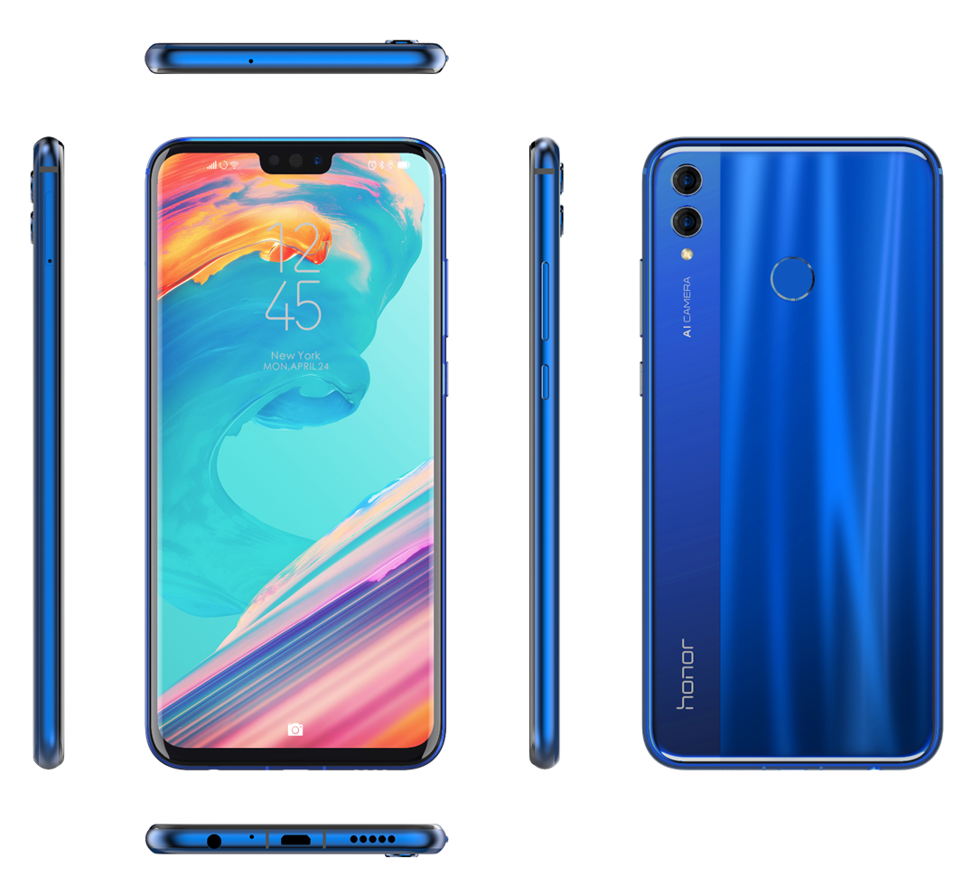

Display
- 6.5-inch 2340p x 1080p LTPS display with 16,700,000 colors, 397 PPI
- 19.5:9 wide screen
- Multiple-point touch-sensitive screen
Size and Weight
- 160.4 mm (H) x 76.6 mm (W) x 7.8 mm (D)
- Approximately 175g (including the battery)
Operating System
- AndroidO + Huawei EMUI 8.2
Processor
- Kirin 710, Octa-Core (4 x Cortex-A73 2.2 GHz + 4 x Cortex-A53 1.7 GHz)
GPU (Graphics Processing Unit)
- Mali G51
Battery
- Typical value: 3750 mAh battery
- Charging duration: approximately 150 minutes from supplied charger
- Airtime: 3G: 21 hours
- Standby time: GSM: 662 hours, WCDMA: 639 hours, LTE FDD: 675 hours, LTE TDD: 697 hours
Memory
JSN-L21 / JSN-L22
- ROM: 128 GB or 64 GB
- RAM: 4 GB
- Expandable storage: microSD card (up to 400 GB)
JSN-L23
- ROM: 64 GB
- RAM: 4 GB
- Expandable storage: microSD card (up to 400 GB)
JSN-L42
- ROM: 128 GB or 64 GB
- RAM: 6 GB or 4 GB
- Expandable storage: microSD card (up to 400 GB)
Camera
- 20-megapixel (F/1.8 aperture) + 2-megapixel dual-lens rear-facing camera with Phase Detection Auto Focus (PDAF)
  - Photo resolution: up to 5120 x 3840
  - Video resolution: up to 1920 x 1080 (1080P, 60fps)
- 16-megapixel (F/2.0 aperture) front-facing camera
  - Photo resolution: up to 4608 x 3456
  - Video resolution: up to 1920 x 1080 (1080P, 30fps)
Audio/Video
- 1080P full HD video recording and video playback
- 3.5 mm headset jack
SIM card
- 3 card slots: nano-SIM card + nano-SIM card + microSD card

Connectivity
JSN-L21
- 4G LTE FDD: B1/3/7/8/20
- 3G UMTS: B1/8
- 2G GSM: B2/3/8
JSN-L22
- 4G LTE FDD: B1/3/7/8/20
- 4G LTE TDD: B40/41
- 3G UMTS: B1/5/8
- 2G GSM: B2/3/8
JSN-L23
- 4G LTE FDD: B1/2/3/4/5/7/28
- 4G LTE TDD: B41
- 3G UMTS: B1/2/4/5/8
- 2G GSM: B2/3/5/8
JSN-L42
- 4G LTE FDD: B1/3/5/8
- 4G LTE TDD: B40/41
- 3G UMTS: B1/8
- 2G GSM: B3/8
Other Connectivity
JSN-L21
- Wi-Fi 802.11 a/b/g/n/ac, 2.4 GHz / 5 GHz , support Wi-Fi hotspot and Wi-Fi Direct
- Bluetooth BT4.2 + BLE
- USB 2.0
- NFC
- GPS/AGPS/Glonass/BeiDou Navigation System
JSN-L22 / JSN-L23
- Wi-Fi 802.11 b/g/n, 2.4 GHz, support Wi-Fi hotspot and Wi-Fi Direct
- Bluetooth BT4.2 + BLE
- USB 2.0
- GPS/AGPS/Glonass/BeiDou Navigation System
JSN-L42
- Wi-Fi 802.11 a/b/g/n/ac, 2.4 GHz / 5 GHz , support Wi-Fi hotspot and Wi-Fi Direct
- Bluetooth BT4.2 + BLE
- USB 2.0
- GPS/AGPS/Glonass/BeiDou Navigation System

Sensors
- Gravity sensor
- Proximity sensor
- Ambient light sensor
- Gyroscope
- Fingerprint sensor
- Digital compass
Colors
- Blue/Black/Red

Laboratory results were obtained by charging the phone using the standard charger with the screen turned off. The actual charging time may vary depending on different conditions.
The Honor laboratory results are for reference only. The actual air time may vary depending on network conditions and user habits.
The Honor laboratory results are for reference only. The actual standby time may vary depending on network conditions and user habits.
MicroSD card is not included.
MicroSD card is not included.
MicroSD card is not included.

