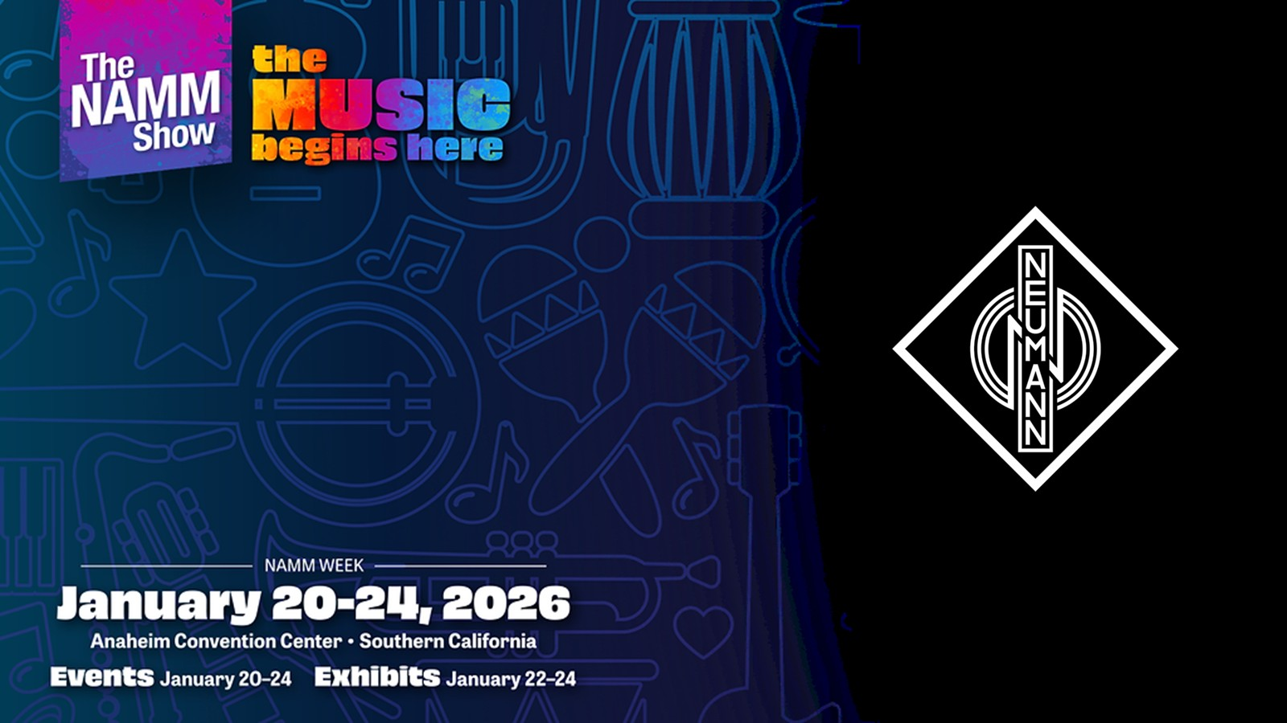

Neumann @ NAMM 2026
Neumann.Berlin Showcases Immersive Audio Innovations and Reveals a New Microphone at NAMM 2026

Anaheim, CA – January 2026 – Neumann.Berlin invites NAMM attendees to experience the future of professional audio at ACC North Level 2, Booth 18810. Step into our immersive 9.1.4 demonstration room, where Neumann experts will guide you through a truly three-dimensional audio experience. Each day will feature four exclusive sessions with an impressive lineup of guest speakers, offering insights from some of the most respected names in the industry. A tentative schedule can be found below.*

Alongside these sessions, explore our Product Display Area, featuring Neumann’s complete signal chain—studio monitors, interfaces, headphones, and microphones—working together as a seamless, integrated ecosystem.
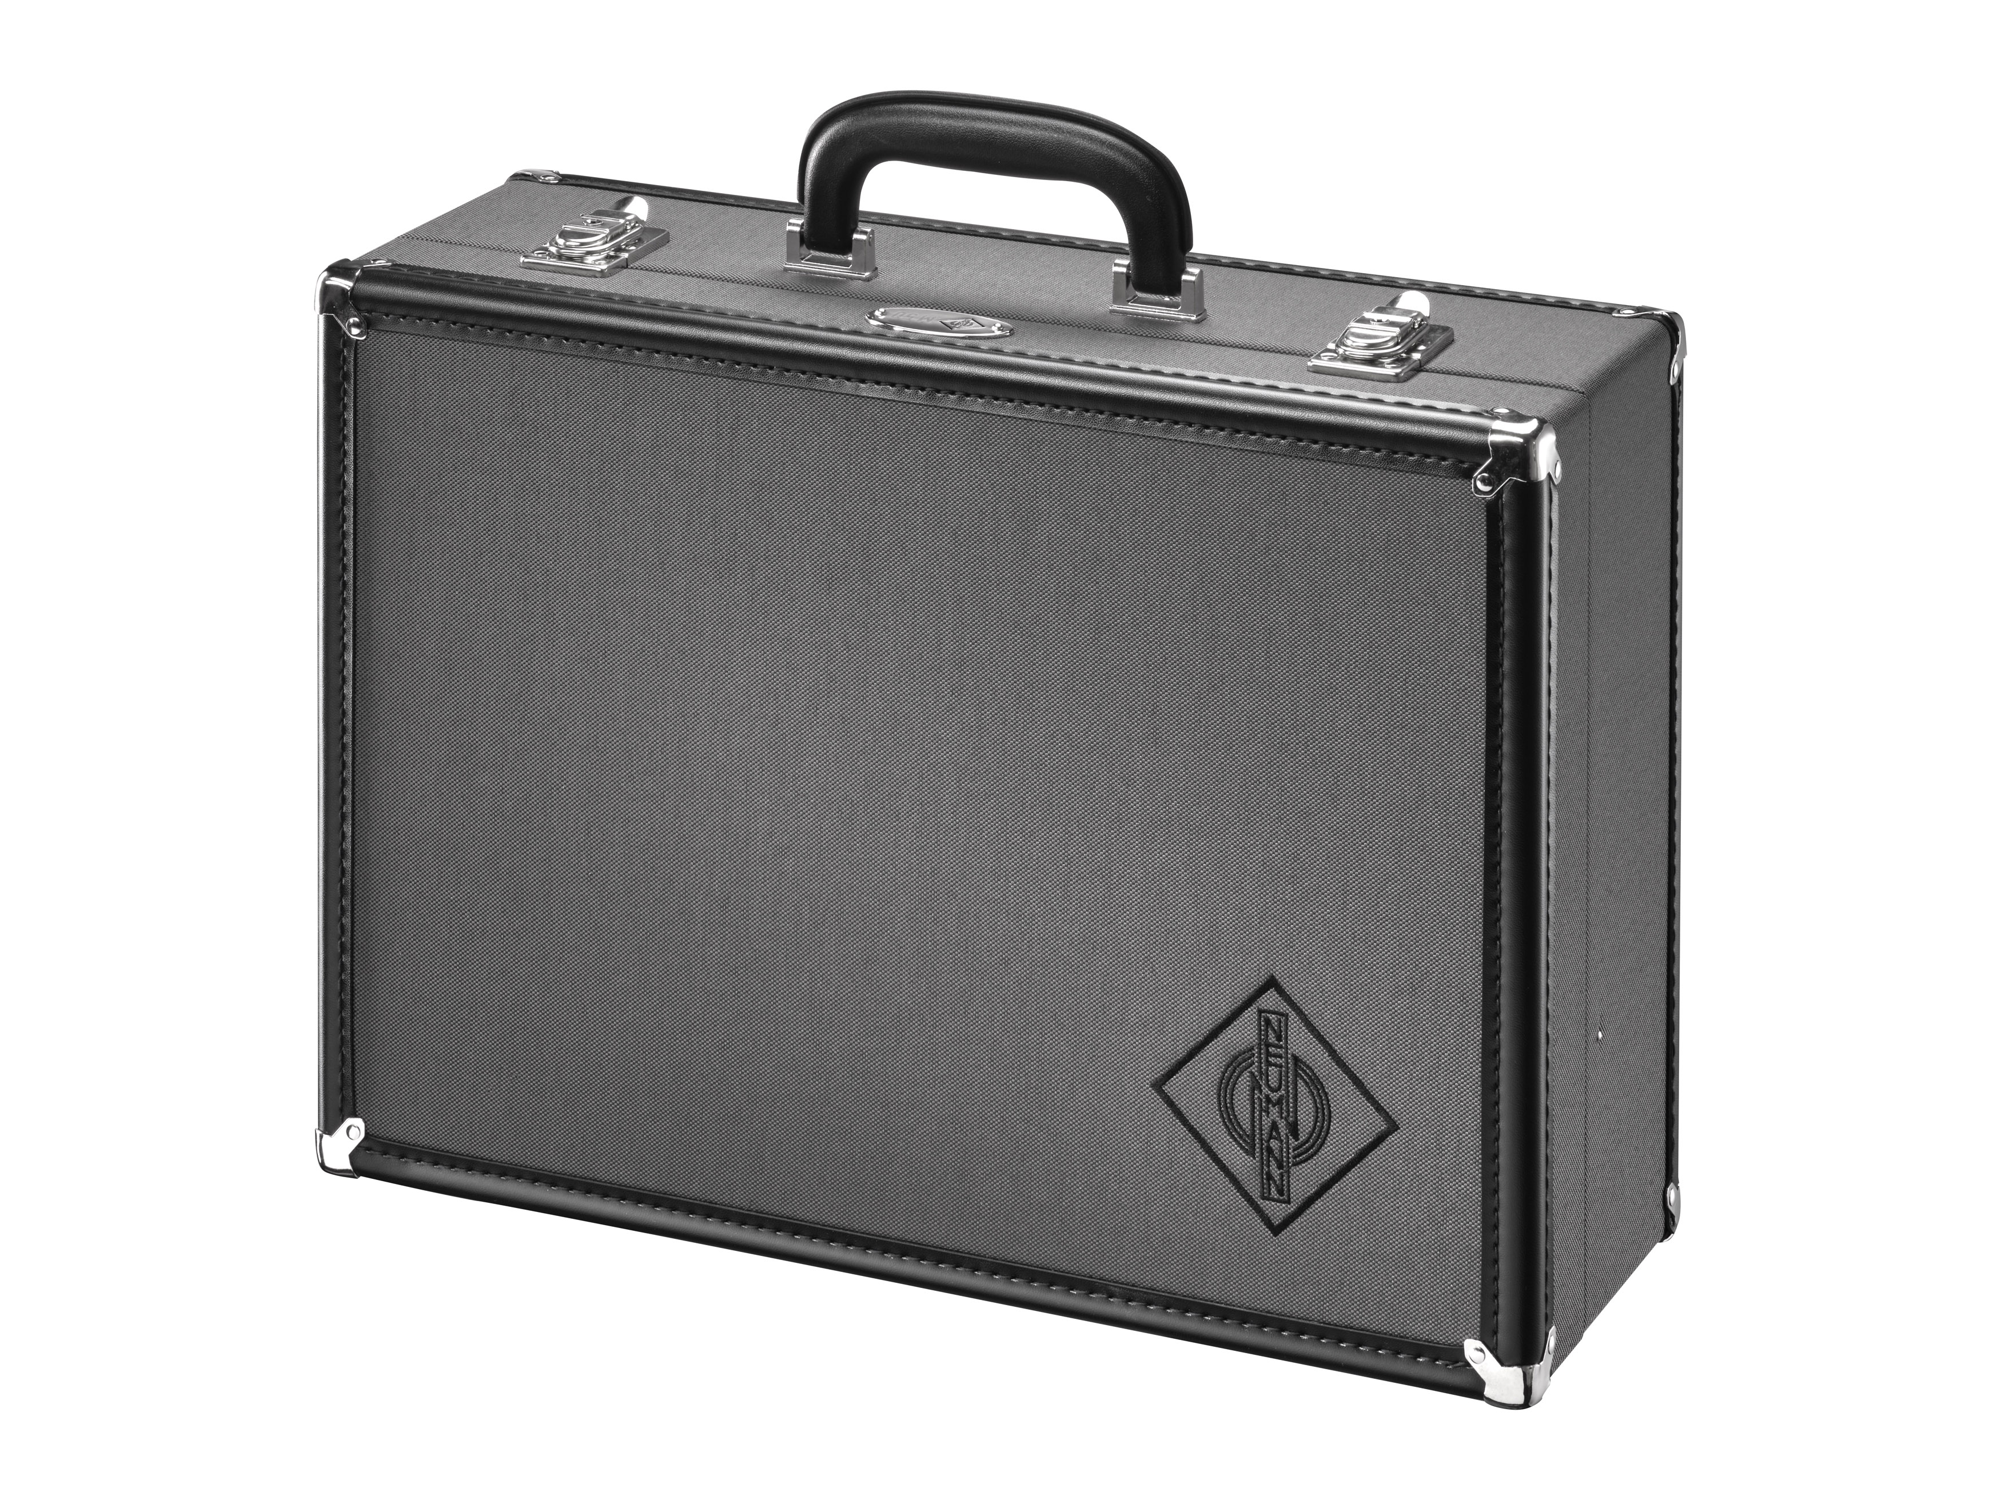
Find out what's inside at NAMM, Booth 18810

Special Highlights
Exclusive Reveal: Neumann will unveil the reissue of a very unique tube microphone!

Industry Recognition: The legendary Neumann U 47 fet will be inducted into the NAMM TECnology Hall of Fame. The ceremony takes place Thursday, January 22, 2026, at 5:00 PM in the NAMM Member Center inside the Anaheim Convention Center and is open to all NAMM attendees.
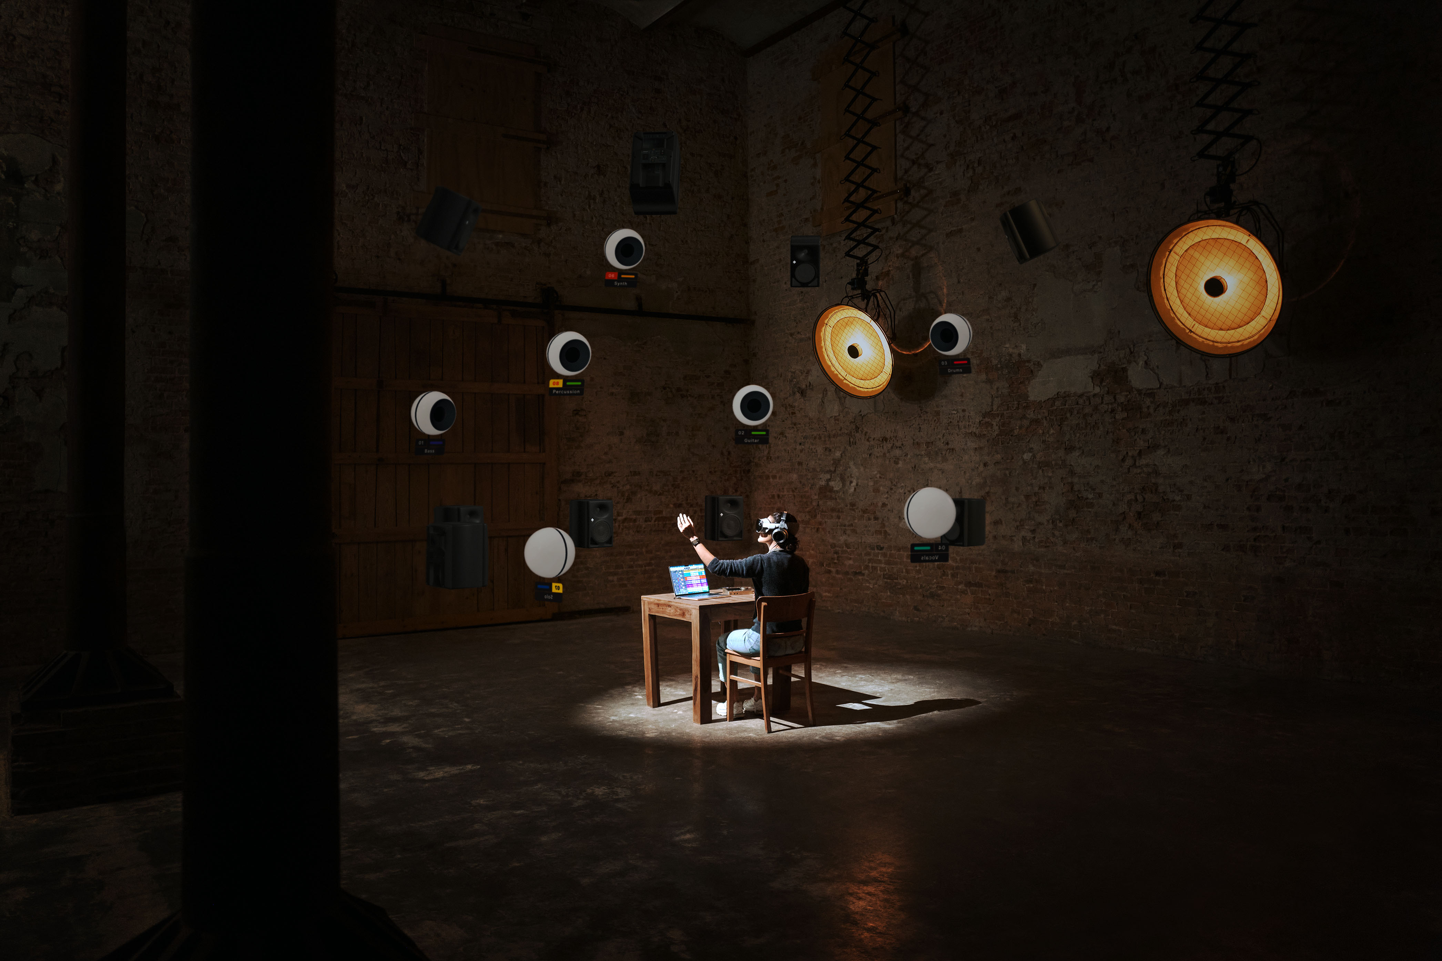
Experience the future of immersive mixing with Neumann VIS

German Pavilion – ACC North Level 1, Booth 14916
Visit us in the German Pavilion for the debut of VIS – Virtual Immersive Studio, a revolutionary software tool that makes immersive audio mixing intuitive, visual, and even tangible. Get a first look at the future of spatial audio visualization and creative control.

We look forward to welcoming audio professionals, creators, engineers, and all NAMM attendees to experience Neumann’s latest breakthroughs firsthand.

* Tentative Guest Speaker Schedule
Day | Time Slot | Session Title
January 22 | 10:00 AM – 11:00 AM | Leslie Ann Jones
January 22 | 12:00 PM – 1:00 PM | Chris James
January 22 | 2:00 PM – 3:00 PM | Andrew Scheps
January 22 | 4:00 PM – 5:00 PM | Michael Romanowski
January 23 | 10:00 AM – 11:00 AM | Ulrike Anderson & Monte Nichols
January 23 | 12:00 PM – 1:00 PM | Eric Schilling, Kellogg Boynton, Herbert Waltl
January 23 | 2:00 PM – 3:00 PM | Matt Wallace & Will Kennedy
January 23 | 4:00 PM – 5:00 PM | Ryan Ulyate
January 24 | 10:00 AM – 11:00 AM | Vance Powell
January 24 | 12:00 PM – 1:00 PM | Claus Tremblay & Ken Caillat
January 24 | 2:00 PM – 3:00 PM | Elle Graham & Chris Nungary (Squeak E Clean LA)
January 24 | 4:00 PM – 5:00 PM | Dale Becker

About Neumann
​Georg Neumann GmbH, known as “Neumann.Berlin”, is one of the world’s leading manufacturers of studio-grade audio equipment and the creator of recording microphone legends such as the U 47, M 49, U 67, and U 87. Founded in 1928, the company has been recognized with numerous international awards for its technological innovations. Since 2010, Neumann.Berlin has expanded its expertise in electro-acoustic transducer design to also include the studio monitor market, building upon the legacy of the legendary loudspeaker innovator Klein + Hummel. The first Neumann studio headphones were introduced in 2019, and since 2022, the company has increased its focus on reference solutions for live audio. With the introduction of the first audio interface MT 48, and its revolutionary converter technology, Neumann now offers all the necessary technologies needed to capture and deliver sound at the highest level. Georg Neumann GmbH has been part of the Sennheiser Group since 1991 and is represented worldwide by the Sennheiser network of subsidiaries and long-standing trading partners. www.neumann.

Stay up to date and follow us on: FACEBOOK I INSTAGRAM I YOUTUBE

Press Contact Neumann:
Raphael Tschernuth
raphael.tschernuth@neumann.com
T +49 (030) 417724-67

Dr. Andreas Hau
andreas.hau@neumann.com
T +49 (030) 417724-15

