

Biuro prasowe better. gaming agency
bettergamingagency.prowly.com

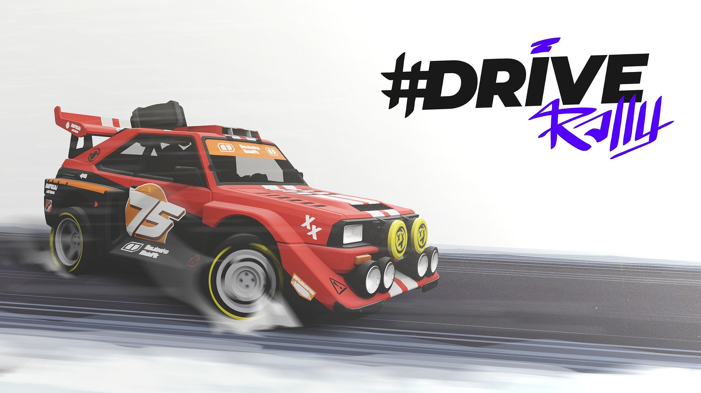

Rev your engines! #DRIVE Rally is gearing up for version 1.0 – coming April 16th!

The golden era of rally racing returns for good on April 16th! #DRIVE Rally speeds into version 1.0, leaving Early Access behind. Get ready for screeching tires, roaring engines, and flying gravel, all fueled by adrenaline and ‘90s vibes. The Pixel Perfect Dude team invites you to experience top-tier rally excitement, where speed, reflexes, and precision are key! #DRIVE Rally will be available on PC via Steam, GOG, and Epic Games Store.

In version 1.0, #DRIVE Rally will offer 22 cars, each in 3 different rally classes, fully customizable, waiting for the best drivers and co-drivers ready to compete. Over 600 km of rally stages across 6 unique locations are set to witness intense challenges in which every second counts. The game offers various gameplay modes – classic championships, free roam with collectibles, or party mode, which allows for local competition for up to 12 players.

#DRIVE Rally – release date trailer

Youtube
https://youtube.com/embed/YPgppj_wezc

The whole team is incredibly excited for the full release of #DRIVE Rally. Since our Early Access debut, we've been working at full speed to deliver top-tier rally excitement to our players. We believe we've achieved that, and our community has been a huge part of this success, supporting us with suggestions and feedback. We’re counting down the days to launch, eagerly awaiting the return of the golden era of rally racing.

- Dariusz Pietrala, Game Director at Pixel Perfect Dude.

The gameplay model in #DRIVE Rally is intuitive for beginners, while challenging for those who want to master every turn. Everything — from cars, rally stages, and maps — has been designed from scratch with the support of an engaged community, offering a fresh perspective on the rally experience. Throughout the race, the bond with the co-driver is essential, fueled by teamwork and mutual emotion. In the battle for trophies, perfect synchronization can prove more valuable than raw engine power.

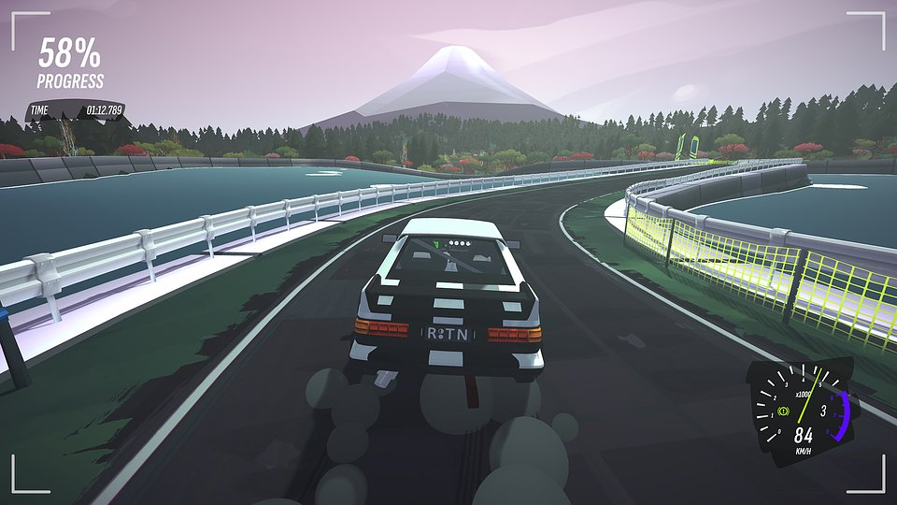

#DRIVE Rally – key features:

● Easy to learn, hard to master – a simple and intuitive driving model that beginners will handle with ease. However, challenging trials await those who know well the sound of gravel under their tires. It's a system designed to highlight the best aspects of racing games.

●Drive your way – classic championships, free roam, or party mode allowing for up to 12 players to compete? #DRIVE Rally offers a variety of ways to enjoy the journey ahead.

● New horizons, new challenges! – over 600 km of rally stages across 6 diverse locations, all to be explored and challenged in 22 unique cars with full controller and wheel support, as well as compatibility with Steam Deck.

● Left three, right one, keep it steady! – the co-driver can be the most loyal fan or the sternest judge. Enjoy victories together, but be prepared for criticism after losses.

● Win with style – take the wheel of cars like Das Holzwagen, The Doggo, or The Bobond, inspired by legendary rally machines, and then customize them to perfectly match your driving style. #DRIVE Rally combines 90s nostalgia with modern tuning options.

● Postcards from rallies – compete in a racing game world like never before. Get creative and capture your best moments in #DRIVE Rally with the special photo mode.

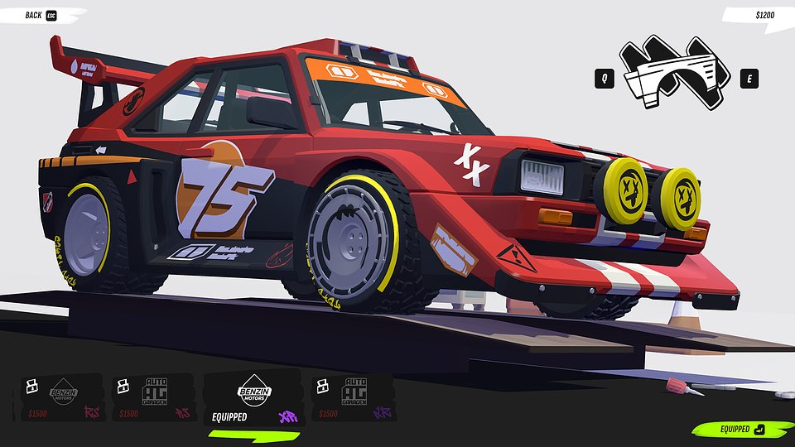

#DRIVE Rally will leave Early Access on April 16th and will be available on Steam, GOG, and Epic Games Store. We encourage you to add the game to your wishlist, follow the game's social media channels (TikTok, X, Facebook), and join the rally community on the Discord server. The console version will be released later this year.

The full press kit is available here.

About Pixel Perfect Dude:

Pixel Perfect Dude is a small yet successful independent studio from Poland. The team has created and supported titles such as #DRIVE and Ski Jump. The studio's games boast 30 million players, numerous nominations, and awards, including the title of "Game of the Year." Pixel Perfect Dude always strives to deliver high-quality titles for all platforms. More details about the studio's activities can be found at pixelperfectdude.com

