For more information, please contact Marta de Paco
On +34 670 780 664 or email press@comunicahair.com

Important:
These images are only available for editorial content.
Credits must be included.
Notification of their publication is expected.

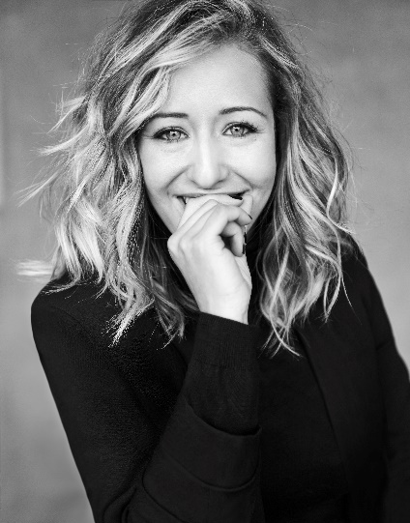
MARÍA MONTES
MANUEL MON ESTILISTAS
BLOOM Collection

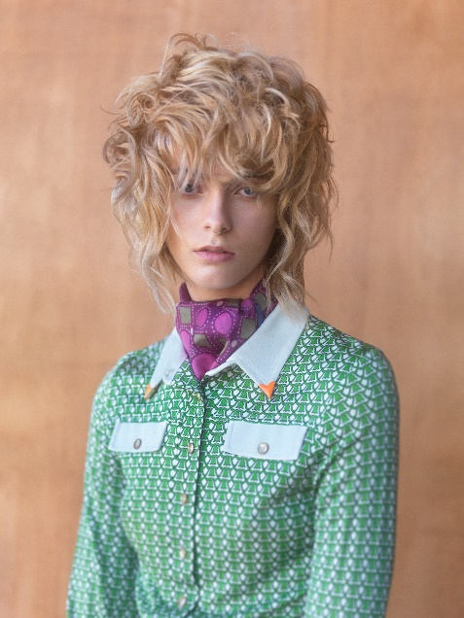
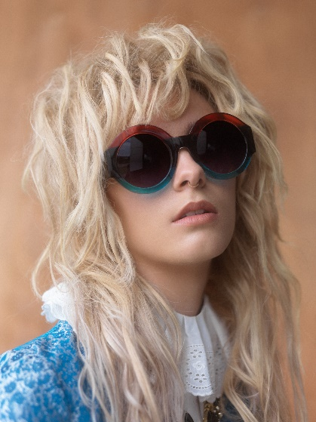
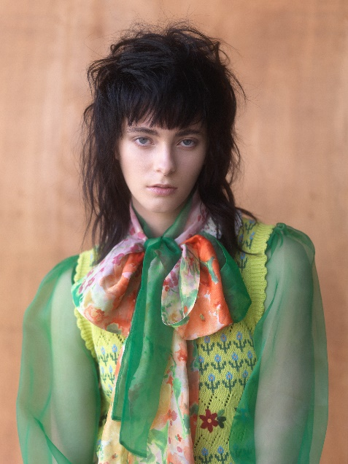

Hair: María Montes @__mariamontes__
Hair Instagram: Manuel Mon Estilistas @manuelmonoficial
Photography: Bernardo Baragaño @vertigoestudio
MUA: María Montes @__mariamontes__
Styling: Ana González Del Pozo @Ana_gonzalezdelpozo
Models: Cristina Pérez @cris_peerez
Products: Revlon Professional @revlonprofessional_es

MARÍA MONTES
MANUEL MON ESTILISTAS
BLOOM Collection

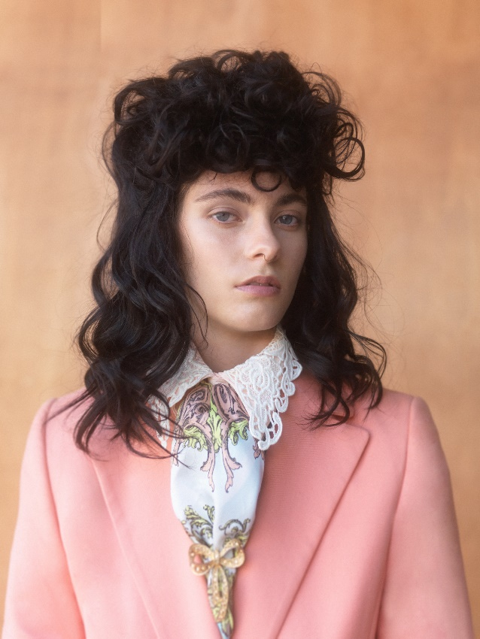

The collection, which is clearly vintage-inspired, recalls the London spirit of the 70s and 80s with youthful looks that evoke classic mullets, although they look very contemporary too. In "Bloom’’, an old atmosphere, the London aesthetic, and volumes flourish. They do it in the present, giving a double version to the past and the present. To work on a technical level, natural hair wigs have been used. These have been cut, colored and styled with Revlon Professional products.

