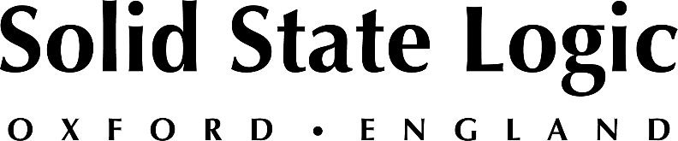

Solid State Logic Adds Software from Key Industry Brands to its Renowned
SSL Production Pack, Bundled free with its SSL 2 and SSL 2+ Audio Interfaces

Bundle now includes software from IK Multimedia, Celemony and Applied Acoustic Systems as well as full versions of SSL Drumstrip, Vocalstrip 2 and is available to new and existing SSL interface owners

Oxford, England, May 23, 2022 — Solid State Logic announces significant new additions to its renowned SSL Production Pack, its powerful software bundle included with every registered SSL 2 and SSL 2+ USB audio interface. The new software additions include titles from key industry brands IK Multimedia, Celemony and Applied Acoustic Systems, in addition to full versions of SSL's DrumStrip, VocalStrip2 among other six-month trial versions of SSL software

Combined with SSL's critically acclaimed 2 and 2+ USB audio interfaces, the SSL Production Pack delivers a complete suite of software tools for producing, recording and mixing. Now, with a new selection of virtual instruments and plug-ins, it is easier than ever for musicians and producers to find their own sound with the enhanced SSL Production Pack.
New software additions to the SSL Production Pack include:

- Amplitube 5 SE by IK Multimedia (guitar amplifier/cabinet/pedal modelling). Unlock the power of AmpliTube 5 with 80 models covering all the “must-have” gear.
- Melodyne 5 essential by Celemony (pitch-correction software for vocals,). Edit your vocals using the basic functions for pitch and timing. Get the perfect mix-ready delay using the high and low pass filters, mid/side width and mix controls.
- Session Bundle by AAS (Three virtual instruments: classic electric piano, acoustic/electric guitar synth and ultra-analogue synthesizere).
Three inspiring virtual instruments for music makers, providing essential sounds for your tracks:
- Lounge Lizard Session
- Strum Session
- Ultra Analog Session

Full information on the SSL Production Pack can be found here: www.solidstatelogic.com/sslproductionpack

The enhanced SSL Production Pack is available now to all new and existing SSL 2 and SSL 2+ interface owners. To learn more about the SSL 2 and SSL 2+ USB audio interfaces and the SSL Production Pack, visit Solid State Logic at the 2022 NAMM Show, Booth 18205.

Solid State Logic is the world’s leading manufacturer of analogue and digital audio consoles and provider of creative tools for music, broadcast, live and post production professionals. For more information about our award-winning products, please visit: www.solidstatelogic.com.

###
For further information contact:
Jeff Touzeau
+1 (914) 602-2913
jeff@hummingbirdmedia.com

Ross Gilbert
+44 (0) 1865 842300
rossg@solidstatelogic.com

